Открытый урок по теме «The world around us»

Цель урока: систематизировать и обобщить знания учащихся по теме «Мир вокруг нас».
Задачи урока:
· формирование элементарных коммуникативных компетенций в говорении и чтении на английском языке с учетом речевых возможностей, потребностей и интересов младших школьников;
- развитие учебно-познавательной компетенции ребёнка, его речевых способностей, внимания, мышления, памяти и воображения;
- формирование общекультурной компетенции - приобщение к новому социальному опыту с использованием английского языка.
Тип урока: Урок обобщения и систематизации знаний и умений
Класс и предмет: Английский язык, 3 класс
Продолжительность урока: 45 минут
Используемые методы обучения: наглядные (демонстрация, показ презентации, визуального материала); словесные (беседа); методы проблемного обучения (частично-поисковые, метод развития критического мышления через чтение и письмо)
Используемые средства обучения: карточки, компьютер, интерактивная доска
Планируемые результаты урока:
Личностные:
-поддержание мотивации к изучению иностранного языка.
-восприятие иностранного языка, как средство общения.
Метапредметные:
- развитие коммуникативных способностей школьников
- расширение общего лингвистического кругозора младшего школьника;
Предметные:
- умение работать с текстом, отвечать на вопросы;
- употребление в устной (диалогической) речи лексических единиц и речевых структур по теме урока.
I. Организационный этап
Приветствие учащихся
Проверка готовности к уроку
- Good afternoon, boys and girls. I`m very glad to see you.
- How are you today?
Речевая разминка
- Let`s begin our lesson with the poem “Nature”.
Look around and you will see:
Berries, flowers, bushes, trees,
Mountains are very high,
Birds are flying in the sky.
You can swim in the sea.
You can climb different trees.
All around us is nature,
Full of wonders and adventures.
Сообщение темы и целей урока
II. Актуализация знаний.
Повторение пройденного материала
- фронтальный опрос
- What`s the weather like today?
- What types of water can we observe? (Precipitation, collection)
- How many states of water are there? (three states)
- What are they? (solid, liquid, gas)
- What forms of precipitation can we observe? (Snow)
- What state of water is it? (solid)
- Is it living or non-living? (non-living)
- Where can we find water? (We can find water in lakes, oceans, seas, rivers, reservoirs)
б) работа с карточками
- Let`s play a game. (Guess the water form.)
- Who wants to go to the blackboard?
- Take one card, please? Don`t show it.
- Your task is to ask the questions and guess the water form.
- Is it a freshwater form?
- Is it a solid form?
- Is it a man-made form?
- Is it a saltwater form?
- Is it a liquid form?
- Is it a natural form?
Icecap (natural, solid, freshwater)
Ocean/sea (liquid, saltwater, natural)
River/lake (liquid, freshwater, liquid)
Reservoir (liquid, freshwater, man-made)
в) применение знаний и умений в новой ситуации.
- We see many things around us. Some are living things. Some are non-living things.
- What are the characteristics of living things? (They can grow, breathe, move, reproduce, die.)

Guess the riddle, please.
I live in Africa.
I am yellow and brown,
I eat leaves.
I have a long neck.
A giraffe. Is it living or non-living? It`s living. (It can grow. It can move. It can breathe. It can reproduce.)
Guess the riddle, please.
I am made of wood.
I have four legs.
You can sit on me.
I`m often in the kitchen.
What am I?
A chair. Is it living or non-living? It`s non-living. (It can`t grow. It can`t breathe, It can`t reproduce.)
True/False
Read each statement.
1) Human beings are living things.
2) Non-living things can breathe.
3)Water, air and sunlight are living things.
4) Living things can grow, use energy and breathe.
5) Non-living things have senses.
6)Living organisms can reproduce.
7) Non-living things cannot move on their own.
8) Non-living things consume food.
9) Microorganisms are non-living things.
10) Non-livings do not grow.
г) работа с текстом
Let`s read the text and do some tasks.
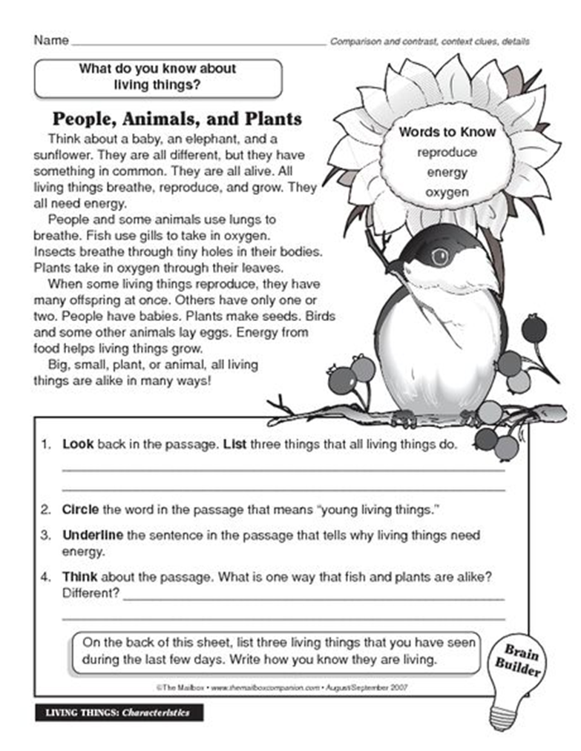

Физкультминутка
Stand up. Clap your hands. Sit down. Stand up. Turn around. Stamp your feet. Sit down.
What life process is it? (Interaction)
What are the life processes of living things? (Nutrition, Interaction, Reproduction)
What life processes can you see?
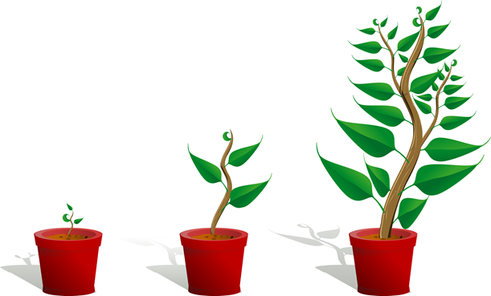
Let`s see. There are some cards for you. Group them. Who wants to go to the blackboard?
People need food.
Plants need water.
Animals need food,
People interact.
Penguins interact to keep warm.
Sunflowers interact with the sun.
People have babies,
Some animals lay eggs.
Plants produce seeds for new plants to grow.
Подготовка к изучению нового материала (создание проблемной ситуации, постановка вопросов)
Kangaroos have baby kangaroos.
What continent do they live on? (Australia)
How many continents are there in the world?
What are they? Asia, Africa, North America, South America, Antarctica, Europe, and Australia.
Let`s sing the song. Stand up, please.
III. Изучение нового материала
Объяснение нового материала
- работа с текстом
Asia is Earth's largest and most populous continent. Asia covers an area of 44,579,000 square kilometres (17,212,000 sq mi), about 30% of Earth's total land area and 8.7% of the Earth's total surface area. The continent, which has long been home to the majority of the human population, was the site of many of the first civilizations. In general terms, Asia is bounded on the east by the Pacific Ocean, on the south by the Indian Ocean, and on the north by the Arctic Ocean
IV. Закрепление нового материала
Выполнение практического задания
Match the continents and their capital cities.
Indonesia – Jakarta
Thailand – Bangkok
Philippines – Manila
Brunei – Bandar Seri Begawan
Turkey – Ankara
Iraq – Baghdad
Japan – Tokyo
China – Beijing (Pekin)
Mongolia – Ulaanbaatar
Uzbekistan – Tashkent
Turkmenistan – Ashgabat
Kazakhstan – Astana
Устная проверка понимания нового материала
Let`s check your knowledge. What is the capital city of ….? (The capital city of … is …)
V. Домашнее задание
Объяснение домашнего задания; запись домашнего задания в дневники
- Your homework is to learn countries and their capitals.
VI. Рефлексия
Обсуждение с учащимися хода и результатов урока; оценивание работы учащихся на уроке
VII. Итог урока

