План-конспект урока английского языка в 8-м классе
по теме «Food from all over the world» или «Кухня народов мира»
(с применением обучающих структур сингапурской методики обучения)

Учитель английского языка
ГУО «Средняя школа № 14 г.Новополоцка»
Томашевич Ольга Васильевна
Место урока: 4 / 10
Тип урока: урок развития лексических и монологических навыков устной речи учащихся.
Цели:
Образовательная цель: формирование лексических навыков говорения по теме «Food from all over the world».
Развивающая цель: развитие навыков грамотно, четко и лаконично рассуждать и выражать свои мысли по теме «Food from all over the world».
Воспитательная цель: создать условия, обеспечивающие воспитание интереса к кухне народов мира; обеспечить высокую творческую активность при выполнении заданий.
Задачи:
- Содействовать активации лексики по теме «Food from all over the world».
- Создать условия для использования лексических единиц в ситуации общения.
- Способствовать созданию благоприятного микроклимата доброжелательности в детском коллективе.
Оснащение и дидактические материалы: доска, аудиозапись, раздаточный материал (рабочая карта урока, карточки для самооценки, тематические картинки, карточки для рефлексии, карточки с этапами урока, Manage Mat – см. Приложение), магниты, учебник «Английский язык» Л.М. Лапицкая 8 класс

The plan of the lesson: «Food from all over the world»
№ | Этап учебного занятия | Содержание этапа,  деятельность учителя | Время | Примечания
I.  1.  2.  3.  4. | Организационно-мотивационный этап  Организационный момент.  Речевая разминка.  Целеполагание.  Фонетическая зарядка. | - Good morning! Glad to see you. How are you? Are you hungry? Did you have breakfast today? What did you eat? What do you usually eat for breakfast?  - Приём Find-the-fiction («Two truths and one lie») (на основе домашнего текста): Look at the statements: two of them are truths and one is a lie. Read and decide which one is a lie. Stas, read number 1, please. Anna, number 2, please. Angelina, the last one.  1) The Sunday roast is a traditional meal eaten by a family at Sunday lunchtime.  2) Lunch is the meal eaten in the middle of the day.  3) Supper is the most common name for the meal eaten in the evening (usually between 6.30 and 7.00). Correct: 7.00 – 8.30  Приём Take off - Touch down:  Stand up if you think that the first sentence is a lie.  Stand up if you think that the second sentence is a lie.  Stand up if you think that the third sentence is a lie.  Stas, explain, why the third sentence is a lie.  Look at the board. Let’s make sentences using the pictures. Begin with “The national dish of …. is … “  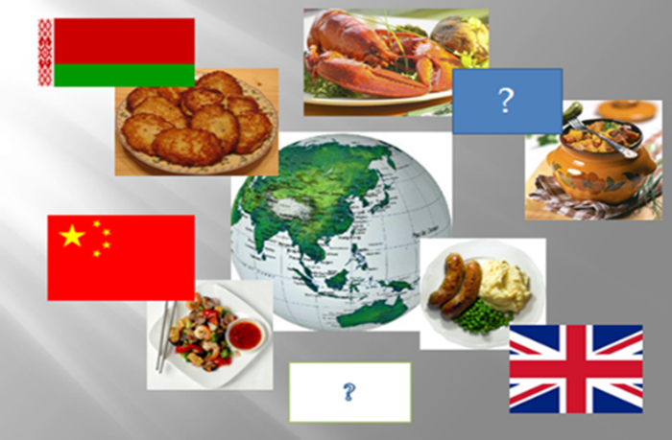  So, guess about what we are going to speak today. What is the topic of our lesson?  You are right. We’re going to talk about different names of the dishes: British dishes, Belarusian dishes and dishes of different countries. And the topic of our lesson is “Food from of over the world”.  Now take your worksheets (exercise I). You have 1 minute to write down the names of the dishes and products you remember from the previous lesson. Stop. Count how many words you’ve written. Pasha, please, read your words.  You see, your lists of the words are not very long.  That’s why the main aims of our lesson are:  - to develop and practice vocabulary related to our topic;  - to improve speaking, reading and listening skills;  - to enrich knowledge about food from all over the world.  To achieve these aims we have to do different tasks and exercises (read!!!) and I hope that at the end of the lesson the list of your active vocabulary will be much longer.  Now take green cards on your desks. Look at them attentively. If you are successful in doing all these exercises at the end of our lesson your mark will be 10.  Today we shall… I have…  1. the Sound Cafe 0 0,5 1 1,5 2  2. speaking about Alesya’s, Ian’s and Lee’s breakfast 0 0,5 1 1,5 2  3. speaking about the famous dishes of the world 0 0,5 1 1,5 2  4. vocabulary exercise 0 0,5 1 1,5 2  5. my active vocabulary (at the end of the lesson) 0 0,5 1 1,5 2  - And now I’d like to invite you to Sound Café. Take your worksheets (exercise II) and divide the words into the groups according to the sounds used in them: Irish, mushrooms, sprinkled, sushi, barley, onion, stew, herbs, oven, served, sour, special, flour, mutton, olive, pearl, noodles, goulash, seafood, vinegar, borscht, simmered, mutton.  [ʃ] [j] [aʊə] [ɜː] [ɪ] [uː] [ʌ]  Irish sushi special goulash borscht onion stew sour flour herbs served pearl sprinkled barley olive vinegar simmered mushrooms noodles seafood oven mutton  Let’s check. (сначала дети зачитывают свои варианты, затем читаем вместе хором) | 1 min  1 min  2 min  1 min  2 min  3 min | (Sentences are written on the board)  (Pictures are on the board)
II.  1.  2.  3.  4. | Операционно-деятельный этап  Развитие навыков аудирования и монологического высказывания  Динамическая пауза  Развитие навыков изучающего чтения  Актуализация изученных ЛЕ | Now open your books at page 71 ex.1  Приём Anticipation-Reaction Guide «Руководство предположения/реакции»:  - Pre-listening: look at the pictures of three different breakfasts. Guess which breakfast Lee from China, Alesya from Belarus and Yan from Scotland eat.  - While-listening: Listen to Alesya, Ian and Lee describing their breakfast, check your guesses and make a list of things the children eat for breakfast. In your worksheets (exercise III), please.  Alesya: I am Alesya. I live in Belarus. My breakfast is usually scrambled or boiled eggs, a piece of bread with cheese and ham and a cup of tea. Sometimes I have a plate of kasha with a glass of milk.  Yan: I am Yan. I live in Scotland. Every morning I have a bowl of porridge and a glass of milk or cereals with milk. On Sundays we always have bacon and eggs with tomatoes. Sometimes we have black pudding. I always have a cup of milk tea as my parents don’t allow me to drink black or white coffee (coffee with milk).  Lee: I am Lee from China. For breakfast I eat a bowl of noodles or a plate of rice with some fish or some meat, usually beef or pork and a plate of vegetables. Sometimes it is simply a plate of vegetables when I need a quick breakfast. I also have a cup of good tea. I never drink milk.  - After-listening: a) Answer my questions, please.  1) What does Alesya from Belarus usually have for breakfast?  2) What does Yan from Scotland usually have for breakfast?  3) What does Lee from China usually have for breakfast?  b) Приём Timed-Pair-Share: Now let’s work in pairs. Students 1 and 2, imagine that you are Alesya and tell your face partners about your breakfast. You have 30 seconds. Stop. Time is over. Now, students 3 and 4, imagine that you are Lee and tell your face partners about your breakfast. You have 30 seconds. Stop. Thank you.  c) Now, Julia, tell us about Lee’s breakfast. \\ Anna, tell us about Alesya’s breakfast. \\ Gora, tell us about Yan’s breakfast.  Yes! Great job!!! Let’s have a rest and play a little! Clap your hands, if you…  1) help your mum to cook dinner;  2) never tried black pudding;  3) have cereals for breakfast;  4) want to try Yorkshire pudding; |ˈjɔːkʃə|  Now stamp your feet, if you …  1) hate gravy;  2) like scrambled eggs;  3) can cook boiled potatoes;  4) have sandwiches for breakfast.  Now it’s high time to move to our text about famous dishes of different countries: SB p.71 ex.4a, 4b, 4c  Pre-reading: 1) Before we begin to work with the text let’s look at unknown words. Take your worksheets (exercise IV), please. You have to read words and their definitions and try to guess their Russian equivalents. At first do this with your shoulder partners. You have 1 minute. Time is over. Now you have to exchange the ideas of translation of the words with your face partners. You have 1 minute. Now, please, tell me if some words are still unknown to you. Do you have such words? Let’s check your translations. Alina, begin to read.  1) mutton – the meat from an adult sheep eaten as a food: баранина  2) a slice – a flat, often thin, piece of food that has been cut from a larger piece: ломтик  3) an oven – the part of a cooker with a door, used to bake or roast food: духовка  4) sauce – a thick liquid (жидкость) eaten with food to add special taste (tomato sauce): соус  5) a cube – a solid object with six square sides of equal size: кубик  6) a goat – an animal related to sheep that usually has horns (рожки) and a beard: козёл  7) stew – a type of food consisting usually of meat or fish and vegetables cooked slowly in a small amount of liquid (жидкость): тушеное мясо  8) flavour – how food pr drink taste, or a particular taste itself: вкус, привкус  9) flour – powder made from grain (зерно), especially wheat, used for making bread, cakes, pasta, etc.: мука  10) fresh – new or different: свежий  2) SB p.71 ex.4a: Look at the names of the dishes and the countries they come from. Match the countries and the dishes. Let’s do this task together. Stas, begin, please.  1) G; 2) D; 3) B; 4) F; 5) E; 6) H; 7) C; 8) A  While-reading: SB p.71 ex.4b: Do you know anything about these dishes? Read the texts and try to remember as many details as possible. You have 3 minutes.  After-reading: a) Now take your worksheets – exercise V (worksheets). Read the sentences and decide if they are true or false. Correct false statements. Work in pairs with your shoulder partners. You have 2 minutes.  1) You can find thick slices of bread in French onion soup. - True  2) Pearl barley has been the most important food in Ireland since the 1800s. – False. Potatoes have been the most important food in Ireland since the 1800s.  3) Goulash is Belarusian national dish. – False. Goulash is Hungary’s national dish.  4) Sushi is a favourite food in Japan. – True.  5) Machanka is the second name for borscht. – Machanka is used as a Belarusian traditional sauce for draniki or blini.  b) Приём Single Round Robin: Now look at exercise VI in your worksheets. Let’s work in groups. You have to answer questions clockwise. So, all questions have to be answered by all students. Students number 1 will begin. You have 3 min.  1) Which dishes have you tried?  2) Which dishes would you like to try?  3) Which dish has a simple recipe?  4) Which dish is hard to cook?  5) Which dish has simple ingredients?  6) What dish can you cook?  Let’s discuss. Stas, answer the first question.  c) Now I’ll give you cards with the names of the dishes. You have 2 minutes to prepare the retelling of the recipe of the dish you have on your card.  d) Now you have to work in pairs with your face partners. Students 1 and 2, tell your face partners the recipes of the dishes from your cards. You have 1 minute. Stop. Time is over. Now, students 3 and 4, is your turn to tell your face partners the recipes from your cards. You have 1 minute. Stop. Thank you.  e) Приём One Stray: Now, student number 2 from the first table goes to the second table. Student number 2 from the second table goes to the third table. And student number 2 from the third table goes to the first table. Please, exchange places. Students number 2, you have 2 minutes to tell your new teammates the recipe of the dishes from your card. Begin, please.  Приём Simultaneous Round Table: And the last task for today is exercise VII in your worksheets. You have sentences. Some words are missed. You have 1 minute to fill in the necessary words. When the time is over you have to pass your cards clockwise so each teammate can add information to the prior responses. (карточка передается 4 раза, пока не вернется к своему хозяину)  1) It is Ireland’s best-known dish from lamb or mutton.  2) French onion soup is made of onions and beef or chicken stock.  3) Spaghetti Bolognese mixes spaghetti with a meat and tomato sauce.  4) Greek Salad is made with tomatoes, cucumbers, black olives and cubes of feta.  5) Slices of very fresh fish, seafood and vegetables wrapped in seaweed are laid on rice.  6) Borscht is eaten cold in summer and hot in winter. Sometimes meat or mushrooms, cabbage, carrots and potatoes are added.  Now I’ll give you cards with keys to the exercise. Please, check your answers.  Take off - Touch down:  Stand up if you have no mistakes.  Stand up if you have 1or 2 mistake.  Stand up if you have 3 or 4 mistakes.  Stand up if you have more than 4 mistakes. | 30 seconds  1,20min*2  3 min  1 min  3 min  2 min  2 min  2 min  4 min  2 min  2 min  2 min  4 min
III.  1.  2.  3. | Рефлексивно-оценочный этап  Рефлексия.  Подведение итогов.  Выставление отметок.  Домашнее задание. | Now let’s go back to the beginning of our lesson. You wrote some names of the dishes. Do you remember? The list wasn’t very long. And our aim was to enrich our vocabulary. Let’s see if we have coped with this task.  Приём Corners.  Take your worksheets, exercise number 1. You have 1 minute to write down the names of the dishes and products you’ve learned during the lesson. Here, please (показать). Stop. Time is over. Count how many words you’ve written.  If you’ve managed to learn 10 or more than 10 words, go to this corner. (T shows the corresponding corner)  If you’ve managed to learn 8-9 words, go to this corner. (T shows the corresponding corner)  If you’ve managed to learn 5-7 words, go to this corner. (T shows the corresponding corner)  If you’ve managed to learn less than 5 words, go to this corner. (T shows the corresponding corner)  Pasha, please, read your words.  Thank you. Take your sits.  Boys and girls, you have worked very well today. So, take your cards. Let’s count what your marks can be today. Please, circle how many points you can have for the exercises mentioned in the card. Count, please. Are you ready with your marks? Julia, what is your mark? .... I agree with it. Great job.  …. you’ve been very active.  … I liked your work at the lesson very much.  … you’ve been less active.  … you’ve been a little bit passive. I will ask you next time.  Your home task. We discussed a lot of dishes. At home you have to write about your favourite Belarusian dish. Open your record books. Write down, please. SB p.74 ex.5b.  Our lesson is over. Goodbye, boys and girls! | 2 min  1 min  1 min

APPENDIX 1
FOOD FROM ALL OVER THE WORLD
(worksheet)
I.
MY VOCABULARY ON THE TOPIC
At the beginning of the lesson | At the end of the lesson
II. The Sound Café. Divide the words into groups according to the sounds used in them: Irish, mushrooms, sprinkled, sushi, barley, onion, stew, herbs, oven, served, sour, special, flour, mutton, olive, pearl, noodles, goulash, seafood, vinegar, borscht, simmered, mutton
[ʃ] | [j] | [aʊə] | [ɜː] | [ɪ] | [uː] | [ʌ]

III. Listen to Alesya, Ian and Lee describing their breakfast and make a list of things the children eat for breakfast:
BREAKFAST
Alesya | Ian | Lee
IV. Read the words and their definitions and try to guess their Russian equivalents:
1) mutton – the meat from an adult sheep eaten as a food: __________________________
2) a slice – a flat, often thin, piece of food that has been cut from a larger piece: _______________________
3) an oven – the part of a cooker with a door, used to bake or roast food: _____________________
4) sauce – a thick liquid (жидкость) eaten with food to add special taste (tomato sauce): ____________________________
5) a cube – a solid object with six square sides of equal size: ________________________
6) a goat – an animal related to sheep that usually has horns (рожки) and a beard: __________________________
7) stew – a type of food consisting usually of meat or fish and vegetables cooked slowly in a small amount of liquid (жидкость): _________________
8) flavour – how food pr drink taste, or a particular taste itself: _______________________________
9) flour – powder made from grain (зерно), especially wheat, used for making bread, cakes, pasta, etc.: _________________________________
10) fresh – new or different: __________________________________
V. Read the sentences and decide if they are true or false. Correct false statements.
1) You can find thick slices of bread in French onion soup.__________________________________________________________________________
2) Pearl barley has been the most important food in Ireland since the 1800s.____________________________________________________________
3) Goulash is Belarusian national dish.__________________________________________________________________________________________
4) Sushi is a favourite food in Japan.____________________________________________________________________________________________
5) Machanka is the second name for borscht. _____________________________________________________________________________________
VI. Answer the questions:
1) Which dishes have you tried?
2) Which dishes would you like to try?
3) Which dish has a simple recipe?
4) Which dish is hard to cook?
5) Which dish has simple ingredients?
6) What dish can you cook?
VII. Fill in the necessary words:
1) It is Ireland’s best-known dish from … or … .
2) French onion soup is made of onions and … or chicken … .
3) Spaghetti Bolognese mixes spaghetti with … and tomato … .
4) Greek Salad is made with tomatoes, … , black … and cubes of … .
5) Slices of very fresh …, … and vegetables wrapped in … are laid on … .
6) Borscht is eaten … in summer and … in winter. Sometimes meat or …, cabbage, … and … are added.

APPENDIX 2
CORNERS
I’ve learnt 10 and more words
I’ve learnt 8 or 9 words

I’ve learnt 5-7 words

I’ve learnt less than 5 words

APPENDIX 3
Карточки для самооценки
Today we shall… | I have…
1. the Sound Cafe | 0 | 0,5 | 1 | 1,5 | 2
2. speaking about Alesya’s, Ian’s and Lee’s breakfast | 0 | 0,5 | 1 | 1,5 | 2
3. speaking about the famous dishes of the world | 0 | 0,5 | 1 | 1,5 | 2
4. vocabulary exercise | 0 | 0,5 | 1 | 1,5 | 2
5. my active vocabulary (at the end of the lesson) | 0 | 0,5 | 1 | 1,5 | 2

APPENDIX 4
Карточки с этапами урока

learn new words

do listening exercises

read the text about the famous dishes
of different countries

speak about the famous dishes
of different countries

APPENDIX 5
Тематические картинки (на доску)

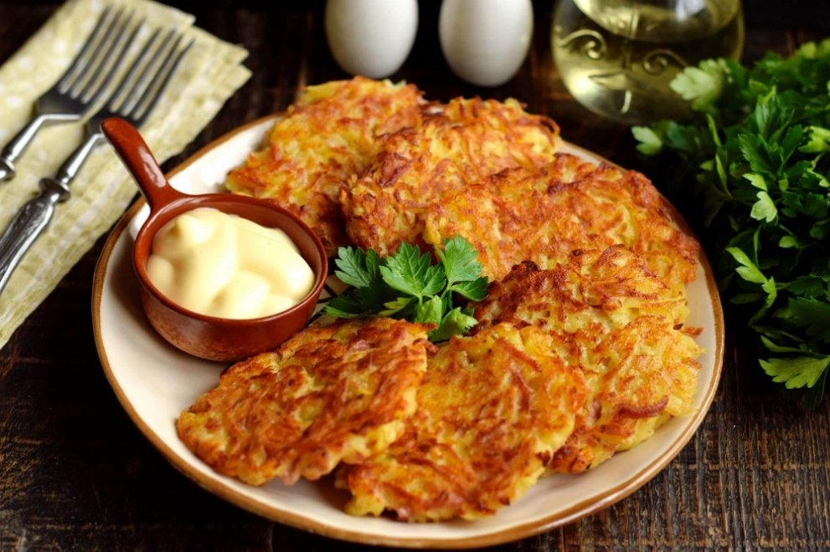

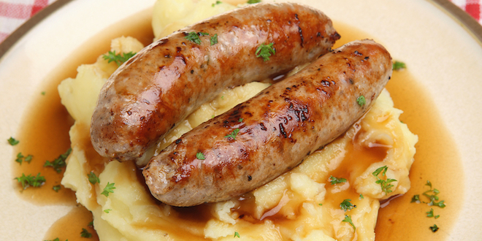
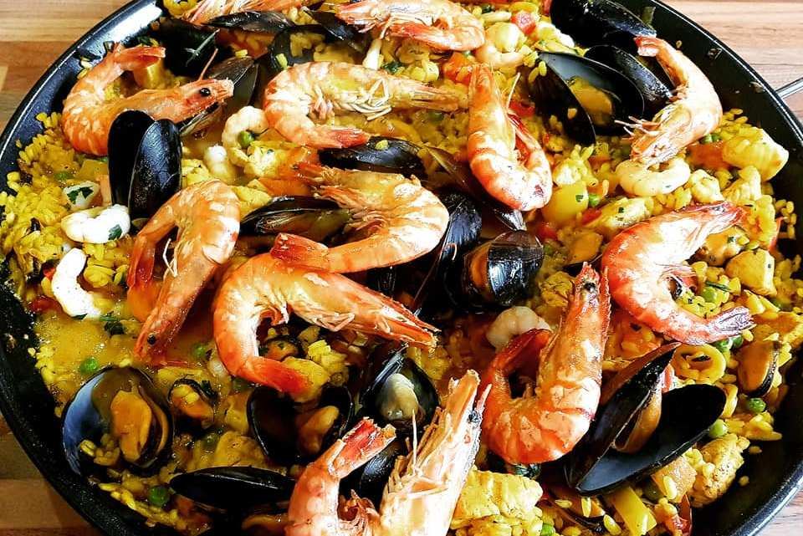

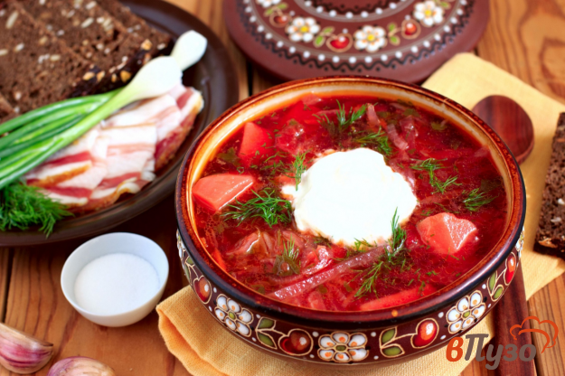
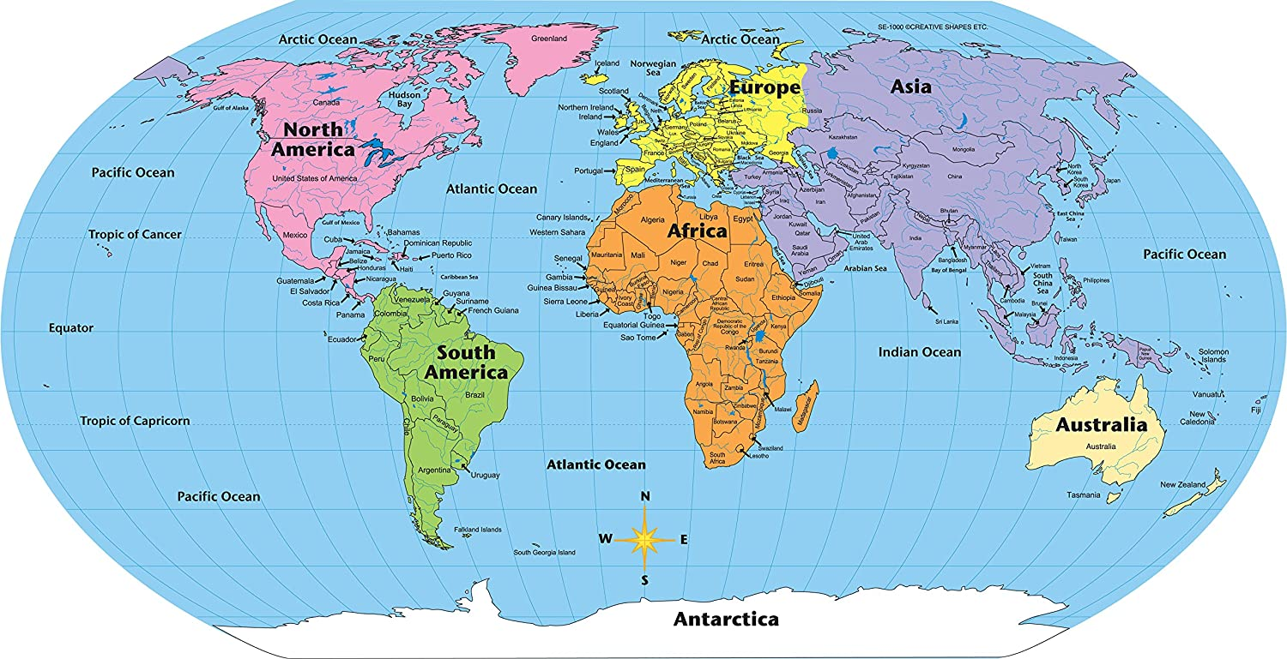

APPENDIX 6
Manage Mat

