УДК 004.4'24

РАЗРАБОТКА ПО ДЛЯ ТОВАРОВЕДЕНИЯ НА ЯЗЫКЕ ПРОГРАММИРОВАНИЮ С#

Арзамазов Н.Р. .1, Береснева Д.Т. .1

1 Нижнетагильский государственный социально-педагогический университет (ф) РГППУ в г. Нижнем Тагиле, email: diana.beresneva@bk.ru

Аннотация
В данной статье рассматривается создание программного обеспечения для отслеживания товарооборота в розничном или онлайн-магазине, так как в связи с локдауном в стране спрос на онлайн-магазины сильно возрастает по сравнению с другими годами. Поэтому важно создать такое ПО, которое поможет людям выбрать необходимые товары. Также в статье рассматриваются преимущества данного ПО, его положительные стороны.
Ключевые слова: Товаровед, C#, товарооборот, разработка

DEVELOPMENT FOR MERCHANDISING IN C# PROGRAMMING LANGUAGE

Arzamazov N.R.1, Beresneva D.T. 1

1 Nizhny Tagil State Social and Pedagogical University (ph) Russian State Pedagogical University in Nizhny Tagil, e-mail: diana.beresneva@bk.ru

Abstract

This article deals with the creation of software to track the turnover of a retail or online store, because due to the lockdown in the country, the demand for online shopping is increasing a lot compared to other years. Therefore, it is important to create a software that will help people choose the products they need. The article also discusses the advantages of this software, its positive aspects.

Keywords: Merchandiser, C#, merchandising, development

Introduction

Most new entrepreneurs are faced with the serious question of how to systematize their business, especially if it involves a store. Most such people have probably faced the problem of choosing a company that can make them a base for storing information, controlling, changing and editing merchandise. In addition, personal experience has revealed that there are quite a few ready-made solutions, but for many of them you will have to pay a large sum of money, and another part of them, could not give what is needed in the turnover of goods of the store. People who have decided to open a store can help with this software, as it will help to easily organize the goods in one or even more stores.

Relevant is the structuring of merchandise turnover, allowing with minimal human involvement to create, conclude and store contracts, make payments, as well as control all possible stages of their editing

On this basis, it was decided to create a free analogue of expensive off-the-shelf solutions for turnover systematization and to create a software product which would simplify and systematize information about the goods accounting in the auto parts store. The goal was to create a software that would be easy to store, sort and modify the information about the goods, in addition to the possibility of supplementing it.

The development environment Microsoft Visual Studio Community 2017 was chosen for the development of this software tool due to the fact that it is free and does not require any additional conditions for downloading (you can download and install from the official Microsoft website), and a lot has been written for it amount of official documentation. In addition, this development environment allows you to run projects built on it, without installing the environment itself, and also allows you to download extensions to implement additional functions.

Based on this, I proposed to the management to create a software product that would simplify and systematize the information about the goods accounting of the school. My goal was to create software in which it would be convenient to store, sort and change information about the goods, as well as the ability to supplement it.

To achieve this goal I had to solve the following tasks:

1. To create a program and its interface;

2. Create a program documentation;

3. Install it on the computers and configure it for the first time;

4. Train the staff;

5. Testing and handing over the project to create and implement the software product.

The "Merchandiser" software as a tool for working with goods

The "Merchandiser" software is a software for structured work with goods, combining the classic management tools and parameter changes, as well as a quick access panel for editing the object properties. Allows you to effectively structure the goods of the organization as a whole and each unit in particular

With the help of the software you can:

1. To edit product's properties;

2. Sort the goods by their parameters;

3. Store information in one place;

4. Control the quantity of goods;

5. Get round-the-clock access to all information about the goods from your work PC;

6. Print the table.

Advantages of "Merchandiser" software:

● Data organization (every interaction with goods should be recorded for its preservation);

improvement of quality of performance of daily tasks (filters according to parameters, and while working with the program, the user will see what information he did not fill in yet, so he will not forget to indicate the important parameters)

Analytical data and reports (the information is in one place, which allows to optimize the data analysis as a whole);

Analyses and reports (the information is in one place, which allows to optimize the data analysis as a whole);

An easy-to-understand interface (an intuitive panel will help even an inexperienced user to grasp all the options);

Analysis of requirements for the "Merchandiser" software development

During the practice the key requirements for the implementation of the "Merchandiser" software in the IT infrastructure of the auto parts stores were obtained.

Information on the name of the goods, goods location, quantity, date of receipt for each item;

simplification of goods parameters editing, creation of filters, and automatization of information filling process;

segmentation of goods by criteria such as location, date of receipt, quantity.

Implementation of key requirements will allow the analysis of available information, which is necessary to trace the quantity and integrity of goods.

Functional requirements were received from the head of practice of the branch of RGPU "NTGSPI":

to keep all the necessary parameters of the goods;

to simplify and optimize the work with the application for the employees as much as possible;

Inclusion of document management in the software to work in one window.

Research goal

Development of special software for retail and online stores in order to facilitate the turnover of goods thanks to the classic management tools and changing parameters, as well as having a panel of quick access to edit the properties of the object.

Materials and methods of research

The architecture of this project was shaped like this:

Using Microsoft Visual Studio Community 2017, the main form was created. Five Button elements, three Textbox elements and one GridView element were added to this form. This form was named "Tovaroved". The result can be seen in Figure 1.

Figure 1. Main form

To visualize the functionality of the application, below is a use case diagram (seen in Figure 2).
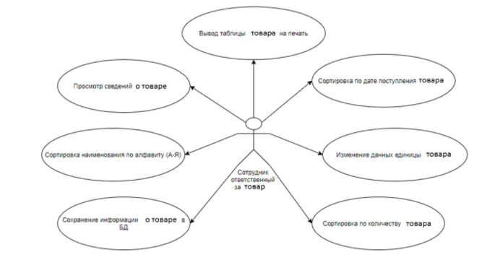

Figure 2. Precedent diagram

Selection of the means of implementation of design solutions

The software tool was developed using the integrated development environment Microsoft Visual Studio Community 2017. The development was conducted in C# - object-oriented programming language.

Microsoft Visual Studio Community 2017 development environment was chosen for the development of this software tool due to the fact that it is free and does not require any additional conditions for downloading (you can download and install from the official Microsoft website), as well as for it is written a lot of official documentation. In addition, this development environment allows you to run projects built on it, without installing the environment itself, also it allows you to download extensions for the implementation of additional functions

C# programming language was chosen because:

it is very reliable;

very reliable;

easy to use;

includes a large number of syntactic constructions;

allows you to work with many Microsoft files;

is object-oriented and suitable for working with forms.

Analysis of requirements for the development of the "Merchandiser" software

During the internship we obtained the key requirements for the implementation of the "Merchandiser" software in the IT infrastructure of the auto parts stores.

Information on the name of the goods, goods location, quantity, date of receipt for each item;

simplification of goods parameters editing, creation of filters, and automatization of information filling process;

segmentation of goods by criteria such as location, date of receipt, quantity.

Implementation of key requirements will allow the analysis of available information, which is necessary to trace the quantity and integrity of goods.

Functional requirements were received from the head of practice of the branch of RGPU "NTGSPI":

● to keep all the necessary parameters of the goods;

● to simplify and optimize the work with the application for the employees as much as possible;

● Inclusion of document management in the software to work in one window.

Conclusion

During the course of the course work on the topic "Development of software for commodity science in C# language" I studied the C# programming language. The tasks that were set when designing the project were accomplished, namely:

The C# language was learned;

The software for the store's goods management was developed;

The database was designed;

A simple and understandable interface has been designed and implemented;

Convenient sorting of goods was thought out;

The software was developed and tested. Design and interface are fully consistent with expectations and the task at hand. This product may be suitable for small businesses as well as small chain stores. In addition, this database can be used when running an online store. In the process of work new possibilities of C# language were studied, for example, using of GridView element and its connection to the database.

Detailed design of the "Merchandiser" software

The basis of the software is to perform three functions: viewing the main table, sorting and editing (see Fig. 3).

SQL menegment database is used to retrieve data by table and for further work with data.

Initially, the user gets to the main form from which he can open the table without sorting or with sorting already enabled by pressing the appropriate button. If the user has already opened the table, he can also sort it as he likes.
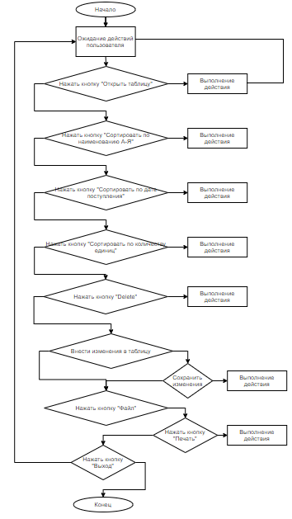

Figure 3. Algorithm of the choice of actions

Before opening the main table, the user cannot make any changes to it.

LIST OF REFERENCES:

1. Petzold C. Programming for Microsoft Windows in C#. Translated from English: Russian Edition Publishing and Trading House, 2002. - 576с.

2. Prohorenok N. HTML, JavaScript, PHP and MySQl. Gentleman's kit Web-master / Prohorenok N. - SPb: BHV-Peterburg, 2009. - 840 с.

3. Putilin A. B., Yuragov E. A. Component modeling and programming in the language of UML. - Moscow: NT Press, 2005.

4. Podelsky V. V. C# language. Basic course [Text]: textbook / V.V. Podelsky - 2nd ed. - Moscow: Finance and Statistics, 2013. - 408 с.

