Учебное занятие в 8 классе по теме «Black Friday»
Е.А.Заяц,
учитель английского языка
ГУО «Гимназия имени И.М.Ерашова г. Лепеля»
Цель: совершенствование коммуникативной компетенции в рамках обозначенной темы
Задачи: закрепление использования лексических единиц в рамках обозначенной темы, совершенствование навыков устной речи, совершенствование навыков работы с текстом, расширение кругозора учащихся,
Прогнозируемый результат: предполагается, что к концу занятия учащиеся смогут составить диалог-мнение по теме занятия.
Оборудование: учебник English 8 (Student’s Book 1) Н.В.Демченко и др. (2020), раздаточный материал, проектор, компьютер с выходом в Интернет
Ход занятия:
Организационно-мотивационный этап
Цель: введение в атмосферу иноязычного общения, формирование познавательного интереса к изучаемому материалу.
Задачи: мотивировать на активное участие в иноязычном общении.
Look at the pictures. What do you think is going on? Why are there so many people? What do they illustrate?
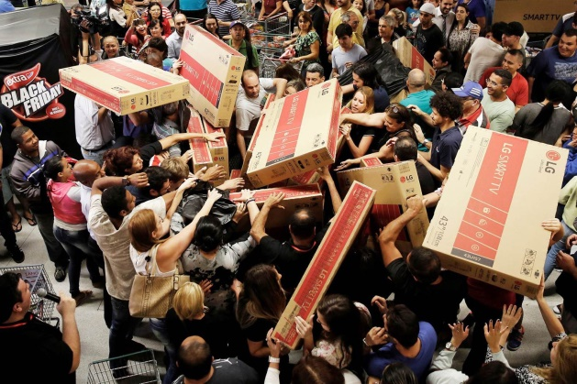
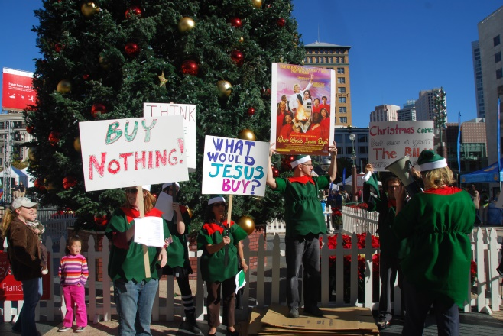
What are we going to speak about today?
Операционно-деятельностный этап
Цель: создание условий для формирования коммуникативной компетенции на основе предложенного дидактического материала.
Задачи: способствовать совершенствованию коммуникативной компетенции, навыков интерактивного взаимодействия.
Answer the questions: Does shopping make you feel happy or sad?
Do you buy only things from your shopping list?
Do you usually spend more money than you planned before?
Have you ever shopped on Black Friday? What did you buy?
Is shopping on Black Friday a real bargain? Why (not)?
Have you ever heard about Black Nothing Day?
What do you like more: Black Friday or Buy Nothing day?
Have you ever taken part in Buy Nothing Day? In what way?
Look at the board (do the task on your computers) and learn new words on the topic (https://learningapps.org/display?v=pt6rw1hca2).
Fill in the words from the previous exercise (раздаточный материал).
Fill in the gaps with the words: obsession, bargain, consuming, discount, Cyber Monday, queue, sales, consumer, deals
- I couldn’t afford to buy a new football, that’s why I bought a second-hand one, which was a real ___________________.
- All shops offer 20-75% ___________________ on their goods on Black Friday.
- It isn’t necessary to stay in a _________________ if you have enough money to buy some goods.
- On Black Friday some people are waiting outside stores to get the best _______________ before they run out.
- Every ______________spends a lot of money because of his desire to buy as much as possible on Black Friday.
- She bought this expensive dress on Christmas ___________ that’s why it turned out to be so cheap.
- I don’t like standing in long queues, that’s why I prefer doing shopping on _______________________.
- Christmas Zombies try to prevent people from ________________ unnecessary things or goods.
- My girlfriend has a strong _______________ to buy gifts for all her relatives on Black Friday.

In groups of 4 read the texts p. 120ex. 1a/ p.121 ex.1a and answer the questions. Make a collage and tell your classmates the information from the text.
Questions to group 1:
- When is Black Friday?
- When and where did it become popular?
- What happens on Black Friday?
- Why do some customers sleep outside?
- When do stores open on Black Friday?
Questions to group 2:
- When is Buy Nothing Day?
- When and where did it become popular?
- What happens on Buy Nothing Day?
- What is a Christmas Zombie walk?
- What is the aim of a Christmas Zombie walk?

Present your stories to the classmates. While listening complete the table:
 | Black Friday | Buy Nothing Day
Date
Origin
Actions
Interesting facts

Answer the questions:
- Should there be days on which stores do not open?
- Are we all becoming too focused on buying things?
- Should there be “no shopping days” in your area?
- What is consumerism? Is it bad or good?
- Who buys more: men or women?
- Should there be more Black Fridays in your region?
- Are Black Fridays necessary for people? Why?
- What do people usually buy on Black Friday?
- How important is shopping for you?
- Are you ready to spend a sleepless night in front of the shop to buy a bargain?
- What ate the good and bad things about shopping malls?
- What do you think of going shopping when it is crowded?
- When is the best time to go shopping?

Work in pairs
Student A: you want to buy something on Black Friday, but your partner is against it. Persuade him that it’s the best deal and it is very important for you.
Student B: your partner wants to take part in Black Friday Sales. But you want to prevent him from consumerism. Give arguments not to buy useless goods.

3. Рефлексивно-оценочный этап
Цель: обобщение материала занятия.
Задачи: содействовать развитию способности к обобщению материала и рефлексии.
Today we have learnt some information about Black Friday and Buy Nothing Day. Complete the poster.
What is Buy Nothing Day?
What is Black Friday?

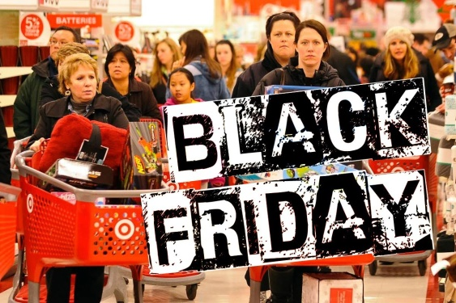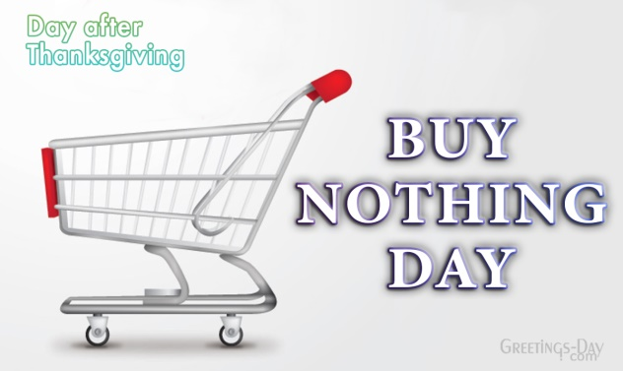

It is the day after the Canadian’s holiday of Thanksgiving.
The rules are simple. Just don’t buy anything at all for 24 hours.

Some stores are opened at midnight. Some stores start opening at 4 or 5 a.m.
The rules are simple. Just stay in a long queue outside stores to get the best deals first they run out.

People stay at home and relax.
The busiest shopping day of the year.

A way for people to ask the question: “Do I need this?”
A way to stay out to get what people need.

Some people organize a Christmas Zombie walk to prevent consumerism.

Home task:
- Are you for or against Black Friday / Buy Nothing Day? Express your opinion.
- Make a poster about shopping and how stores attract customers. Show your work to your classmates in the next lesson and be ready to speak about it.
- Write a newspaper article about black Friday or Buy Nothing day. You may include interviews with people who are for and against it. Read what you wrote to your classmates in the next lesson.

Приложение
Fill in the gaps with the words: obsession, bargain, consuming, discount, Cyber Monday, queue, sales, consumer, deals
- I couldn’t afford to buy a new football, that’s why I bought a second-hand one, which was a real ___________________.
- All shops offer 20-75% ___________________ on their goods on Black Friday.
- It isn’t necessary to stay in a _________________ if you have enough money to buy some goods.
- On Black Friday some people are waiting outside stores to get the best _______________ before they run out.
- Every ______________spends a lot of money because of his desire to buy as much as possible on Black Friday.
- She bought this expensive dress on Christmas ___________ that’s why it turned out to be so cheap.
- I don’t like standing in long queues, that’s why I prefer doing shopping on _______________________.
- Christmas Zombies try to prevent people from ________________ unnecessary things or goods.
- My girlfriend has a strong _______________ to buy gifts for all her relatives on Black Friday.

