Цель деятельности учителя: формирование коммуникативной компетенции учащихся
Задачи:
образовательные: развивать навыки говорения, чтения, аудирования и письма по теме «Кино», способствовать развитию лексических навыков по теме, совершенствовать навыки восприятия иноязычной речи; совершенствовать коммуникативные навыки; расширять общий и филологический кругозор учащихся;

развивающие: развивать способности учащихся осуществлять продуктивные и рецептивные речевые действия, умение анализировать, сравнивать, делать выводы;

воспитательные: способствовать воспитанию чувства гордости за свой край, чувства любви к своей малой родине, воспитывать толерантное отношение и прививать интерес к культуре и истории страны изучаемого языка; воспитывать потребность практического использования языка, формирование чувства ответственности при работе в паре.

Тип урока: урок обобщения и систематизации знаний.
Ожидаемые результаты:
а) предметные: научить строить монологические и диалогические высказывания, развитие умений учащихся оперировать известными понятиями, владение средствами выражения чувств и эмоций на английском языке, развитие чувства прекрасного в процессе обсуждения произведения, приобщение к ценностям мировой культуры;
б) личностные: формирование готовности отстаивать общечеловеческие ценности, расширение кругозора, творческих способностей учащихся, формирование коммуникативной компетентности учащихся;
в) метапредметные: формировать способность и готовность вступать в иноязычное общение, развивать навыки смыслового чтения, исследовательских учебных действий, умения планировать свое речевое и неречевое поведение.

Формирование УУД:
личностные: формирование интереса к овладению английским языком , умения слушать и вступать в диалог, участвовать в коллективном обсуждении проблем;
регулятивные: применение знакомого языкового материла по теме в речевой ситуации; умение решать проблемные ситуации и принимать решения; умение распознавать в тексте нужную информацию;
познавательные: умение делать выводы, выделять причинно-следственные связи (ответы на вопросы по прослушанному тексту); увеличение словарного запаса обучающихся (отработка и закрепление ЛЕ по теме);
коммуникативные: способствовать формированию готовности к иноязычному общению, воспитанию доброжелательного отношения друг к другу и культуры поведения; уметь воспринимать иноязычную речь на слух (речь учителя, ученика, диктора); владение монологической речью.

Формы работы учащихся: индивидуальная, групповая, фронтальная, парная.

Необходимое техническое оборудование: интерактивная доска, презентация, раздаточный материал, учебник.

Ход урока.

I. Организационный момент
- Good morning, dear children. How are you today? Look! There are some guests in our classroom. Say “Good morning” to our teachers. Sit down, please. So, let`s start our work. And I hope our lesson will be interesting for you.
- Who is on duty today?
(отчет дежурного)

II. Постановка цели и задач урока. Мотивация учебной деятельности учащихся.
-Now I want you to look at the screen and guess the theme of our lesson
(показ слайдов)
- I’ve received a video message from our English-speaking friend John. Let’s watch it!
(видеообращение: Hi, friends! How are you all today? I’ve heard a lot about your hospitable, fascinating and unique country. I’d like to know more about your sunny republic! And maybe some day I’ll visit the Land of Mountains!)
- Shall we help our friend to learn more about our republic?
- Now I invite you to visit the magic world of the cinema and to take part in the process of film making. Imagine that our guests are film goers and you are cinema workers. As you know every film consists of some parts. That’s why our film will have some parts too:
- The opening scene
- Episodes
- Final scene
- But we have to do some tasks to shoot each part of our film. After shooting we’ll send each of them to our film editor who will fit pieces of our film together to make a finished movie.
- Now I want you to look at the checklists on your desks. You’ll assess yourselves and fix your points for the tasks here.
(приложение1)
- So, how can we name the theme of our lesson?
Well the theme of our lesson is …
Welcome to the magic world of the cinema!
(заставка)

IV. Основная часть.
- The Opening Scene
- Фонетическая зарядка
- Let’s start our film with the opening scene. You know we can’t shoot a film without actors! Let’s do a casting! An actor must speak correctly. Please, pronounce any tongue twister as quickly as you can.
1) The 33 thieves thought that they thrilled the throne throughout Thursday.
2) Whenever the weather is cold.
Whenever the weather is hot.
We’ll weather the weather, whatever the weather,
Whether we like it or not
3) Peter Piper
The next task is to choose the word from the pile, read it correctly and decide what column it belongs to “Genres of the films” or “Cinema workers”.
(western, director, cartoon, horror, thriller, documentary,
- Речевая разминка
- What do you think about films of different genres?
-Westerns are pretty good.
- Action films are gripping.
- Comedies are extremely fantastic.
- Horror films are absolutely awful.
- I think horror films are not so bad.
- Thrillers are totally astonishing.
- Thrillers are not my cup of tea, because there are plenty of thrillers with very violent murders. (It’s very harmful for children. They may get very nervous and aggressive)
- Melodramas are really great.
- Documentaries are very good.
- I think documentaries are boring.
- Not always, I think. They can be touching, interesting. They bring viewers into new worlds and experiences through the presentation of factual information about real people, places, and events.
- Cartoons are really interesting.
- Musicals are absolutely magnificent.
- Adventure films are enjoyable.
- War films are moving.
-Science fiction films are powerful.

- What action films have you seen lately?
Mad Max, Wonder Woman, Inception, Star Wars, Deadpool, Captain America, Mission Impossible
- Are you fond of horror films?
I am fond of horror films, because sometimes I want to tickle my nerves.
I don’t like them because…
- Can you call the film about R. Crusoe an adventure film?
Yes, because in this film there is a trip in which many events take place with the hero.
- What is the centre of film industry in the USA?
- Where is Hollywood situated?
- What American film corporations do you know?
- What famous actors do you know?

- Episode 1.
Работа в группах с использованием сингапурских структур обучения Simultaneous Round Table

- Thank you very much. Oh! It’s high time to shoot our 1st Episode!
Take a sheet of paper, fold it in a half, then once more time, take the inside corner and fold it like this. Now write down the word Cinema in the center. You should write four words which you associate with this word in the corners of the paper. Now write down sentences with these words, you have 1 minute for that. Read these sentences and choose the best ones.

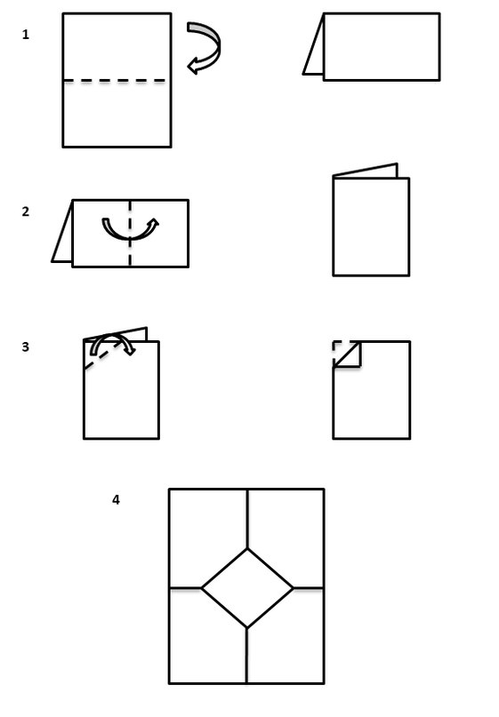
- Episode 2. Use of English
Развитие грамматических навыков и навыков аудирования
- Well done! We should do the next task to shoot the 2nd Episode. You are to watch two short videos from the famous films and report what the actors will say. Use the Reporting Verb in Past Tense. Remember: verb of the reporting speech is called Reporting Verb, Verb of the reported speech is called Reported Verb.
(просмотр видео, перевод прямой речи в косвенную)
- Your time is up. Swap over your sheets of papers. Compare with the right answers on the screen. Sum up your points. You can get 7 points.

- Episode 3. Who Is It?
Аудирование с детальным пониманием прочитанного
- Have a look at the screen and try to guess the name of one of the most outstanding actors in the world. Don’t forget to put the letters instead of numerals.
2 1 14 4 5 18 1 19 (Banderas)
- Now listen to the text about Banderas and get ready to write a test.
(Упр.1, стр.37)
Exchange your papers and check the test up. You can get 1 point for each correct answer. Sum up your points.
Now we’ve done with the 3rd Episode
- Commersial Break (рекламная пауза)
Физминутка.
- Well, looks like it's time for our first and the only commercial break. This is a good moment to take a break for our health. Let’s have a rest! Let’s do some exercises for your eyes. Look at the screen, please.

- Episode 4.
Чтение с детальным пониманием прочитанного (Работа в группах)
- Who writes the script or the film? Now we are going to be scriptwriters. I’ll give you a poster with some short texts and several pictures. Your task is to read the text and match the pictures of these actors with the information about them.
(упр. 5, стр. 20)
- Your group will match the types of the films with their descriptions.
(Упр.8, стр.22)
- People of different professions are involved in film making. Who are these people? Match the name of the professions and what they do.
(… has general control of the money for a film but he doesn't direct the actors
…is the boss and tells everybody what to do. He works very closely with the actors in particular
…does all the dangerous things on the screen instead of actors
…chooses the best bits of the shooting film, cuts film and puts the bits together
…prepares costumes: dresses, suits for films)
-Present your group work, please. Who will be the first? This Episode is ready. Let’s send it to our film editor.

- Final Scene
- Let’s see what we’ve done (просмотр видеоролика о Дагестане)
What do you think about our video? Do you like it?
-Do you love our republic? And for what it is possible to love?
1) It can be loved and respected for nothing, but for something: for what it has, for the fields, mountains, forests, seas, but simply for the fact that we live here.
2) Love for the Motherland is already in us from the very beginning, is transmitted with the mother’s milk. And it grows with us as we grow
- So, it’s natural that we should love our country because we breathe in its air, we live under its sky and we are a part of its soil.

- Рефлексия.
Let assess yourselves now. Take your checklists and fill in them over all criteria.
(учитель опрашивает несколько учеников, какие отметки они получили и могли бы они быть улучшены, каким образом?) What mark have you got for the lesson? Could you improve it? How?
- What emotions do you feel ? Why?

I feel….. because …….

positive emotions
satisfaction
happiness
joy
success
admiration
proud
surprise
negative emotions
dissatisfaction
irritation
boredom
sadness
anxiety
fear

because I……………..

- was not bored
- worked hard
- didn’t relax
- answered properly
- was active
- was emotional
- fulfilled the task
- received a reward
- received a good mark

IX. Домашнее задание.
T: Now write down your homework in your daybooks. Ex.11, p.43. Get ready to speak about the cartoon you like/dislike.
- Подведение итогов
- What have we done at our lesson? Did you like the lesson? What did you like most of all?
What award does our lesson deserve? If you think the lesson was good, raise Oscar, if you didn’t like it, raise Golden Raspberry
-We have learnt a lot. You worked hard today. Thank you. I`m satisfied with your activity and results in work. Many thanks for your hard work. The following marks will be …
The lesson is over. Goodbye.

МКОУ «Эминхюрская СОШ имени А. Г. Саидова»
Сулейман-Стальского района Республики Дагестан

План-конспект
урока
по английскому языку
на тему:
«PERFORMING ARTS: Cinema»
Учитель:
Имамова Назима
Бинямудиновна

Date_______________________ Name _________________________________
Checking Criteria |  |  |  |  |  | Your score | Score | Mark | Comment
The Opening Scene | Episode1 | Episode2 | Episode3 | Episode4 | Your activity at the lesson
You can get 5 points | You can get 3 points | You can get 7 points | You can get 5 points | You can get 5 points | 1 point – active, 0 point – passive
 |  |  |  |  |  |  | 23-26 points  19-22 points  13-18 points  12 points or less | 5  4  3  2 | Well done! Excellent!  Good! Not bad!  You can do better!  Revise and try again!

