Конспект учебного занятия в 8 классе

По теме: «Тратим деньги разумно»
«Spending Money Wisely»

Учебный предмет: английский язык Класс: 8 А класс (Углубленное изучение)
Учитель: Тюняева Екатерина Юрьевна
Образовательное учреждение: МОУ гимназия № 41 муниципального образования городской округ Люберцы Московской области

Тема урока: «Spending money wisely» из второго модуля 2h “How to be … a responsible shopper ”
(“Как быть … компетентным / ответственным покупателем” )

Цель урока: создать условия для формирования коммуникативной компетенции обучающихся и совершенствования их речевых навыков.

Задачи урока:

Практическая:
– составить диалогические и монологические высказывания, используя лексику по теме.
Образовательная:
– познакомить с правилами и уловками покупателя;
- научить обучающихся использовать фразы и выражения по теме;
Воспитательные:
- воспитание культуры обучающихся;
- воспитание чувства ответственности за свою деятельность;
- воспитание чувства бережливости и экономии;

Развивающие:
– развивать познавательный интерес к изучению языка;
– развивать коммуникативные навыки, способность к самооценке и взаимодействию с другими;
– развивать навыки самостоятельной работы, работы в команде и парной работе.

Формируемые УУД: | Формируемые УУД на уроке:  - Личностные УУД:  - повышение учебно-познавательной мотивации, уважительного отношения к культуре страны изучаемого языка, развитие креативности (творческой способности обучающихся).  2. Метапредметные УУД:  - осознанно пользоваться речевыми средствами в соответствии с задачей коммуникации, умение работать в команде, формулировать и аргументировать свою точку зрения и координировать ее в соответствии с позиции других обучающихся;  - умение структурировать и понимать информацию;  - умение четко выражать свои мысли в соответствии с задачей коммуникации;  - владение устной и письменной формами речи.  3. Предметные УУД:  - освоение во всех видах речевой деятельности грамматической структуры написания приветственной открытки;  - освоение понятия неформального стиля в личных сообщениях.
Формы организации деятельности учащихся: | Урок получения практических навыков. Фронтальная, индивидуальная, парная и групповая формы работы.
Используемые технологии: | В ходе урока используются элементы следующих педагогических технологий:  - личностно-ориентированное обучение;  - обучение с использованием ИКТ – технологий;  - здоровьесберегающие технологии;  - технология сотрудничества;  - коммуникативная технология;  Применяются следующие методы:  - проблемное изложение  - Словесные: беседа, вопросно-ответные упражнения.  - Наглядно-демонстрационные: использование слайдов, видеосообщения и наглядного материала по теме.  - Практические: работа в группе  Приемы:  - прием сравнения  - приём обобщения  - прием самоконтроля
Техническое обеспечение урока: | - Компьютер с локальной сетью, проектор, колонки, учебная доска в кабинете.
Дидактическое обеспечение урока: | - Раздаточный материал: наглядные пособия (речевые опоры) тексты с заданиями,  - Карточки с диалогами, картинки по теме «Используй свои деньги с толком», презентация.  - Аудиофайл.
Список учебной и дополнительной литературы: | УМК: "Starlight" 8 класс, авторы: Баранова К. М., Дули Д., Копылова В. В., Мильруд Р. П., Эванс В., 2020.
Ход учебного занятия
I. Organizational moment.
T: -Good morning, boys and girls. I’m glad to see you. I hope you are all feeling well. Yesterday I went shopping and bought everything what I wanted or, maybe, didn’t want to buy. You know, it was Monday yesterday. What about your shopping habit? Do you like to go shopping? How much money do you spend? Do you have any pocket money?

Students’ own answers:

S1 : The best day to shop I think is Monday or Tuesday, because it is a beginning of the week and all people are concentrated on their job tasks и так далее.

II. Introduction to the topic of the lesson. Motivation.

T: Now having answered the questions and practiced some English words and word combinations try to guess the theme of our lesson and what we are going to speak about. Look at the slide, what do you see?
Students answer: people give money…. People spend money…
The picture with the owl appears. T: How can you join the first and the second picture in the slide?
Slide 1

S: I think we are going to speak about money and the ways of spending and saving money.
T: You are right, of course, we are going to speak about money: “Spending money wisely” (Slide 2)

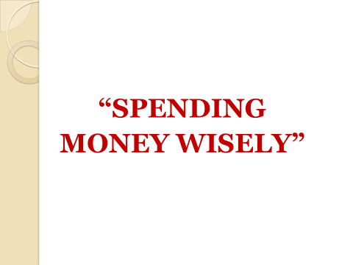
T: I want you to read the proverbs and say whether you understand, agree or disagree with them.
Which of them refer to the theme “ Spending money wisely” ? Which of these sayings do you like most?
(Slide 3)

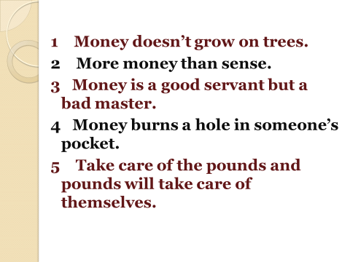 S1: “Take care of the pounds and pounds will take care of themselves”. As for me I agree with this proverb because I also think that we should save money and buy only useful stuff.
S2: “Money doesn’t grow on trees”-- this means that money must be earned and that it is not easy to acquire it. It often means that you should be careful how much you spend …
S3: “ More money than sense” -- you have a lot of money which you waste by spending it in a foolish manner .

S4: “ Money is a good servant but a bad master” -- Without money, it is. impossible to survive in this world ... That means : everybo should control the money instead of being controlled by it.
S5: “ Money burns a hole in someone’s pocket” -- you never have money for emergencies.
T: Good job, students! And now I suggest you looking around and choosing the statements best describe you. Stand up and go around the classroom.
There are some statements on the board. Students choose them, explain the reason of their choice and take their places according to the group “Be green” \ “Be smart” \ “Be ethical” – the signs are on the desks.

BE GREEN
1. I try to avoid unnecessary packaging
2. I often buy second-hand.
3. I buy recycled products.
4. I never throw anything out.
BE SMART
1. I usually buy things that are on sale.
2. I enjoy bargain- hunting.
3. I often shop on-line.

BE ETHICAL
- I prefer chain-store retailers.
- I always check where and how a product was made.
- I always choose fairtrade products.
(Slide 4)
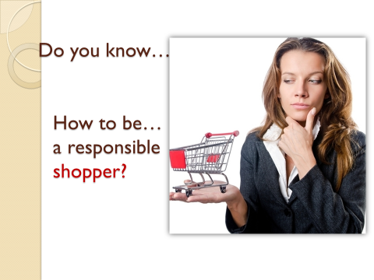

III. Development of listening skills.

Т: Now we are going to listen to some information about it and find out How to be a responsible shopper. You are working in your own group. The group “Be ethical” is taking notes and looking for the answers in the first part of the text, the group named “Be green” in the second one and at last the group “Be smart” in the third paragraph. You should to find out what means to be a responsible shopper, what he \ she buys, whether a shopper is aware of his human rights and how to save money.
After listening
Т: You have three minutes to discuss this problem clearly and one representative from the group gives your common ideas.
Students listen to the text and take notes in their groups, they work together.
S1 S2 S3 answer the main question: “How to be a responsible shopper…”

IV. Activation of monologue speech skills.
T: We have listened the text “ How to be … a responsible shopper “.
(Slide 5)
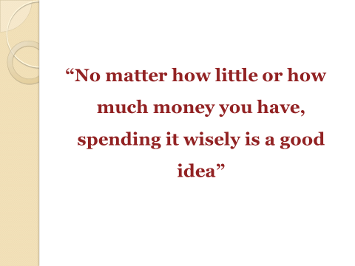
And how can you spend money? Of course, wisely!!! Now I’m showing you some pictures to help you to formulate the tips we can give everybody, let’s think and try to give advice how to save money. I ask you , S1 and S2 to join to the first and the second group.
Look at the slide. You should match the pictures and the tips given on your desks.
(Slide 6)
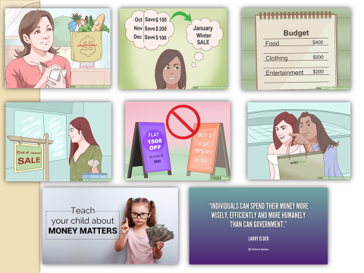

You have three minutes to complete the task. If you have some problems, ask me, please…
На столах у двух групп расположены картинки, изображенные на слайде и описания к ним (советы)
T: It’s time to start our discussion. (Every students shows his \ her picture and gives the right tip)

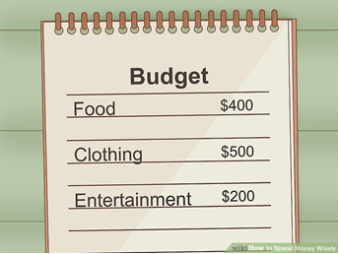
S1 : Create a budget. Organize your purchases by category (food, clothing, entertainment, etc
Spending wisely involves thinking and researching.
S2 : Plan your purchases in advance. Write down what you need to buy while you're calm and at home.

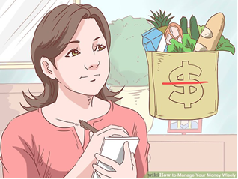
S3 : Before you make a purchase, make a shopping list. It will help you to spend money only on the things you need.
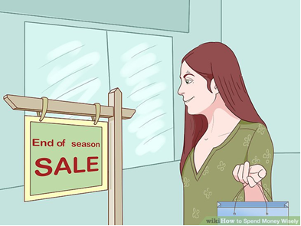
S4 : Shopping while hungry or listening to loud music or seeing an advertisement about “sale” can be a bad idea if you don't stick to your shopping list.

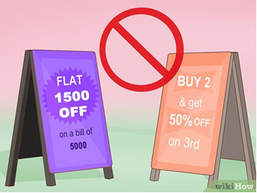
S5 : Don't purchase something just because it's reduced price. Don't buy something on the basis of an advertisement.
S6 : Don't be fooled by marketing.
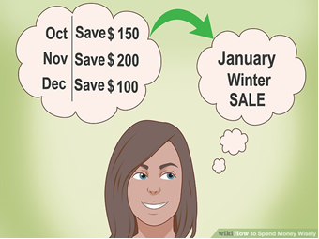
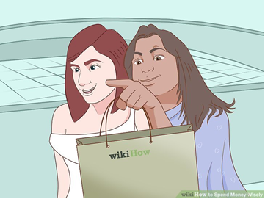
S7 : Do not take advice from store employees. If you need a question answered, politely listen to their response but ignore any advice on purchasing decisions.

S8 : Giving pocket money parents should explain their children how to manage it well.

V Development of speech skills.
(Slide 7)
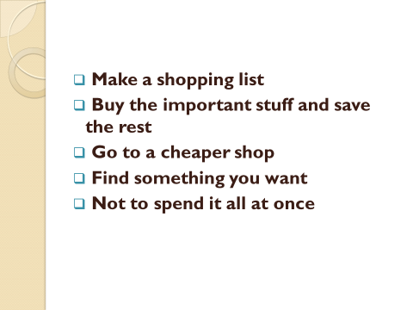
T: Dear student, can you give me the common tips help you to spend your money wisely?
One of the students answers.
T: Now, let’s make dialogues using the phrases from the blackboard. You have cards with different situations ( Ученикам раздаются карточки с предложенной ситуацией и ролью ). You have 5 minutes to complete the dialogues, you should work in pairs and after it , act out your own dialogues. Be positive, creative and active!
Situation 1
Parent ( Father)  You are the father of a teenager. Your salary is 15 thousand roubles a month. You give your son 300(three hundred) roubles pocket money every week.  Your son comes to ask for extra money. On the one hand you would like to help him, on the other hand you cannot spend more than your salary.  - Listen to your son’s request and decide whether you will give him extra money or not, depending on the reasons he gives.  - Decide how much extra money you can give  - If you decide to give the money, try to minimize this unplanned expenditure: to suggest a cheaper shop, etc. | Teenager (Son)  You are a teenager. You get 300 ( three hundred) roubles pocket money a week.  Your friend has invited you to a birthday party and you need to buy a present for him/her. Also you want to buy new trainers and some clothes for the party.  You go to your parents to ask for extra money.  - Decide what present you want to buy for your friend.  - Think of the arguments you will use talking to your father.
Situation 2
Parent (Mother)  You are the mother of a teenager. Your salary is 80 thousand roubles a month. You give your daughter 3000 (three thousand) roubles pocket money every week.  Out of your salary you have to pay the rent (квартплата), buy food, clothes and save for the next summer holidays.  Your daughter comes to ask for extra money. She spent all her pocket money but can’t remember on what things. On the one hand you would like to help her, on the other hand you want your daughter to spend money wisely.  •Listen to your daughter’s’s request and decide whether you will give her extra money or not, depending on the reasons she gives.  •Decide how much extra money you can give  •If you decide to give the money, try to minimize this unplanned expenditure: suggest cheaper shop, planning purchases etc. | Teenager (Daughter)  You are a teenager. You get 3000 (three thousand) roubles pocket money a week.  Your friend has invited you to a birthday party and you need to buy a present for him/her. Also you want to buy new fashionable trainers and some design clothes for the party.  You go to your parents to ask for extra money.  •Decide what present you want to buy for your friend.  •Think of the arguments for buying new shoes and clothes you will use talking to your mother.

Students act out the dialogues. They appreciate each other.
VI Reflection.
T: Great job, my dear friends! I think, you enjoy our discussion today. And at the end of it I suggest you filling the table and writing down several words about your participation.
Students fill the table.
My participation | My feeling and emotions | My difficulties | Valuable thoughts for me from the lesson

T: OK, it’s time to stop. Do you know the person in the slide? Look…
(Slide 8)
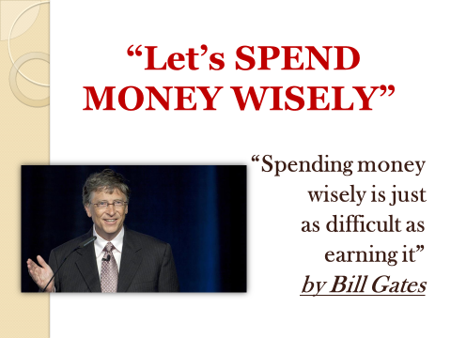
Students tell who is in the photo and one of them reads the quotation.
T: As a result, I can say, you know how to spend your or maybe your parents’ money wisely! I’m handing out now your homework cards. Thank you very much for your participation today. Good luck!

Task: Answer the questions. Write 80-100 words

- “Take care of the pounds and the pounds will take care of themselves” (agree or disagree)
- Do you have pocket money?
- What do you need it for?
- How much pocket money should teenagers of your age get?
- Do your parents always give you pocket money?
-How much money do they give you?
-Do you save your money?
- How do you spend it?

