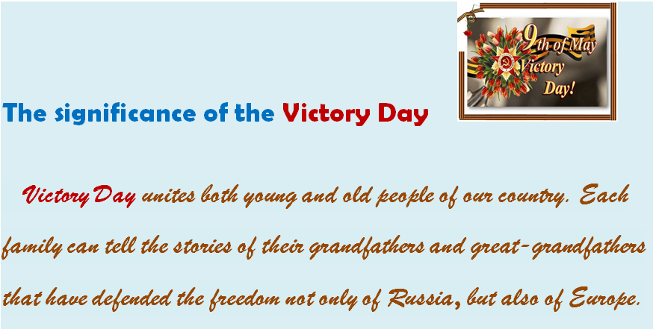
Before reading the text:
1. Choose the correct word to make true sentences about yourself:
1. Almost every family in Russia has a person who didn’t return from the battlefield and mine is / is not an exception.
2. On the Victory Day we are grateful to our saviors / survivors, to those who sacrificed their lives for us.
3. We attend a local military parade /event, organized by the local authorities and watch the fireworks at night on Victory Day.
4. Most veterans wear their medals /photos as they head to the parade or an event organized by a local veteran organization.
5. We give flowers, usually red carnations, to veterans / everybody in the street and lay wreaths at war memorial sites.
6. Our schools usually host a program prepared by the students / parents, featuring wartime songs and poetry.
7. Also, there is St. George ribbon campaign, which has occurred after / on the eve of the Victory Day.
8. We also watch popular Soviet films based on the events of World War II / World War I, which is also known as the Great Patriotic War.

2. Look at the pictures and label them. Common symbols of the Victory Day in our country are: St. George ribbon; red carnations; Red Star medal; the Eternal flame; moment of silence (for); Immortal regiment; Victory Banner ;military parade; Victory Day salute; mobile kitchen trailer; war songs; memorial service for soldiers.
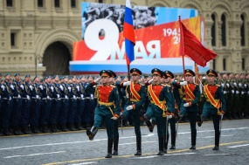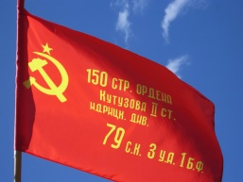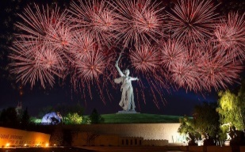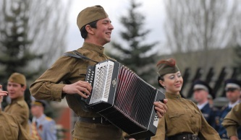
-------------------- ------------------- ---------------------- ------------------------

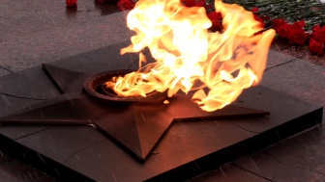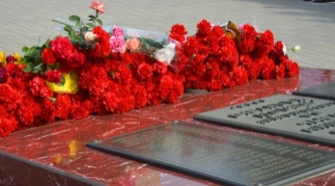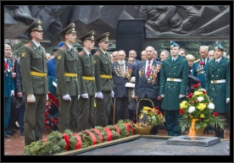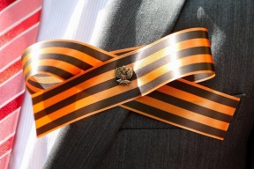
------------------------ ------------------------- --------------------- --------------------
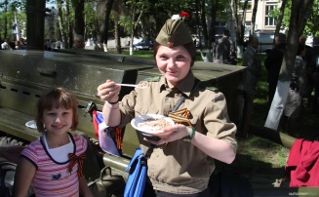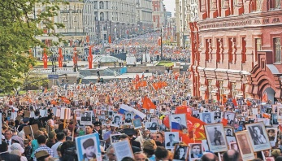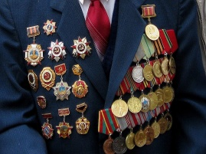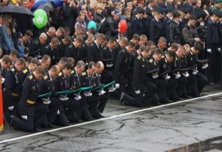
------------------------ ------------------------- --------------------- ------------------- Study Skills
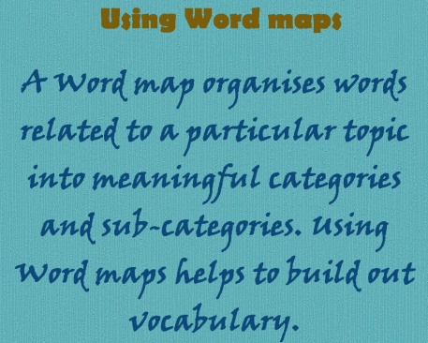
3. Copy the word map into your notebook. In a minute add as many words as you can think of. Compare with your partner. (Here are some words to help you):
People (Militarians)
Actions
Military vehicles
Weapons
Great Patriotic War

(tank; plane; bomber; parachute; helicopter; warship; aircraft carrier; submarine; submachine gun; machine-gun; pistol; mortar; cannon; torpedo; missile; officer ; ammunition; bullet ;shell; grenade; bomb; explosive;commander; soldier; private; sergeant; General; marshal ;sailor on submarine; border guard; sailor; battle; defense; offence; retreat; defeat; capitulation ; armistice; armament ;attack; order; conscription)

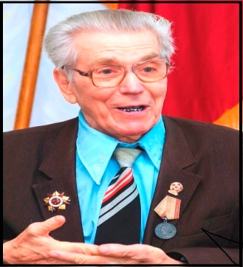
4. Read the text.
The man's a legend
Alexey Nikolayevich Mikheyev first appeared on newspaper pages and TV screens about ten years ago. Journalists admired the feat of a one-legged veteran from the town of Dokuchayevsk, who dared to sky-jump with a parachute at the age of 85. Then he successfully landed from the height of 3600 metres when he was 87 in order to prove that life is not over in the old age. This living legend also celebrated his glorious ninetieth jubilee in the sky, showing that there are no former paratroopers and if a person once fell in love with the sky, this passion will last a lifetime.
Alexey Nikolayevich was born and grew up on the shore of the lake Ilmen in the fishing village of Vzvad (Novgorod region of Russia). From the age of 12, Lenya fished on a par with his father and other adults. Being drafted into the army he served in the paratroopers but after Hitler had launched an invasion of the Soviet Union and the war had begun, he was transferred to the rifle troops. He was called to defend the native land in 1941 and in 1942 during the battle near Stalingrad his left leg was seriously wounded. The front-line doctors were unable to evacuate him in the crossfire and the gangrenous leg was hastily cast in the military field hospital but … it was too late. So at the age of 21 Alexey lost his left leg and was demobilized. He was just a simple soldier, whose life has become a tiny contribution to the case of liberation of our country from the fascist invaders.
After the amputation, Alexey Nikolayevich returned to his family in Vzvad where there were only old people, women and children left in the village. So the one - legged guy, who was good at locksmithing and carpentry, had enough work to do. He helped to restore the village hospital: hospital chairs and plaster tables, roof repairs and bathrooms - everything was done by his skilled hands. He himself was sure that nothing was impossible for a person, if there was a desire.
Five years later, the consequences of a battle wound to his wife Praskovia Nikolayevna, who was a scout and served in the ranks of the 11th army of the North-Western front, made them change their living place and they moved to Dokuchayevsk.
Their apartments with dozens of wall paintings, self-portraits, marble sculptures, carved furniture and dishes make you understand that Alexey Nikolayevich simply had no time to complain about numerous postwar illnesses. Lots of schoolchildren and students from the local technical schools often came on an excursion to the "Home Museum" of the war veterans. Alexey Nikolayevich not only showed his masterpieces to the audience but recited more than 120 works of poetry and prose by Pushkin and Lermontov, Turgenev and Nekrasov, organised concerts in the local Palace of Culture, made (up to 240-km) cycling trips.
By everything Alexey Nikolayevich did in his life, he appealed to people: “Live! Enjoy the peaceful sky! Value every minute of your life and don't waste it! A Man is given so much and has so much to do!”

a) Match the headings to the paragraphs. There is one that you don’t need to use. Think of an alternative heading for each paragraph. Discuss with a partner.
A. Parting words B. His life-time dream C. Pre-war period of life
D. Main hobbies of life E. A chair engraving as a photo album of his life
F. Jack of all trades G. Love of art and literature
b) Match the words/phrases in bold in the text to the pictures below:
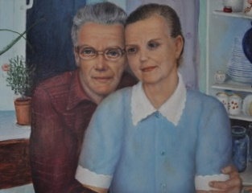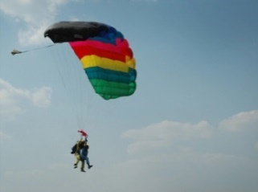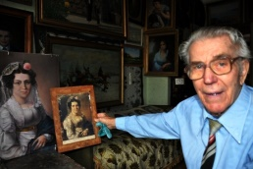

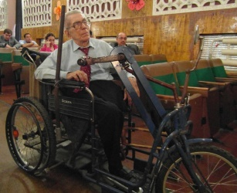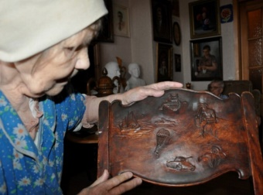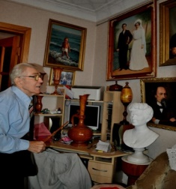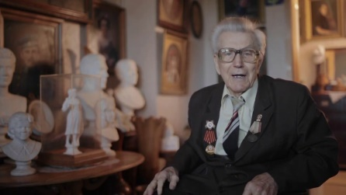

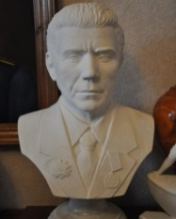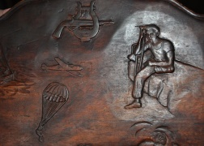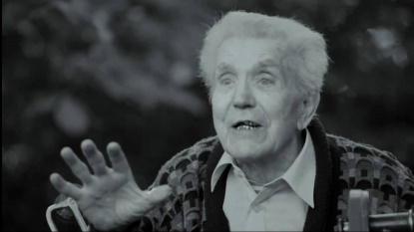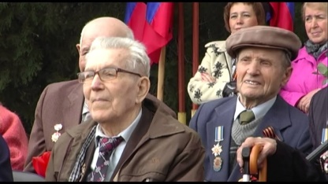

c) Find synonyms in the text for the words below:
1) esteemed; respected 11) made a challenge
2) attract attention 12) in the aim of demonstrating
3) little participation 13) to express displeasure
4) ninety years anniversary 14) hurriedly
5) was injured 15) equal to, the same as
6) couldn’t 16) results; effects
7) lose one’s heart (to) 17) bicycle rides
8) effectively 18) joined the army
9) want; long for 19) released from the armed forces
10) flat 20) relocated
Word formation
5. Let’s start with the words and word combinations connected to the Great Patriotic War. Fill the words in the table without translating. Use the suffixes of the nouns, adjectives, Participle I and Participle II in the table below. You have 3 minutes. Work in pairs. You may look at the table “Word formation”. Find the suffixing and conversion. In suffixing we use noun suffixe –sion (invasion) and in conversion we don’t change the word (honour, sacrifice)

NOUNS | ADJECTIVES / PARTICIPLES | VERBS
invasion
 | occupied
 | defensive
 |  | memorize
honour
 | injured
starvation
 |  | sacrifice
celebration
 | wounded
contribution
 | demobilized
 |  | participate
 |  | evacuate
 |  | prove
liberation
explosion | bombing
attack
 |  | capitulate

6. Read the text again, then close your book and tell your partner two things you have remembered.

7. Look at the words and their meanings and make up sentences of your own, using some of them:
a danger of war | опасность войны
to launch a war, to unleash a war | начать войну
occupation troops | оккупационные войска
to open hostilities | начать военные действия
to cease hostilities | прекращать военные действия
hostile | враждебный:
to suffer heavy losses | нести большие потери
to suffer a defeat | потерпеть поражение
the principle of inviolability of frontiers | принцип неприкосновенности границ
the renunciation of war | отказ от войны
renounce | отказаться
to renounce the use of force | отказаться от применения силы
to settle a conflict by peaceful means | решать конфликт мирным путем
the armed forces | вооруженные силы, войска
call (for) | призывать к чему-либо

Idioms
8. a) Look at the idiomatic expressions and match them to their meanings. Do you have similar idioms in your own language?

1. To bite the bullet a) призрачный шанс
2. Fight an uphill battle b) важная персона
3. Long shot c) преодолевать препятствия
4. Join the battle d) вышибать клин клином
5. A shot in the dark e) начать обсуждение
6. A big shot f) получить много денег
7. Stick to one's guns g) держать удар, не падать духом
8. To fight fire with fire h) надежда на удачу
9. To make a bomb i) настаивать на своем

b) Read the following expressions, proverbs, sayings and abbreviations
and try to find Russian equivalents to them:

a minefield ['maɪnfiːld]
to give up without a fight
to take no prisoners
armed to teeth
to be caught in the crossfire
attack is the best method of defense
come unscathed out of the battle
a threatened blow is seldom given
every bullet has its billet
forewarned, forarmed
POW- Prisoner of war
KIA – Killed in action
MIA – Missing in action
c) Complete the sentences using the expressions:
1. Have you heard about the accident? You know he doesn’t have a driving license, nevertheless he ____________________________________________________.
2. When I was all at despair he said, “You should never___________________”.
3. Don’t you know it’s dangerous? It’s like going through___________________.
4. Remember! No fear! In these situations _______________________________ .
5. He was reported ______________________________________ in March 1943.
6. Children were not only____________________________________________; they were also often the intended targets of violence, abuse and exploitation.
7. These words originate from the time when East and West faced each other _________________________________________________________________.
Writing Skills
Writing a haiku.
A haiku (俳句 high-koo, "light verse") is a short three-line poem that uses sensory language to capture a feeling or image. Haiku poetry was originally developed by Japanese poets. They are often inspired by nature, a moment of beauty, or a poignant experience. Follow our rules for writing a haiku and capture your own special moment.
Follow the line and syllable structure of a haiku. Haikus follow a strict form: three lines, with a 5-7-5 syllable structure. That means the first line will have five syllables, the second line will have seven syllables, and the last line will have five syllables.
Describe the subject with sensory detail. Haikus are meant to give the reader a brief sense of the subject using the senses. Think about how your subject smells, feels, sounds, tastes, and looks. Describe the subject using your senses so it comes alive for your reader and feels powerful on the page.
Use concrete images and descriptions. Avoid abstract or vague descriptions. Instead, go for concrete images that are easy for the reader to visualize. Rather than using metaphor or simile, try describing the subject with details that are particular and unique.
Write the poem in the present tense. Give the haiku immediacy by using the present tense, rather than the past tense. Using the present tense can also make your lines simple and easy to follow.
End with a surprising last line. A good haiku will have an ending line that is intriguing and leaves the reader hanging. It may leave the reader with a surprising last image or reflect on the previous two lines in a surprising way.
To write a haiku, start by brainstorming ideas for the poem. Then, write the poem with strong details and detailed imagery. Make sure you polish the haiku and listen to how it sounds out loud so it is at its best.
9. a) Here are some examples of war-haiku. Read them aloud and recite one of them to the classmates.
The heroes of war
With medals
Lay on yonder field

With a gun
On my shoulder – I forget
My paper and pencil

My best friend died
Some tiny grains of dust
On the chess board

A fallen soldier
How loud the ticking
Of the watch

People fight people
But nothing is accomplished
But bloodshed and death
Explosions, embers
Tearful eyes, fiery skies
Ashes come and go

b) Try to make up a haiku of your own. To write a haiku, start by brainstorming ideas for the poem. Then, write the poem with strong details and detailed imagery. Make sure you polish the haiku and listen to how it sounds out loud so it is at its best.
10. Write the haiku poems on the following topics: “Victory Day”; “Flowers to war veterans”; “Immortal regiment”; “The man’s a legend”. Here are some tips for you:
Haiku is a simple message that captures a simple feeling.
In haiku soul is more important than form.
You have to write three lines in a haiku but they do not have to rhyme.
Remember! Haiku is the best trainer for mind and imagination.

