The main directions of innovative development of the tourism industry and infrastructure in the Republic of Kazakhstan

Annotation: The President of Kazakhstan identified tourism as one of the most important clusters for the development of the non-resource sector of the economy. The republic has been given a responsible task: in the near future to become one of the 50 most competitive countries in the world. It is important to understand today that the Kazakhstani tourist complex is capable of becoming a powerful lever for the overall acceleration of growth and modernization of the republic's economy.
This is evidenced by the growth trends in the volume of inbound and domestic tourism and the creation of a system of state regulation of tourism activities within the framework of the tourism development program. The number of foreign tourists has significantly increased, and the level of demand for travel within the country has increased.
Key words: Republic of Kazakhstan, tourism, infrastructure, international, product, market.

As international experts in the field of tourism note, the state of development of the tourism industry in Kazakhstan in recent years is characterized by its progressive and sustainable development. In the coming years, our country has the opportunity to become one of the largest travel and tourism economies. Abroad Kazakhstan is beginning to be regarded as one of the most stable countries with unique tourism opportunities. In addition, all the same foreign experts believe that this will be facilitated by such advantages of the republic in the world tourism market as the hospitality and goodwill of Kazakhstanis, the country's natural attractions, its history and wealth of cultural and ethnic diversity, as well as tourist infrastructure.
Today we need to build all the necessary infrastructure for the modern tourist industry. If we want tourists to come to us, we must urgently reconsider many approaches in this direction: from the cost and timing of obtaining visas to the construction of large tourist centers of recreation and entertainment.
Many government departments and regional executive bodies should be interested in the development of tourism, since tourism covers a huge range of services and production in various industries. Much depends on the initiative of local authorities, on their understanding that tourism can become a source of prosperity for the region. In addition, to create powerful tourist centers, capital investments are required, both from the state and domestic and foreign investors. Therefore, it must create the necessary conditions for the early emergence of a developed tourist complex that meets all international standards and requirements.
As we said above, for the development of the tourism industry and its infrastructure, capable of providing a steady influx of tourists, taking into account the specifics of the national tourism product, it is necessary to develop the following areas:
- development of transport and road infrastructure for general use and to meet tourist needs;
- development of related infrastructure: water, electricity, sewerage and solid waste disposal systems, telecommunications in existing and potential tourist areas;
- creation of tourist complexes, ethnographic museums and recreation areas;
- organization of restoration and museumification of historical, cultural and ethnographic monuments;
- development of projects and construction of tourist facilities, including medium and small accommodation facilities, taking into account the provision of year-round use.
Tourism, seen as an individual activity, combines two main elements - travel and stay. The first of these represents its initial, extremely dynamic phase. Outwardly, it is built as a transport process and is associated with meeting the need to move in space, change the place of residence of tourists.
The high rates achieved in the development of tourism in the last decades of this century are directly related to the achievements of scientific and technological progress in the field of transport. The transformation of travel into a mass phenomenon (including travel for tourist purposes) is due in no small measure to almost revolutionary changes in the transport system. The beginning of these changes was laid by the creation of railways and a steam locomotive, then a car appeared and later an airplane, which has now turned into a vehicle for the mass movement of people.
The development of tourism and transport is a mutually connected and mutually conditioned process. However, as a rule, in the study of relations in the system "tourism - transport" in the scientific literature, a predominant place is given to the role and importance of transport as a factor in the development of tourism. This is natural and logical, since tourism is a relatively new socio-economic phenomenon, and largely became a consequence of the birth and development of transport. If we take into account, however, the continuously increasing scale of this phenomenon and its increasing importance in the system of economic relations in the world scale, it will become clear that more attention needs to be paid to both feedbacks and dependencies in the tourism-transport system. This role especially increased in the years after the Second World War, when significant quantitative and qualitative changes occurred in the volume, dynamics and structure of the tourist flow both on a national and international scale. Some of these changes have acquired the character of progressively developing processes and phenomena and directly determine the impact of tourism on the development of transport. In this regard, the most important of them should be noted.
First, there is a high rate of growth in the number of tourist trips both internationally and within individual countries. If recently 25.3 million foreign tourist trips were undertaken in the world, then in our time their number has increased to more than 213 million, i.e. increased by 8 times. In Europe, over the same period, the number of tourist trips increased from 16.9 to 152 million, or 9 times. Several studies show that the growth rate of the number of tourist travel on a national scale (domestic tourism) is much higher.
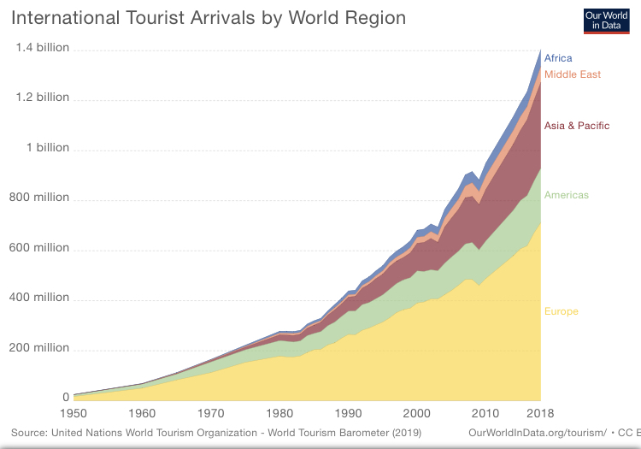
Figure 1. International tourist arrivals by World Region

Second, the number of tourist trips is growing at a faster rate than the number of non-tourist trips. This is especially true for countries with developed domestic and international tourism. To this we can add that within the total number of travels by almost all modes of transport, there is a high (and in some cases prevails) share of travel with a purely tourist purpose. Thus, 45% of air travel in the world is undertaken for tourism purposes.
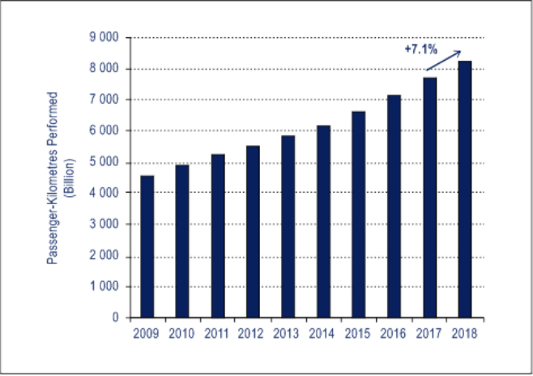
Figure 2. Passenger-Kilometrs performed
Total schedule Traffic, 2009-2018

Third, the share of travel in the total duration of tourist trips is constantly increasing. This is due to the growing desire of people to increase the volume of impressions, to actively consume various tourist goods in a relatively short period of time. In the scientific literature, a number of authors identify as an independent type of tourism - migration, wandering, transport tourism, which emphasizes the increasing role of movement in the implementation of tourist travel. In this regard, we note a constant increase in the average travel distance of one tourist (from 1965 to 1975 - by 150 km). Let us also point out the continuous increase in income from the sale of tourism services and goods that are directly related to the development of transport. This is due to the fact that transportation costs for tourist travel, according to some data, account for about 1/4 of the total tourist costs, and in some cases (for intercontinental travel) - almost half of these costs.

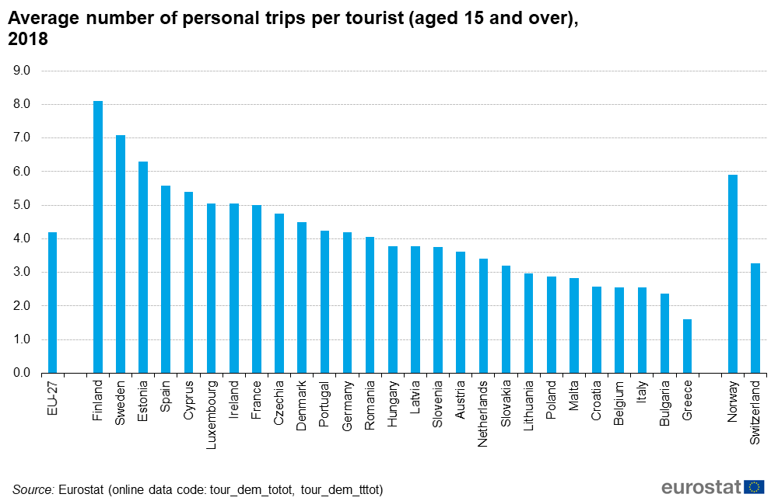
Figure 3. Average number of personnel trips per tourist in EU

The impact of tourism on the development of transport is very broad and multifaceted. It requires the development of the material and technical base, the improvement of the organization and management of transport, the service system, as well as the implementation of an appropriate policy of transport tariffs.
The transformation of tourism into a mass phenomenon creates a number of problems associated with its transport services. This applies to both public transport and specialized transport operating within the framework of tourist organizations. In general terms, these problems boil down to the following:
- creation of the material and technical base of public tourist transport, corresponding to the tourist needs of the country;
- improving the organization of transport;
- improving the quality of transport services for tourists.
The correct solution to these problems is associated with the need to meet the growing requirements for tourist services and with the solution of the problems of increasing the efficiency of tourist activities.
The changes that have taken place in the development of tourism are reflected in both the organization of travel and the system of transport services.
The massive nature of tourist flows predetermines the emergence of new needs, a new attitude of tourists to the motives, goals and preferences in organizing tourist travel. As a result of this, along with the classic ones, new types of tourism appear, which raise tourist demand to a qualitatively new level, requiring transport to meet new needs for its services. That is why transport organizations, along with the quantitative and qualitative improvement of their material and technical base, must take into account new requirements and organizational changes in their activities, including:
a) the separation of independent transport companies, whose activity in general (or predominantly) is the implementation of transport of tourists;
b) the implementation of the integration of transport and tourism enterprises. This is especially the case for the largest air transport firms, which currently control a huge hotel stock;
c) the creation of a specialized unit within the framework of tourism enterprises, which is tasked with maintaining its own fleet of vehicles in order to provide transport services for tourists during their stay in a tourist area;
d) the establishment of strong relationships and the implementation of close contacts between transport and tourism enterprises to achieve maximum coordination of activities related to serving foreign and local tourists. In this regard, the creation of travel agencies - organizers of tourist travel and the operation of vehicles is characteristic;
e) reorganization and restructuring of the activities of transport companies depending on the situation in the international tourism market or seasonal fluctuations in tourism.
However, not all is well in this area of ​​tourist services. In some regions of Kazakhstan, the roadside service is poor. Most of the domestic travel companies complain about the poor condition or lack of roadside services in the regions of the country, in particular, the poor state of sanitary facilities (toilets) in roadside infrastructure. For example, in SKYu on the Shymkent-Turkestan highway there is not a single decent bathroom and the roadside service is in a deplorable state. In front of the mausoleum of Haji Yassaui, the bathroom, intended for the ritual of ablution, is a clay hut, and water is sold to pilgrims and sightseers in plastic bottles.
In this regard, the Committee for the Tourism Industry of the Ministry of Tourism and Sports of the Republic of Kazakhstan (hereinafter referred to as the Committee) and the Committee for Construction and Housing and Communal Services of the Ministry of Industry and Trade of the Republic of Kazakhstan (KDSZHKH MIT RK) made some changes and additions to the state norms in the field of architecture , urban planning and construction, according to which it is necessary to provide for the premises of sanitary facilities (toilets) for drivers and passengers in roadside service facilities. (Order of KDSZHKH MIT RK dated October 20, 2008 SNiP RK 3.03-01-2001 "Standards for technological design. Stationary filling stations").
In turn, the Committee, together with the Departments of Tourism, Sports and Physical Culture of the regional akimats, conducted surveys of roadside infrastructure facilities. As a result of this work, inconsistencies in sanitary facilities (toilets) were identified. The availability of appropriate sanitary facilities is available at large gas stations and food stations built recently. However, at gas stations built earlier, sanitary facilities do not meet the new standards and are mainly located outside gas stations, service stations and food points. In this regard, recommendations were sent to regional akimats to improve the condition of roadside infrastructure facilities in districts, cities of the region and bring them into line in accordance with the above norms, as well as take appropriate measures before the opening of the summer tourist season. In the near future, it is planned to create working commissions in the regions with the aim of studying the entire roadside tourism infrastructure for drawing on the projected roadmap of existing and promising facilities on republican highways and local roads leading to unique tourist recreation areas, archeological, historical and natural monuments.
At present, work is underway to increase the investment attractiveness of Kazakhstan in the field of tourism and attract investors to the tourism sector of the economy. To date, according to the data of local executive bodies, a unified information base for investment projects has been formed, which contains 106 projects of the tourism industry.
In order to implement the state policy on attracting investments in the tourism industry, the authorized body in the field of tourism and sports created a working commission for the assessment and selection of the most relevant investment projects in the field of tourism, which includes representatives of Samruk-Kazyna National Welfare Fund JSC, JSC "Development Bank of Kazakhstan" and JSC "Entrepreneurship Development Fund “Damu”. To date, five meetings have taken place, during which 34 projects have been considered.
So, the following investment projects were approved and recommended for further implementation:
- in the Akmola region Ethnographic complex "Sheber auyly" with the exhibition center "Palace of Masters" (LLP "Sheberler auyly - 2"), Recreation center "SHARZHUM" (LLP "AKKA TO1ZH"),
- in the Almaty region, the Tamgaly State Historical and Cultural Natural Reserve, the Talkhiz Tourist and Ethnographic Complex (Zhibek Zholy Company LLP),
- in the Atyrau region Construction of a tourist center on the site "Kazyna-Tal" (LLP "Karavan-Saray"), Construction of a recreation center in the Sarytogay rural district of the Makhambet region ("IP Ageleuov"),
- in the East Kazakhstan region, the recreational and tourist complex "Katon-Karagai" (KH "Katon-Karagai deer park"), the health-improving complex "ANA" (00 "Women of the East: taking care of children"),
- in the Zhambyl region, the Koksay ski base (Baiterek sayakhat ortalygy LLP), the Tau Samaly Tourist Center (Tlebay Baba LLP),
- in the Karaganda region, the International health and tourist center "Balkhash - Nursaya" (Corporation "Alamo Group"),
- in the Kyzylorda region Yurt hotel on the Aral lake Kambash (IP Isaev Aldabergen), etc.
The implementation of these projects will contribute to the creation of new jobs and will not allow a significant increase in the unemployment rate, which are the main directions of the Action Plan of the Government of the Republic of Kazakhstan for 2009 on the implementation of the Address of the Head of State to the people of Kazakhstan dated March 6, 2009 "Through the crisis to renewal and development" ...
Informatization is one of the most important directions in the development of tourist infrastructure, one of the striking features of the system of public relations in developed countries. Humanity has entered a stage in the development of civilization in which information and knowledge play a decisive role in all spheres of human activity. At the same time, information is becoming the most important factor in economic growth in modern society.
It is necessary to understand that technological progress today is not only the main factor in ensuring the well-being of the nation, but also the most important condition for the process of its sustainable development. At the same time, priority attention should be paid to information technologies, which, due to their special properties of the catalyst, will actively contribute to the country's technological breakthrough not only in the information sphere, but also in many other equally important areas.
In the modern information society, the importance of information as a commodity is increasing. This is a consequence of the general growth of information needs and an expression of the development of the information services industry. Evidence of this is the increasing contribution of the information sector to the creation of national wealth.
Informatization is developing most dynamically in the field of market infrastructure: enterprises that provide intermediary services in the sale and purchase of goods, securities and currency, as well as advertising and representation services and audit activities, are equipped mainly with new modern information technology.
The next revolutionary stage in the informatization of society is associated with the extraordinary growth in the use of global computer networks.
The worldwide computer network Internet is developing so rapidly that every year the number of its subscribers and the volume of information resources practically doubles. The tourist business does not remain aloof from this boom.
Automation and widespread use of electronic technology are becoming one of the most pressing challenges in the tourism industry. The creation of powerful computer systems for booking accommodation and transport, excursion and cultural and recreational services, the introduction of the latest technology in the tourism sector, information on the availability and availability of certain types of trips, routes, the tourism potential of countries and regions - the whole range of these issues, taking into account the development integration processes are put on the agenda of the current and future activities of the World Tourism Organization.
A special place in the promotion of tourism products and services is occupied by the latest multimedia technologies - they are able to attract a large number of users, are notable for their low cost and high communication. The main means of electronic marketing include: the Internet, e-mail and multimedia discs. The effective use of high-tech communications makes it possible to significantly expand the capabilities of advertising companies and PR campaigns, to increase the efficiency of interaction between all subjects of the tourism market.
The Internet. Every year more and more subjects of the tourism market of various levels are striving to create their own space on the Internet. In 2006, according to experts, more than a third of all tourist trips will be sold via the Internet.
Advertising on the Internet is the most promising direction, first of all, because it is a very mobile and efficient way of transmitting information. In addition, online advertising does not require very large resources (for example, the cost of creating and maintaining a site is from 500 to 5000 dollars, and an advertising campaign using banners costs from 100 to 1000 dollars).
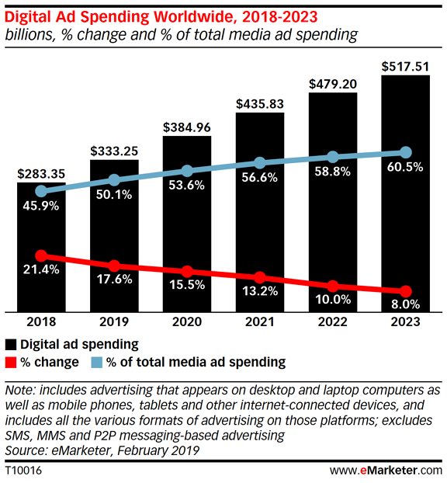
Figure 4. Digital Ad Spending Worldwide, 2018-2033

One of the most effective means of the Internet space is the creation of a multilingual information portal, the main task of which is to promote the country both in the world and in the domestic tourist market. High information saturation
Networks combined with presentation capabilities make the Internet attractive to the global travel industry. The technological capabilities of the Web are practically unlimited - from the creation of the simplest sites to the appearance of sound animation videos. An important advantage of the Internet is its high cost effectiveness. In addition, the Internet allows you to conduct any large-scale actions - conferences, forums, marketing research, as well as to promptly respond to any situation in order to minimize negative and enhance positive factors, which is essential for the formation of a positive image of the country.
The presence of its own Internet resource shows the level and quality of management, and virtual images created with the help of electronic technologies have no less impact on consumers than television.
One of the directions of infrastructure development is the implementation of the Sites in the activities of the tourism administration. The Internet, with its almost unlimited possibilities, is of great interest to regional tourist administrations, since it brings information about tourist products and services to a large number of people around the world at a relatively low price. Until recently, many regional tourism administrations and tourism destination marketing organizations considered the Internet to be a peripheral system operated by information technology departments. At present, the attitude to network resources has changed radically, active work in the network has become one of the most important areas of activity for tourism administrations. Among the main advantages of the Internet is the provision of a simple and quick way of booking a tourist product by consumers, which gives very significant savings in the production and distribution of traditional printed advertising materials, in telephone conversations, and business correspondence. However, networking at the regional level should be complex and systemic: the sites of tourist regions cannot be viewed only as a commercial tool - they represent, first of all, the region on the World Wide Web and contribute significantly to the formation of its favorable image.
Undoubtedly, these steps will give certain results in the development of domestic and inbound tourism, which in turn will provide some assistance in the quickest way out of the financial crisis, since the funds spent on tourism services will remain in the republic.

References:
- Nakipova G.E. The current state and development of domestic tourism in the context of the global crisis // Mat. int. scientific-practical conf. "World Tourism: Major Trends in an Economic Instability" (December 2, 2009). - Karaganda, 2009. – p. 70-74.
- The concept of tourism development in the Republic of Kazakhstan. On the development of tourism as a profitable sector of the economy in the Republic of Kazakhstan. - Almaty: Rarity, 2001. - p. 21.
- The website of the Ministry of Tourism and Sports of the Republic of Kazakhstan - URL: http://www.mks.gov.kz/rus/.
- Smagulova K.S. Development of the tourism industry and its impact on the economy of Kazakhstan // Materials of international scientific-practical. conference "World tourism; main trends in conditions of economic instability" (December 2, 2009). - Karaganda, 2009.- S.133-135.
- The website of the statistical office for the European Union – URL: https://ec.europa.eu/eurostat/about/who-we-are
- Official website of eMarketer, first place to look for data research in digital for business professionals – URL: https://www.emarketer.com
- The website of World Tourism Organization – URL: https://www.wto.org/english/news_e/pres20_e/pr862_e.htm
- Tourism of Kazakhstan 2008-2012: Statistical collection in Kazakh and Russian languages. - Astana: Agency of the Republic of Kazakhstan on Statistics, 2013. - 133 p. // http://www.stat.gov.kz
- Dyusembekova Zh.M. Marketing Research: A Textbook. - Almaty: Economics, 2013 .- 472 p.

