“Knitting clothes at home is a waste of time and money. Is it really so in Russia and in America?”

Работу выполнили: Мамонова Айрида, Башкирцева Люба,
ученицы 8 «а» класса
МКОУ «Гимназия № 25» городского округа Ревда
Свердловской области

Руководитель: Огородникова Любовь Михайловна, учитель английского языка высшей квалификационной категории
МКОУ «Гимназия № 25» городского округа Ревда
Свердловской области

2020 год

Contents:

- Introduction. Objective, goals for accomplishment, the subject-matter,
the objects, research methods…………………………………………………3
2. Main body……………………………………………………………………...4
2.1 The number of knitters in Russia and America compared……………………4
2.2 Knitting appeals in both countries…………………………………………….6
2.3 The reasons of a negative approach to knitting as a waste of time and money..9
3. Conclusion……………………………………………………………………..11
4. References……………………………………………………………………..12

- Introduction
It is interesting to study cultures. For example, it is interesting to get to know how many knitters in America and in Russia are and why they enjoy knitting so greatly [Phyllis McIntosh2011:49]. Apart from that, why some people in both countries get knitting as a waste of time and money.
So, the objective of the project work is to consider why knitting is a popular hobby in America and in Russia and why some people in both countries consider knitting a waste of time and money.

Goals for accomplishment:
- To find out about the number of knitters in both countries, therefore to consider where knitting as a hobby is more enjoyed in Russia or in America and why.
- To find out why some people in both countries get knitting as a waste of time and money.
- To make a conclusion.
The subject-matter of the research is knitting supplies and knitting appeals in both countries.
The objects of the research are the article «Knitting. A Craft Makes a Comeback» and blog http://vk.crochetclub
Research methods are: comparison, doing a survey, interviewing.

2. Main body
The joy of «making a piece of string into something I can wear» has turned knitting into one of the most popular hobbies in the United States. For knitting fans knitting is a creative outlet, a form of artistic expression that can be shared with others.
Nearly half of those responding to a survey by the Craft Yarn Council of America[Phyllis McIntosh2011:49] said they especially enjoy making gifts for family and friends, knowing that their creations will endure for years and likely be cherished by the recipients. For some activist types, hand knitting even represents a form of rebellion against what they see as often shoddy mass-produced goods.
Then, a chief advantage for all ages is that knitting is a completely portable hobby. Busy Americans knit on buses and subways, in coffee shops and during meetings in doctor’s waiting rooms and while watching sporting events.

2.1. The number of knitters in Russia and America compared
According to the Craft Yarn Council of America one third of all American women aged 25 to 35 now knit. In just three years, there ranks increased 150% percent while the number of youngsters and teenagers taking up the needles doubled[Phyllis McIntosh2011:49]. http://vk.crochetclub reports that only one sixth of all Russian women now knit[ http://vk.crochetclub].

As you can see, there are three times fewer knitters in Russia than in America.
Some of them simply enjoy the process of creating new stitches by inserting the end of the needle through one of the stitches on the shaft of the other needle.
What is more, many knitters say that turning to their needles and yarn is a great stress reliever and escape from both the frenzy and tedium of daily life. According to Dr. Herbert Benson, the repetitive action of knitting creates a state of relaxation similar to yoga or various forms of meditation. Research indicates that knitting can lower the heart rate and blood pressure. Keeping the hands occupied with knitting has been shown to help people stop smoking, avoid overeating and cope with pain and depression.

2.2. Knitting appeals in both countries
Knitters are passionate about their craft both in Russia and in America because of such knitting appeals as:
Knitting appeals | USA | Russia
The joy of «making a piece of string into something I can wear» | + | +
knitting is a creative outlet, a form of artistic expression that can be shared with others | + | +
enjoy making gifts for family and friends | + | +
hand knitting even represents a form of rebellion against mass-produced goods | + | +
knitting is a great stress reliever and escape from both the frenzy and tedium of daily life | + | +
knitting helps people stop smoking, avoid overeating and cope with pain and depression | + | +
busy Americans knit on buses and subways, in coffee shops and during meetings in doctor’s waiting rooms and while watching sporting events | + | _

As you can see, knitting appeals in both countries appeared to be very much alike.

My granny enjoys knitting as well. And she especially enjoys knitting with super bulky knitting yarns which are best for large projects such as sweaters and jumpers.
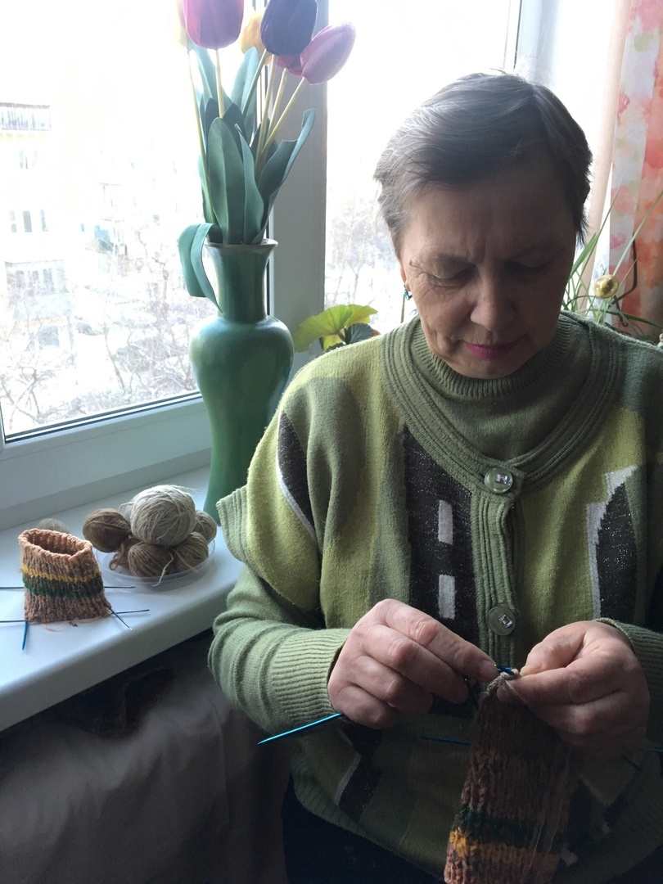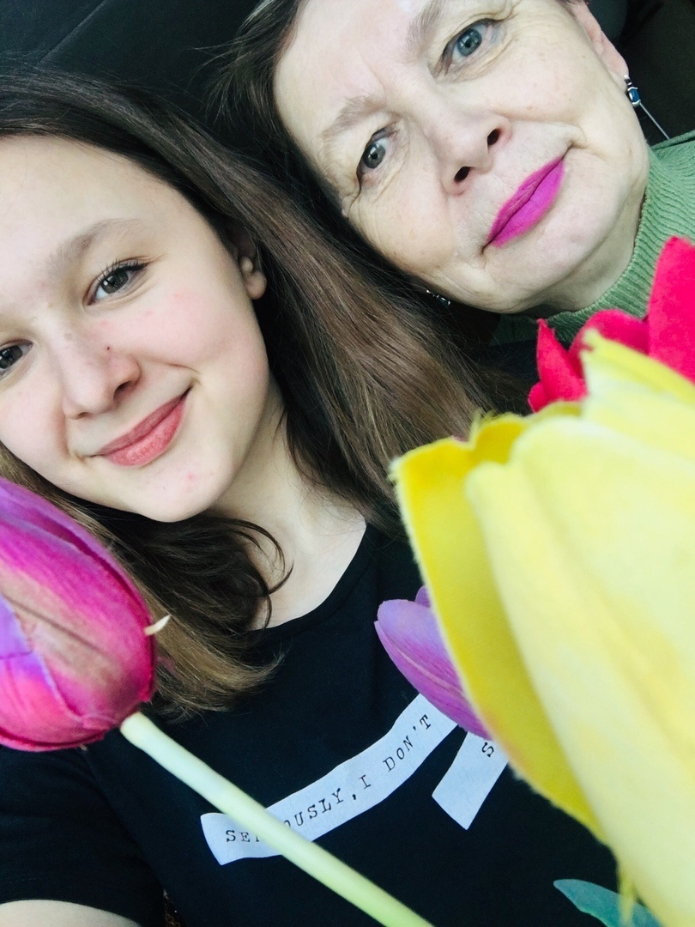
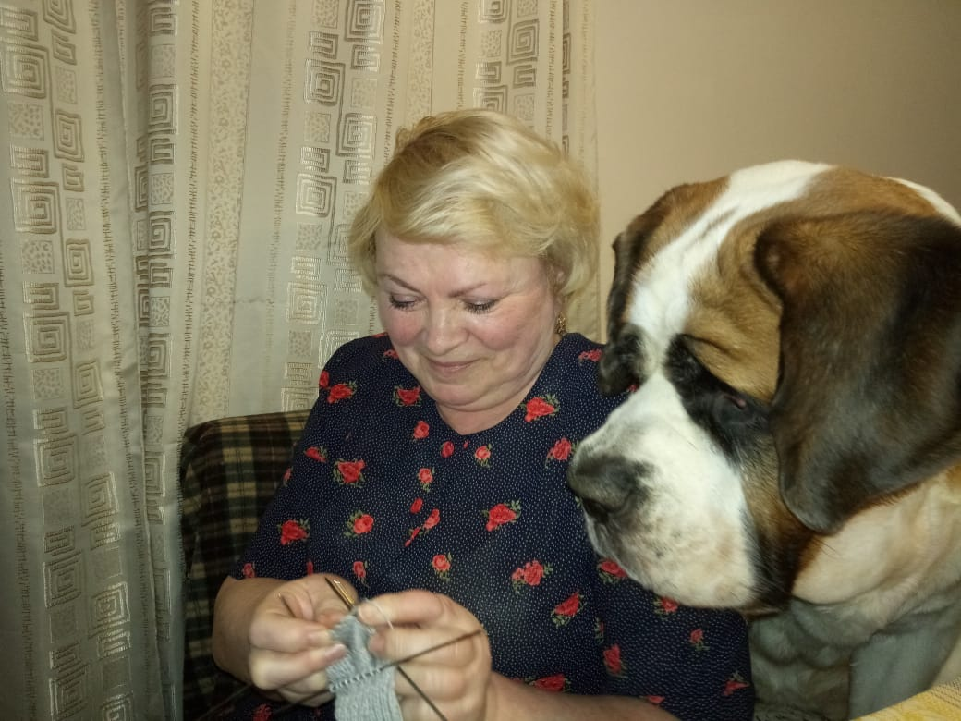

My best friend and me like knitting more delicate garments: scarves, mittens and shawls.
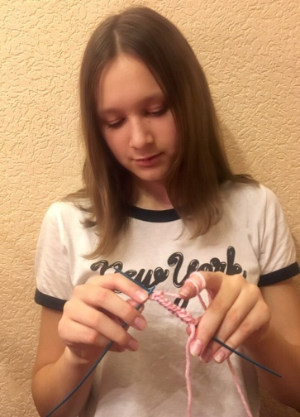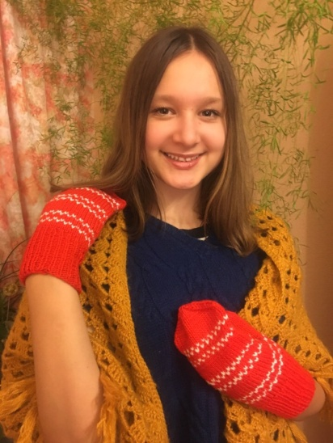
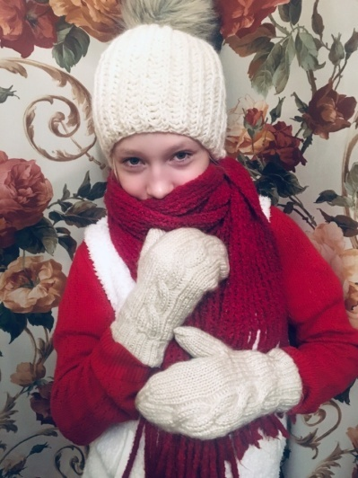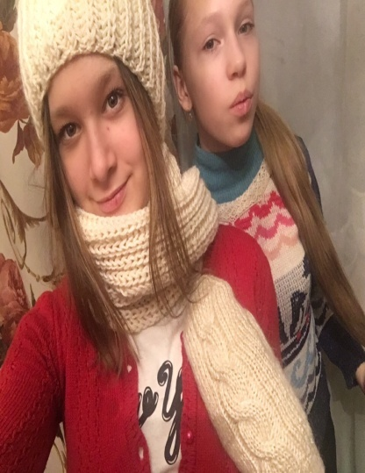

2.3 The reasons of a negative approach to knitting as a waste of time and money.

As for my mum, she believes that knitting clothes at home is a waste of time and money. I asked my mum why she thinks so. She said that for example to knit an adult sweater you need about 7 skeins of thick yarn made from sheep’s wool or other animal- based yarns such as cashmere or angora. They cost about 2000 rubles. Besides, it takes my mum to knit an adult sweater about a week, 3 days to knit socks and mittens and 3 skeins which cost about 700 rubles.

garment | number of skeins, yarn | cost | time  consumed
adult sweater | 7- 8 skeins  animal-based yarns (sheep’s wool, cashmere, angora) | about 2000 rubles | 7- 14 days
socks | 3- 4 skeins  animal-based yarns (sheep’s wool, cashmere, angora) | 700- 1000 rubles | 3-7 days
mittens | 2- 3 skeins  animal-based yarns (sheep’s wool, cashmere, angora) | 500- 800 rubles | 2- 6 days

So, to some people this hobby is too expensive and so time-consuming [Phyllis McIntosh2011:49] that is why they get knitting as a waste of time and money.
To buy the same garments in the store is sometimes cheaper and doesn’t take too much time.

Conclusion
To conclude, I found out about the number of knitters in America and in Russia. There are three times fewer knitters in Russia than in America. That is why, knitting is likely to be a more enjoyable hobby in the USA than in Russia. Apart from that, knitting appeals in both countries appeared to be very much alike. However, there are people in both countries who get knitting as a waste of time and money because of expensive yarn and a great amount of time one needs to knit just one garment. I personally consider knitting as a joy, a kind of relaxation similar to yoga or various forms of meditation. I like it.
Whatever their impression or motivation, knitters are passionate about their craft. Some even see in it a larger symbolism. Knitters say: “We are all joined together. Each stitch is vital to hold the garment together, just as each person is vital to the world.”[Phyllis McIntosh2011:49].

References:
- Phyllis McIntosh. “Knitting. A Craft Makes a Comeback.” English teaching Forum. Volume 49 November 1, 2011.
- Essential Dictionary For learns of English. International Student Edition- MacMillan, 2008.
- http://vk.crochetclub

