Управление образования Мостовского районного исполнительного комитета
Государственное учреждение образования
«Мостовский районный центр творчества детей и молодёжи»

Исследовательская работа по английскому языку
«Из Беларуси в Нидерланды с любовью»
«From Belarus to the Netherlands with love»

Автор: Тарарук Ксения,
объединение по интересам «English Grammar»
Руководитель: Радкевич Наталья Григорьевна, педагог дополнительного образования объединения по интересам «English Grammar»

Content

- Introduction……………………………………………………… | 3
- From Belarus to the Netherlands with love …………………….. | 4
2.1 Sights of the Netherlands…………… ...………………………... | 4
- Sights of Belarus ..…………………..…………………………… | 5
2. 3 Comparative characteristics of travel in Belarus and the Netherlands……………………………………………………………… | 7
- Conclusion ……………………………………………………….. | 9
- Applications.……………………………………………………… | 10

Introduction

It is impossible to measure the value of what travel gives a person. For every person traveling there is a great benefit.
Reasons to travel a great variety - the passion for travel, the love of culture. Traveling is becoming a way for people to cope with different situations, relive a new experience, and find themselves. That is why people love to travel.
For each person in travel laid a certain charm. St. Augustine is known for his quote: "The world is a book, and those who do not travel read only one page."
In the book of the world all the pages are different. Everything is new, everything is changing.
Recently, people began to travel more and that is why - in the modern world of employment from 8 to 17, mortgages, loans and regular accounts become like an eternal race, almost indistinguishable from each other and very boring. Under the weight of such a life, a person often forgets about what is really important for him and what he would like from life. People became hostages between the way to work and back, that they forgot how the sky looks and in general how to breathe.
People may have many reasons to go on a trip, but everyone is looking for some change. Journey makes a difference in the life of a person and gives it a piquancy.
A person is always looking for something new, something previously unseen - the next page in the book of the world, even if it is temporary. This makes travel so interesting, intriguing and desirable for all of us. This is the benefit of travel for a person.
The relevance of this work lies in the fact that it reflects the importance of travel for a person, a comparative description of travel in his native country and abroad.
The purpose of the work: to explore the sights of Belarus and show the benefits of rest in your country over the rest in foreign countries (for example, the Netherlands).
Work tasks:
• To conduct a survey among students of the Minsk Financial and Economic College about their travel preferences.
• Explore the sights of Belarus and the Netherlands in literary sources;
• Carry out a comparative analysis between holidays in Belarus and the Netherlands;
Research hypothesis: the territory of Belarus has a rather high tourist potential for traveling in their own country, but not in foreign countries.

2. From Belarus to the Netherlands with love

Every person in his life dreams of traveling. Many seek to spend their holidays outside their country, believing that there is nothing to see at home.
Thus, among the students of the Minsk Financial and Economic College a survey "Dream Journey" was conducted. The analysis of the questionnaires showed that 80% of respondents prefer to rest abroad. 100% of students named a large number of attractions in foreign countries, and only 30% of respondents named landmarks of their country. 47% of students would like to see the sights of the Netherlands, so in this work a comparative analysis will be conducted with this country.
The author of this research will try to unleash the tourist potential of Belarus and show the benefits of recreation in his country.

2.1 Sights of the Netherlands.

Whoever enters the Netherlands, when crossing the border, will see a patchwork carpet in the porthole below, in which green rectangles of the earth stand out, colored with tulip fields and lined with blue threads from all sides.
Canals, rivers and lakes are everywhere here, they have cut and cut along all the cities, they accompany you on the road between them: they flow parallel to the highway and railway tracks.
What is remarkable for tourists in the Netherlands? In literary sources, the author of the work found places that deserve the attention of tourists:
1. Channels
In 2010, Amsterdam canals became a UNESCO World Heritage Site. Therefore, a boat or a pleasure boat is an ideal way to explore Amsterdam. Most of the attractions of the city falls into the field of view of tourists, and the guide will tell about them. Right flush with the water - small cafes and restaurants, ducks and swans are swimming in some places. This place is compared to Venice, with the difference that in the warm season the water is cleaner and there is no smell, that the walk is much nicer.
2. "Garden of Europe"
Park Keukenhof referred to as the "Garden of Europe". Every year in spring in the town of Liss between the Hague and Amsterdam on 32 hectares hundreds of breeders parade their achievements. And this is a thousand varieties of flowers, among which the main one is a tulip. Sea of ​​tulips. Several million of his multicolored heads sway in picturesque waves every year. Many tourists go to the Netherlands at this time.
A simple inhabitant can visit the original museums of the Netherlands:
1. Nemo Museum - National Center for Science and Technology
To the museum, located on the water, not far from Amsterdam Central Station, there are two bridges, and from the observation deck on the roof there is a wonderful view of the old part of the city.
There are no usual museum tablets here: “Do not touch your hands!” On the contrary, most of the exhibits are intended for this purpose: this explains how the world works. Visitors will learn a lot of amazing and interesting things about the most simple and everyday things around us. Science, technology, information technology, biomedicine - on 5 spacious floors of the museum for children and adults will be extremely interesting.
2. Anne Frank House
In 1934-1944, Anna Frank lived in Amsterdam, the author of the famous "Diary ..." published posthumously and later translated from Dutch into all the languages ​​of the world. Based on the novel filmed several screen adaptations.
A small museum is located in the house number 263-267 on the embankment Prinsengracht, where the family of a Jewish girl was hiding from the Nazis. Here Anna more than one and a half years wrote the diary.
Despite the small exposition, one of the most visited museums in Amsterdam impresses tourists, especially those who have read the novel.
3. Madame Tussauds Museum in Amsterdam
One of the ten world branches of Madame Tussauds London Museum is located in the center of Amsterdam (Dam Square, 20).
After visiting it, take a fascinating and exciting journey into the world of the most famous and recognizable personalities in various fields.
Here are some of the country's colorful sights of tulips and beautiful water canals.

2.2 Sights of Belarus

Unfortunately, Belarus can not be called the most popular country among tourists. However, such an attitude can be considered unjustified. There is no sea here, of course, but there are a lot of beautiful places, historical places and comfortable sanatoriums, hotels and boarding houses for travelers.
The nature of Belarus is beautiful. The purest lakes and rivers, dense forests, green fields - the country is simply created for green tourism and actively develops precisely this direction. In addition, the Belarusians themselves are hospitable people who are always happy to see guests.
What can you see in your own country? The answer is very simple - a lot. Belarus is amazing castles and ancestral estates, beautiful temples and monasteries, unique corners of untouched nature, fascinating museums and ethnographic villages, native places of famous artists, writers and scientists.
Here are just some of the sights of our country:
1. Brest Fortress.
At the beginning of the Great Patriotic War, the main citadel of Belarus was the first to take a strike and for 28 days held back the onslaught of the German fascist invaders. In honor of the defenders of the fortress, a grandiose memorial complex was erected, in the center of which a monument, “Courage”, 33.5 meters high, depicting a warrior and a banner, was erected.
2. Belovezhskaya Pushcha.
The legendary Belovezhskaya Pushcha is one of the oldest reserves in the world, the largest of the preserved parts of the vast relict forest of Europe. The unique natural area that unites Belarus and Poland is included in the UNESCO World Heritage List.
3. House - Mark Shagal Museum in Vitebsk.
The most famous native of Vitebsk, Mark Shagal, is one of the brightest representatives of the world avant-garde of the 20th century. All his life the artist kept a quivering love for his native city: its roofs, temples, people are on every Shagal’s canvas. Vitebsk House-Museum represents one of the richest collections of Shagal in the world - more than 300 original graphic works and reproductions of the most famous paintings.
4. Museum - the estate of Ilya Repin.
The museum of the great peredvizhnik artist Ilya Repin is located in the environs of Vitebsk. In 1892, for a fee for one of his most famous paintings, "The Cossacks write a letter to the Turkish Sultan," sold to Alexander III, the master bought the estate Sofiyevka, returning her old name to Zdravnevo. More than 40 canvases ("Autumn Bouquet", "Belarusian", "Duel", "Moonlight Night", "In the Sun"), numerous drawings and sketches were created here.
5. August Channel.
The 19th century engineering miracle — an artificial waterway connecting the Baltic and Black Seas — is one of the world's top three, along with the Gotha Channel in Sweden and the Caledonian in Great Britain. Here you will see unique hydraulic structures, go on a trip by boat or kayak to picturesque and environmentally friendly places. The channel is located on the territory of the Avgustovskaya Pushcha, which is called Europe’s “green lungs”.
6. Khatyn State Memorial Complex.
The symbol of the tragedy and incredible courage of the Belarusian people, the memory of every third resident of the country who died during the Great Patriotic War ... The Belarusian village of Khatyn is notorious for the whole world. Here on March 22, 1943, 149 inhabitants, including old people and 75 children, were martyred. The fascists burned defenseless people alive in a closed shed, and those who tried to get out of the fire were “watered” with machine gun fires. An impressive memorial was founded in memory of the tragedy of Khatyn and hundreds of other villages destroyed together with the people. Since its opening in 1969, more than 36 million people from different parts of the world have been here.
This is only a small part of all the attractions of our country. Only our capital Minsk has more than 30 sights. This is the Upper Town, the Trinity Suburb, and the Minsk City Hall. Minsk is famous for its Independence Square and Victory Square, the property of the country is the National Library.
Each city of Belarus has its own places that will be interesting for tourists.

2.3 Comparative characteristics of travel in Belarus and the Netherlands

Since the purpose of this work is to show the advantages of recreation in Belarus, the author will conduct a comparative description between Belarus and the Netherlands.
We considered the sights of both countries, and now we will try to understand where it is more profitable and more pleasant to rest.
When a person goes on a journey, he is most concerned about the weather in the country where he is going. Wherever a Belarusian goes, he is waited everywhere for a few days of acclimatization. Be it Egypt with a heat of 35 - 40 degrees or the Netherlands with heavy rain. Many Belarusians can hardly withstand the climatic conditions of another country, so the journey turns out to be spoiled.
Going on a trip, tourists want to get acquainted not only with the sights of the country, but its people, culture, customs and traditions. But before recognizing the culture of another country, a person needs to know the customs and traditions of his area. Very often, residents of other countries are interested in our tourists, how people live in our country. Therefore, this is another reason to travel around your country, studying your native traditions and customs.
One of the main barriers to travel is - knowledge of the language. It is difficult to listen and understand the guide who does not speak Russian or Belarusian. To understand and study the history and beauty of another country, you must also know its language. This is another reason to travel around Belarus.
For research, the prices of tours to various countries were studied.
Prices for tours to the Netherlands range from 293 Belarusian rubles to 1,790 Belarusian rubles, which greatly undermines the budget of the average Belarusian family. Not every Belarusian can afford such a trip.
Tours in Belarus cost from 35 Belarusian rubles to 250 Belarusian rubles. Every average Belarusian can afford such a trip at least once a year. For this money you can enjoy the beauty of your native country and spend an unforgettable journey through Belarus.

3. Conclusion

Based on the above, we can conclude that the Netherlands is a very beautiful country. Many Belarusians dream of traveling there, but this work shows that such a journey will not be cheap, the climate of this country will not suit everyone. There is no guarantee that the tourist will not fall on heavy rains and will spend his entire trip at the hotel.
This work proves that traveling around Belarus has several advantages:
- there is no need to adapt to a different climate;
- there is no need to know a foreign language;
- travels in Belarus provide an opportunity to explore your country, its customs, traditions, attractions;
- the cost of tours in Belarus is available to everyone.
No wonder they say: "Visiting is good, but at home is better."

4.Applications

Questionnaire "Dream Journey"

1. What is your name and surname?
2. Your age?
3. Where would you prefer to travel?
4. Name the sights of foreign countries.
5. Name the sights of Belarus.
6. What country sights would you like to see?

Sights of the Netherlands
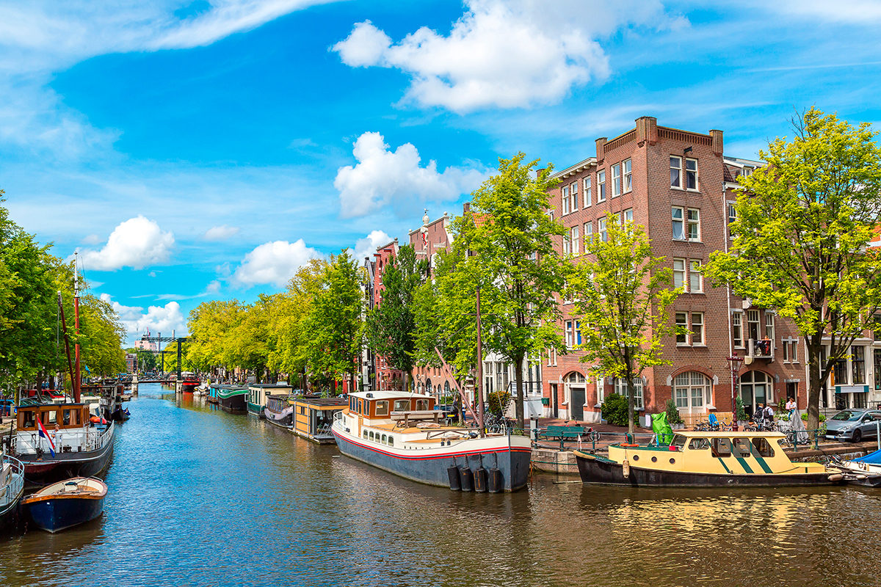
Photo 1. Amsterdam canal
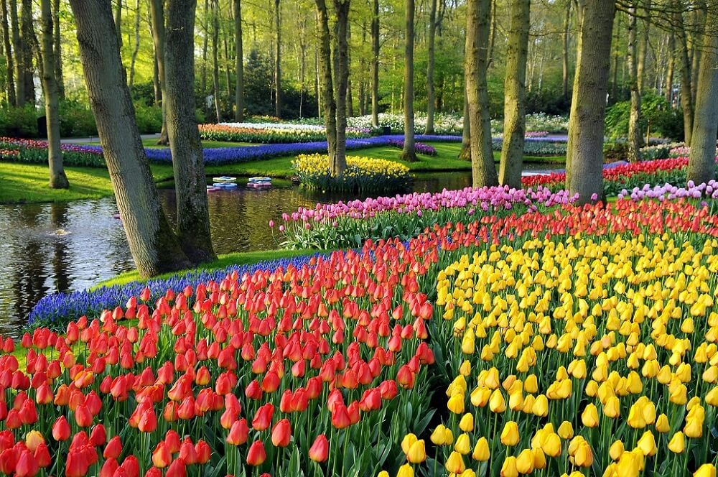
Photo 2. "Garden of Europe"

Photo 3. Nemo Museum
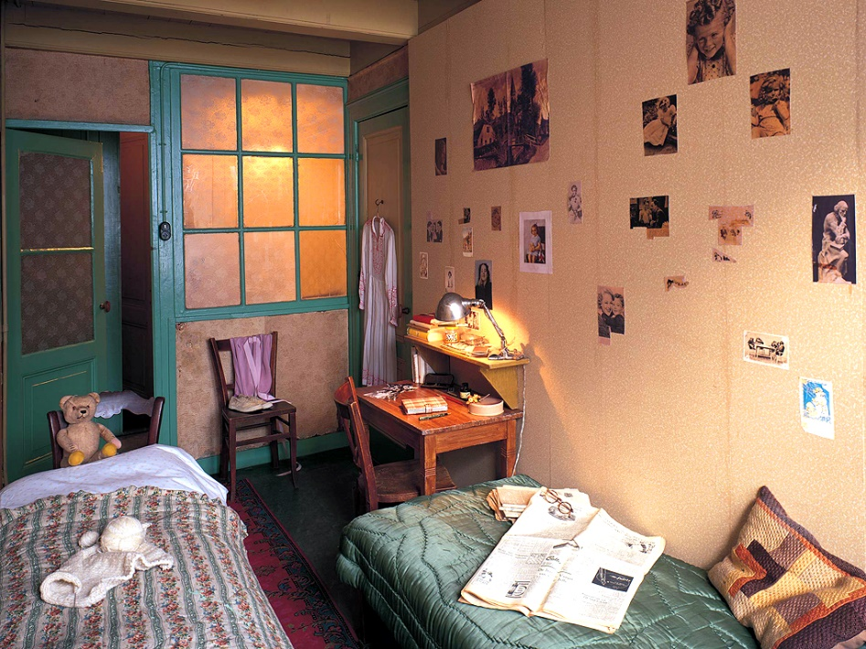
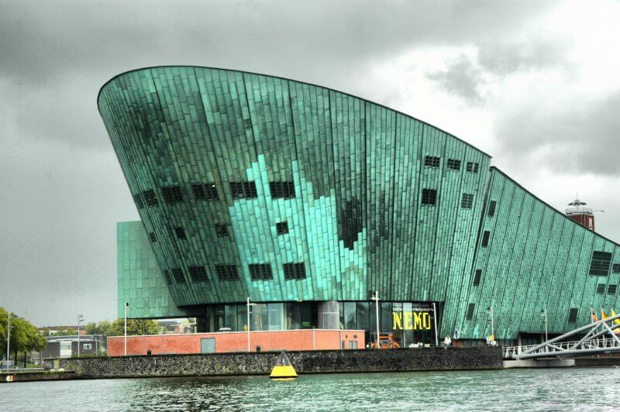
Photo 4. House - Museum of Anne Frank

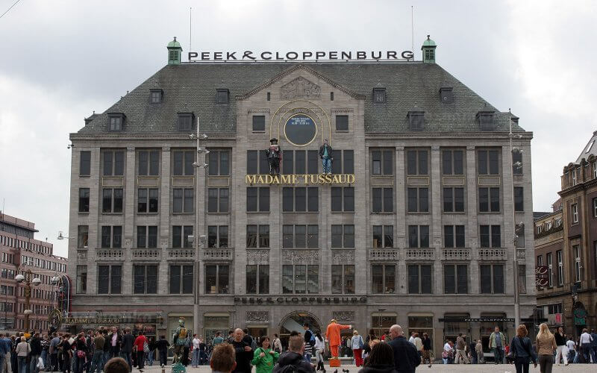
Photo 5. Madame Tussauds Museum

Sights of Belarus

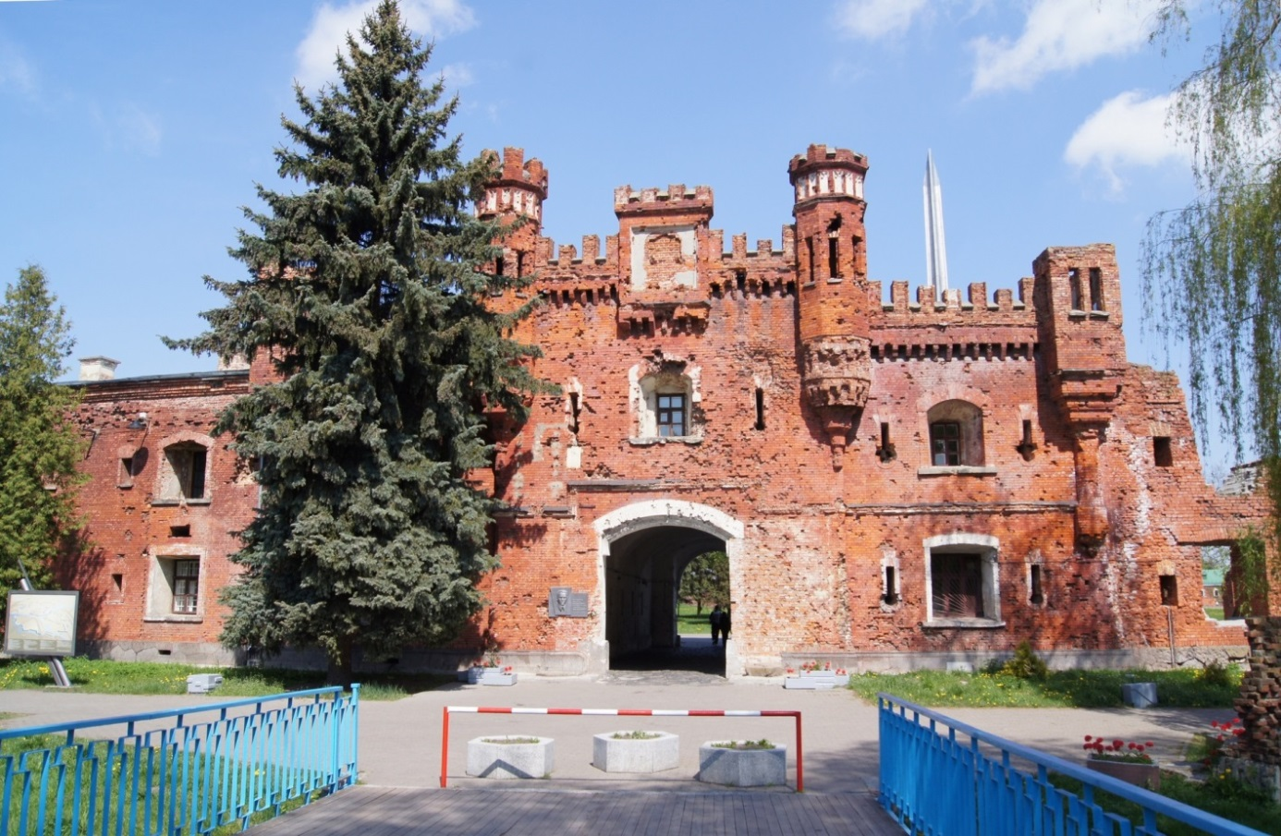
Photo 6. Brest Fortress

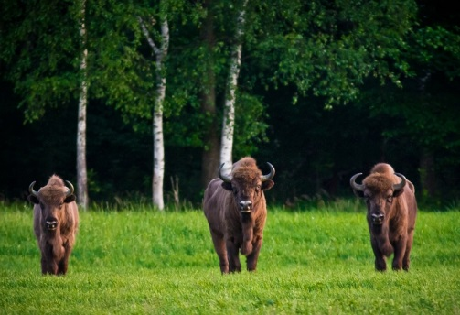
Photo 7. Belovezhskaya Pushcha

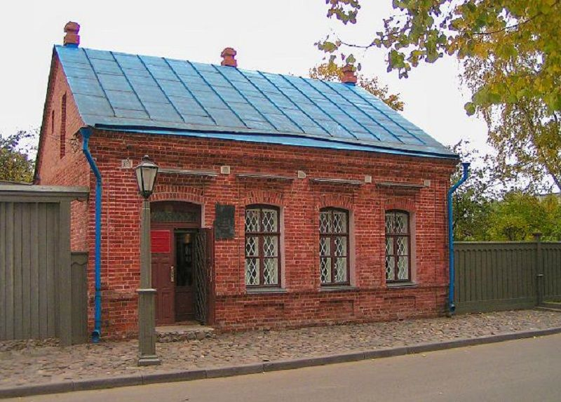
Photo 8. House - Museum of M. Shagal
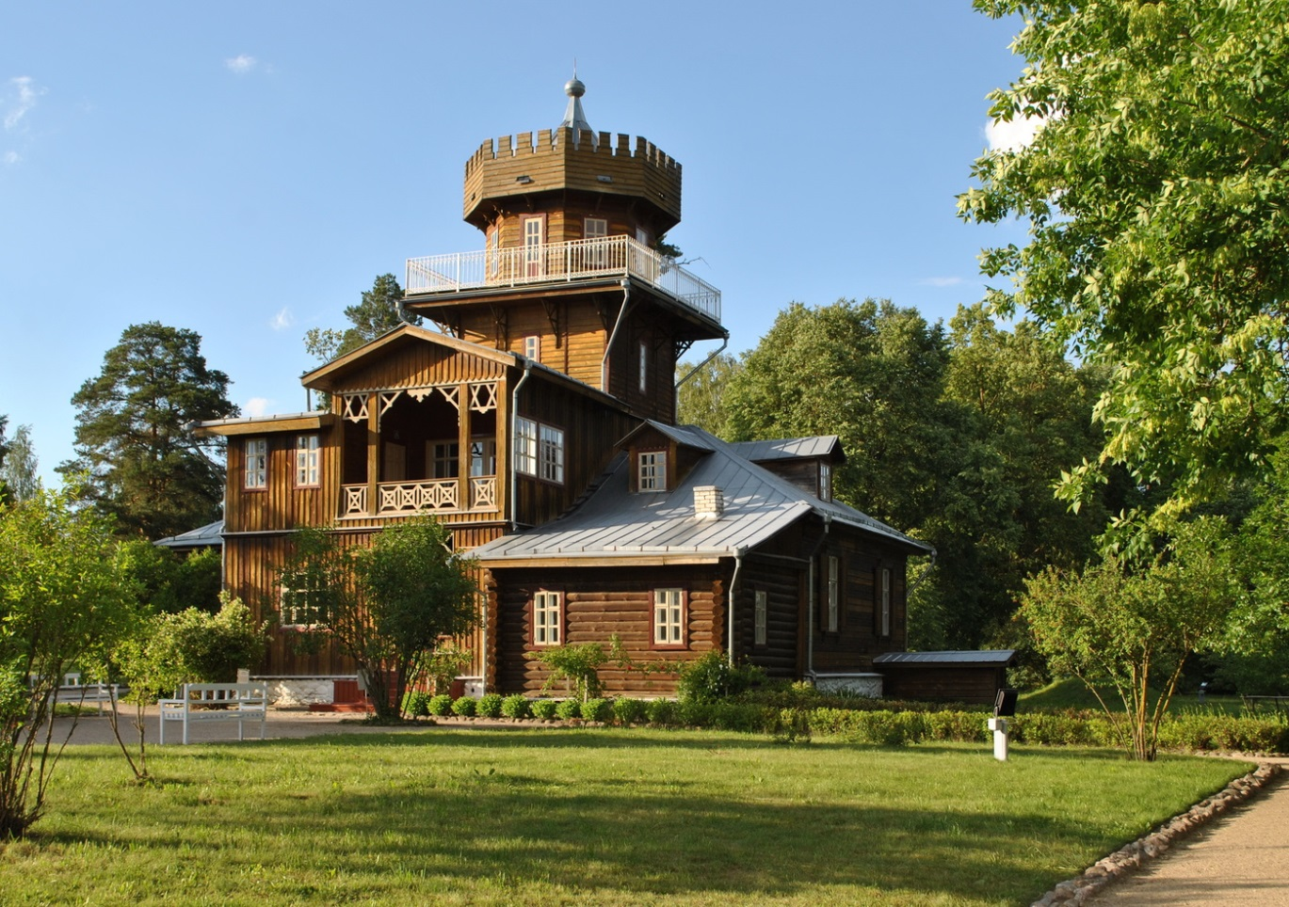
Photo 9. Manor - Museum of I. Repin

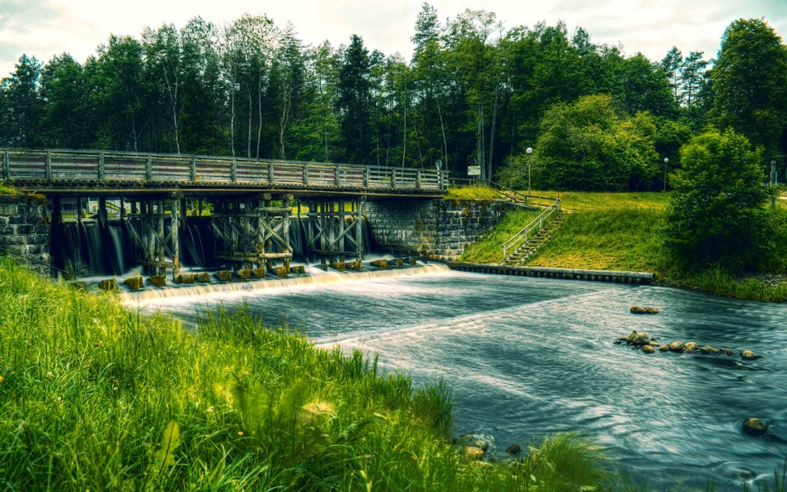

Photo 10. August Channel

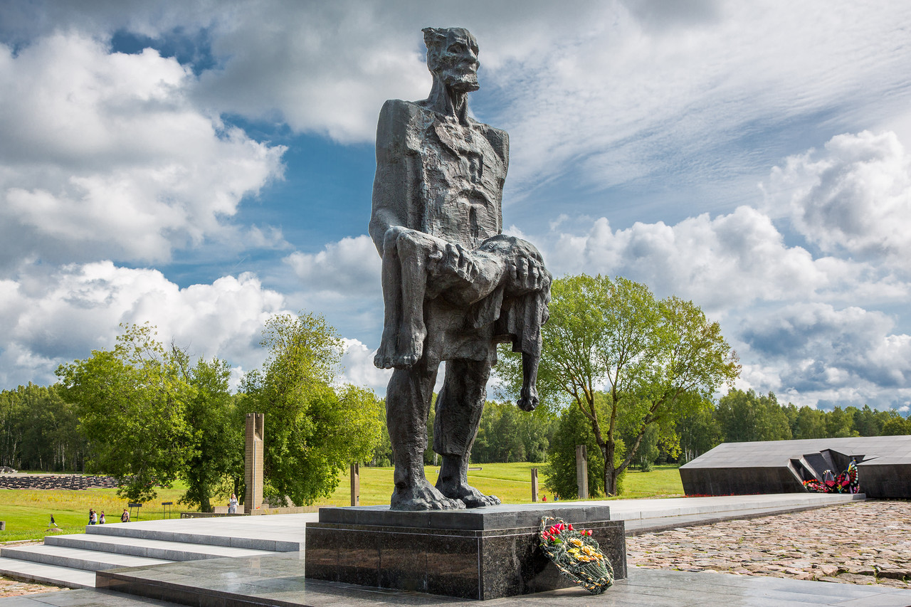

Photo 11. Memorial complex "Khatyn"

