Department on Education of Gantsevichi District Executive Committee
State Educational Establishment
«Kukovo Secondary School»

FROM FLORISTIC SYMBOLS, HERALDY TO THE HISTORY AND NATIONAL CHARACTER

Educational research in the English language

Roman Leles
Form 10
Supervisor Director of the study
Klimovets M.M.
Bachelor of Education
Teacher of English

Кukovo, 2018

Contents
Introduction 2
1. Symbol as an element of a culture 4
2. Flower symbolism 5
2.1. National flowers of the United Kingdom 5
2.2. Flower symbols of England 5
2.3. Flower symbols of Scotland 6
2.3. Flower symbols of Wales 7
2.4. Flower symbols of Northern Ireland 8
2.5. Flower symbols of Belarus 9
2.6. Flower symbols in schools and preschools in Gantsevichi district 11
2.7. Flower symbols in heraldy 12
3. The results of the survey 13
Сonclusion 14
Bibliography 16
Supplements 18

Introduction
The priority of modern linguistics is the study of the language as a cultural code of the nation, and not just as means of communication and knowledge. Any language is an opportunity to understand the cultural characteristics of a nation, to penetrate into the country's history. Echoes of the past are preserved in proverbs, phraseology, metaphors and symbols.
When we remember one or another country, we usually associate it with any flower or plant, which are common and popular in the state.
The concept of "national flower" is very ancient. The national flower was playing an important role as a symbol, a mark of distinction for certain people. Nevertheless, nowadays the flowers have not completely lost their role in the international arena and they are often the "logos" of their countries.
We conducted a survey among the pupils of the 7-th – 11-th forms in Gantsevichi district, which revealed their awareness on flower symbolism in the cultures of the Belarusians and the British (Supplement 1).
We also interviewed teenagers aged 13 –17 from various parts of the UK in order to find out their level of awareness on their national floral symbols and Belarusian floral symbols, using the social network Instagram. (Supplement 2).
The survey results showed that both teenagers from Belarus and teenagers from the UK are not deeply aware of the role of floral symbols in the history and culture of the country. Most teenagers didn’t think about the motives of the origin and choice of national floral symbols. Some respondents did not know and did not think about the use of floral symbols and their role nowadays.
We decided to find out from a reliable resource the motives and principles of selection of the national floral emblem of Great Britain and Belarus in the context of their cultures. We believe that flower symbols can show our national character, which is connected with typical features of people living in this or that country. That is why we were interested to learn how national symbols are used in modern society in our country and in the UK.
The hypothesis of my research is that in the culture of Great Britain and Belarus there is a flower symbol, reflecting the historical events, the character and the mentality of the nation.
The topic is very important for me. In the future I want to become a professional interpreter and I am aware of the need to develop as a multicultural linguistic person, able to talk about my national culture in my native language and international English. It can help me to improve my English.
The novelty of this work is the study and comparison of the national floral emblem in the context of Belarusian and British cultures. The most difficult and significant part of our work is study and analysis of floral characters as elements of the family coat of arms of the Wendorffs, a noble family, dating back to the XVII century, who were buried in old cemetery in Yasenets and school emblems and logos in my village and in Gantsevichi district.
The purpose of my research is to study the motives of the choice of the national floral emblem in the English and the Belarusian cultures.
The main objectives of research are to:
1. Investigate the literature and Internet resources on flower symbolism.
2. To study the motives and principles of selection of the national floral emblem of Great Britain and Belarus in the context of their cultures.
3. Define the cultural identity of the selected floral characters.
4. Carry out a comparative analysis of the floral characters as elements of cultures, reflecting the character of the British and the Belarusians.
5. Identify some common features of the use of floristic symbols in modern society in the UK and Belarus.
The object of the research is the cultural identity of floral characters.
The subject of the research is the cultural identity of flower symbolism of Great Britain and Belarus.
We used the following methods and techniques: studying and reviewing of the literature, Internet resources, comparing, summarizing, questioning.
This year is declared as the year of a Small Homeland by the President of our country. We would like to share our research based on the facts and surveys of villagers and students of Kukovo school on the theme of flower symbolism and heraldry. We hope that the data of the research work will allow us to look deeper and more consciously into the history of the small homeland.
The material of our research can be used as the additional material during English lessons and extracurricular activities. We have created a commemorative booklet for pupils.

1. Symbol as an element of a culture
Symbolism is a system of symbols, signs, differing usually with the variety of content with which abstract ideas and concepts are expressed.
The symbols are valuable because they reflect the history, culture and everyday life of different countries. They have great importance in the history of art and literature. Thoughts and language are closely connected with the symbols.
“Culture combines many elements to create a unique way of living for different people. We identify four of the elements that exist in every culture, albeit in different forms: symbols, language, values, and norms. Culture exists anywhere humans exist, and no two cultures are the same” [1]. In our research, we are going to take a closer look at symbols.
The first element that exists in every culture is a variety of symbols.
“A symbol is an object or a concept that represents, stands for or suggests another idea, visual image, belief, action or material entity. Symbols take the form of words, sounds, gestures, ideas or visual images and are used to convey other ideas and beliefs. A red rose may symbolize love and compassion” [2].
According to “Тлумачальны слоўнік беларускай мовы” by А. Я. Баханькоў, сімвал – гэта “умоўнае абазначэнне, знак чаго-небудзь” [3, p.322].
According to «The Advanced Learner’s Dictionary of Current English” by A.S. Hornby “symbol– a sign; a mark, object, animal, idea, which represents something else” [4, p.293].
Thus, we see that the definition of “symbol” in the English and Belarusian languages has the identical meaning. Therefore, a symbol is anything that is used to stand for something else.
All cultures include symbols that confer meanings to things and events. These symbols are expressed through what we call language. Language conveys the beliefs and values of a culture.
Various folk cultures and traditions assign the symbolic meanings to plants, including flowers.
Flowers do not only delight us by their flavor and appearance, but they also reflect the history of the state and national traditions. I suppose, that in the culture of Great Britain and Belarus there is a flower symbol, reflecting the historical events, the character and the mentality of the nation. I try to studyand realise the motives of the choice of the national floral emblem in the English and Belarusian languages and cultures. We were interested to learn about the use of national floral symbols in modern society in the UK and Belarus.

2. Flower symbolism
Since ancient times, flower symbolism has been a significant part of cultures around the world. Flowers follow us in every important event in life: birth, date, marriage, holidays, graduations, illness, and even death. Flowers grow practically in every garden.
It should be noted that the legendary associations and religious meanings of flower symbolism have existed for centuries; the use of the symbolic meaning of flowers to represent emotions was developed to a high degree during Victorian times. “Due to the strict protocol of the times, emotions, wishes and thoughts were not openly expressed between men and women. Instead, an elaborate language based on flower symbolism was developed. Gifts of either single flowers or bouquets conveyed clear messages to the recipient” [5].
“During the Victorian era, flowers adorned nearly everything--hair, clothing, jewellery, home decor, china plates, stationary, wallpaper, furniture and more. Even the scents of flowers had their own meanings in the language of flowers.
With the increasing complexity of flower symbolism, handbooks were written to guide the understanding of the symbolic meaning of flowers.
The first book written on flower symbolism in modern times was Le Language des Fleurs by Madame Charlotte de la Tour in 1819. The most popular book on flower symbolism, which remains a prominent resource today, is Kate Greenaway's Language of Flowers (1884)” [6].
We use flowers today to convey feelings in a more general way than in Victorian times. More often flowers are given as gifts for special days and holidays.

2.1. National flowers of the United Kingdom
The United Kingdom of Great Britain and Northern Ireland has four historic parts: England with its capital in London, Scotland with its capital in Edinburgh, Wales with its capital in Cardiff and Northern Ireland with its capital in Belfast.
Many flowers and plants have been adopted by countries as symbols and representations of organizations and causes. The botany of plants is learned in many ways and through the symbolism of the rose, shamrock, thistle and daffodil in the countries of the United Kingdom. These flowers have become well known and recognizable through their common characteristics

2.2. Flower symbols of England
The floral symbol of England is the RED ROSE. (Supplement 3).
Although Rose is a symbol of England, initially it is not native to England. The rose has had many uses throughout history. Roses appeared in Europe from Asia. The red rose began its illustrious symbolic history in Greek and Roman iconography, where it was tied to Aphrodite, or Venus, the goddess of love. Later, in early Christian times it became associated with the virtue of Virgin Mary. By the time Shakespeare rolled around it had already become a poetic standard that he, and later Gertrude Stein, both famously played with in their works. Throughout its long, storied history, the red rose still reigns as the ultimate symbol of passionate affection.
In the 15th century rose decorated the arms of the House of Lancaster. “The Lancaster argued for the throne of England with the Yorkists whose arms had a white rose. The war for the throne between the Lancastrians and the Yorkists became known in the history of the country as the War of the Red and White Rose. It lasted 30 years (1455-1485). When the Lancastrians won the war, their arms of the Red Rose became the symbol of the whole England” [7].
“The Tudor rose, which takes its name from the Tudor dynasty, was adopted as a national emblem of England around the time of the Wars of the Roses as a symbol of peace. It is a synergetic symbol in that it merged the white rose of the Yorkists and the red rose of the Lancastrians—cadet branches of the Plantagenet’s who went to war over control of the royal house” [8].
The war of the Roses is a very important period for the British culture and history. It has been a turning point in the history of the United Kingdom. With the close of the Wars of the Roses, we may recognize the complete ending of the Middle Ages in England, and the establishing of the “Renaissance,” which begins Modern History.
The design took the white rose of York as the center of the flower, and the red rose of Lancaster as the outside ending. The design symbolized unity and mutual regard. Nowadays, this rose is usually red and is used, for instance, in the emblems of the English Golf Union and England national rugby union team. Also the Tudor Rose emblem can be found on many old buildings in England.
The rose was designated the official flower and floral emblem of the United States of America in 1986. The red rose is also part of the official logo of the Democratic Socialists of America (DSA), being a symbol of socialism generally. Red roses often appear in poetry, literature, classical artwork, contemporary films and everywhere in between. Renowned Scottish poet, Robert Burns, compared his love to a red rose in the poem Red, Red Rose, and the card “soldiers” in Alice in Wonderland lost their heads for painting white roses red, just to name a few classics.
Thus, we believe that the rose reflects the following main features of the English: peacefulness, devoutness, self-possession, ability to stay calm in all kinds of situations, unity and mutual regard.

2.3. Flower symbols of Scotland
The Scottish symbol is a wild plant called the THISTLE (Supplement 4).
One legend said that the Scandinavians were going to attack a Scottish village. But it turned out the Scots knew they were coming. So the Scots started to prepare for war. “Late at night, the Scandinavians came barefoot so as to not awaken the Scottish warriors in the village. But the thorns of the thistle hurt their bare feet. Their howls of pain pierced the silence and the Scots awoke to fight the enemy” [9].
The thistle, the floral emblem of Scotland, also features in Scottish and British heraldry through symbols, logos, coat of arms and on British currency.
In the language of flowers, “the thistle (like the burr) is an ancient Celtic symbol of nobility of character as well as of birth, for the wounding or provocation of a thistle yields punishment” [9]. Often, the inhabitants of this country associate the nature of this plant with their own treats: unpretentious, stubborn, purposeful thistle, indeed, similar to the Scots.
The thistle has been the national emblem of Scotland since the reign of Alexander III (1249–1286) and was used on silver coins issued by James III in 1470.
It is the symbol of the Order of the Thistle, a high chivalric order of Scotland. It is found in many Scottish symbols and as the name of several Scottish football clubs. The thistle, crowned with the Scottish crown, was the symbol of seven of the eight former Scottish Police Services (from which a new national Police Service was formed in 2013), the sole exception being the former Northern Constabulary. The thistle is also the emblem of Encyclopedia Britannica, which originated in Edinburgh, Scotland.
It is also used to symbolize connection with Scotland overseas. For example, “in Canada, it is one of the four floral emblems on the flag of Montreal; in the US, Carnegie Mellon University features the thistle in its crest in honor of the Scottish heritage of its founder, Andrew Carnegie” [9].
Thistles aren't just found in gardens, parks and in the countryside. Keep your eyes peeled and you will see the insignia emblem cropping up all over Scotland, from the strip of the international rugby team and football clubs, to local businesses and major organizations and corporations, to the uniforms of police officers. Today the Thistle is seen on everything from sporrans and jewelry to soap and tea-towels, and it's a Scottish symbol recognized all over the world.

2.3. Flower symbols of Wales
The Welsh symbol is a vegetable called the LEEK (or, on occasion, the flower, the daffodil). (Supplement 5)
The daffodil (Narcissus) is the symbol of Wales. The Welsh wear a daffodil and the leek in Wales on St David's Day. Saint David is a man who had a great influence on the formation of Christianity in the country and built more than ten monasteries on its territory.
According to one legend, King Cadwaladr of Gwynedd ordered his soldiers to identify themselves by wearing the vegetable on their helmets in an ancient battle against the Saxons that took place in a leek field. The Elizabethan poet Michael Drayton stated, in contrast, that the tradition was a tribute to Saint David, who ate only leeks when he was fasting. Whatever the case, the leek has been known to be a symbol of Wales for a long time; Shakespeare, for example, refers to the custom of wearing a leek as an “ancient tradition” in Henry V. In the play, Henry tells the Welsh officer Flu Ellen that he too is wearing a leek “for I am Welsh, you know, good countryman” [10]. The 1985 and 1990 British one pound coins bear the design of a leek in a coronet, representing Wales”.
Daffodil is a symbol of cold beauty, narcissism, vanity and selfishness.
In Greek mythology, Narcissus is related the story of a beautiful young man and hopelessly in love with a nymph Echo: Narcissus as punishment for neglecting love Echo was sentenced to love reflected. According to the legend, “narcissus flower grew up where a beautiful Greek Young Narcissus fell in love with his reflection in the water, died of self-love. In the ancient world it is believed that the human soul is present in his reflection, which is an omen of death, so narcissus flower has become a symbol of youthful death. Traditionally it is pinned to the bodies of the dead” [11].
“Alongside the other national floral emblems of countries in the Commonwealth (including the English Tudor Rose, Scottish thistle, Irish shamrock, Canadian maple leaf, and Indian lotus), the Welsh leek appeared on the coronation gown of Elizabeth II. It was designed by Norman Hartnell; when Hartnell asked if he could exchange the leek for the more aesthetically pleasing Welsh daffodil, he was told no” [12].
The daffodil has also been adopted as a common symbol for cancer research worldwide. Fields of daffodils growing in the heart of the Black Mountains, Wales may soon yield a cost effective drug, galantamine, for use in the treatment of the early stage of Alzheimer’s disease. The daffodil can be used as ceremony and reception decorations. Poet's daffodil is cultivated in the Netherlands and southern France for its essential oil, narcissus oil, one of the most popular fragrances used in perfumes.
Undoubtedly, the daffodil personifies national and the cultural uniqueness of the Welsh, desire for beauty, creativity and originality.

2.4. Flower symbols of Northern Ireland
The national flower of Northern Ireland is the shamrock, a three-leaved plant similar to clover. (Supplement 6).
The shamrock has been used as a national symbol since the 18th century due to its association with Ireland’s patron saint – St. Patrick. It was around this time that the shamrock began to change from a symbol purely associated with St. Patrick to an Irish national symbol when it became an emblem for revolutionary nationalist groups.
The shamrock firmly entered the consciousness of the Irish people, as a symbol of the freedom and independence of Ireland. Irish people are renowned for their friendliness and politeness. A distinctive feature of the local population is attentiveness and desire to help.
Since the 1800 Acts of Union between Britain and Ireland the shamrock was incorporated into the Royal Coat of Arms of the United Kingdom, depicted growing from a single stem alongside the rose of England, and the thistle of Scotland to symbolize the unity of the three kingdoms. Since then, the shamrock has regularly appeared alongside the rose, thistle and (sometimes) leek for Wales in British coins such as the two shilling and crown, and in stamps. The rose, thistle and shamrock motif also appears regularly on British public buildings such as Buckingham Palace.
The shamrock has become a key emblem associated with Saint Patrick’s Day, the custom of wearing shamrock on the day is still observed and the plant is a common sight during the celebrations.
St Patrick was on a mission to convert the Celts to Christianity and to do this he set out to convert pagan customs into Christian.
“An Irish tale tells of how Patrick used the three-leafed shamrock to explain the Trinity. He used it in his sermons to represent how the Father, the Son, and the Holy Spirit could all exist as separate elements of the same entity. His followers adopted the custom of wearing a shamrock on his feast day.
The name of St. Patrick is surrounded by a rich tradition of oral legends and myths most of which has been exaggerated over the centuries. It is so because inventing exciting tales as a way to remember history has always been a part of Irish culture. Some of these legends say that Patrick raised people from the dead” [13].
The shamrock is the national flower of Northern Ireland, like the rose in England or thistle in Scotland. The shamrock plant is recognized the world over as the badge of Ireland. It is now used by many state bodies to represent Ireland and Irish culture abroad. In fact, the symbol of the shamrock is protected by law as a trademark and its use is restricted to goods or services of Irish origin.
It was also mentioned in many songs and ballads of the time. For example, a popular ballad called The Shamrock Shore lamented the state of Ireland in the nineteenth century
It is probably most frequently aimed at tourists as it is the logo of the Irish Tourist Board, Failte Ireland, but its appearance is not restricted to helping visitors part with their money. You can find the emblem on everything from the tail fin of the airline Aer Lingus to the lampposts of Dublin.
Shamrock commonly appears as part of the emblem of many organizations in countries overseas with communities of Irish descent. Outside Ireland, various organizations, businesses and places also use the symbol to advertise a connection with the island.

2.5. Flower symbols of Belarus
Belarus also has its national symbols. “The symbol of Belarusian fields is the cornflower – a small blue flower” [14, p.72]. We call this flower gently and lovingly: valoshka or vasiliok. (Supplement 7)
Centaurea cyanus, commonly known as cornflower or bachelor's button, is an annual flowering plant in the family Asteraceae, native to Europe. In the past it often grew as a weed in cornfields (in the broad sense of "corn", referring to grains, such as wheat, barley, rye, or oats), hence its name. Since ancient times our ancestors have believed that this blue flower is a symbol of happiness and longevity.
Slavic legend explains the origin of the name. “One mermaid fell in love with a young man named Vasil. But he did not answer her affection and refused to follow her to the underwater kingdom. Love mermaid offended and turned the young man in a blue flower, which came to be called by its name - vasiliok (cornflower)” [15].
Valoshka is growing in Belarusian fields. It is blooming in Belarusian literature, in Belarusian soul. Vasiliok is a symbol of Belarus, a symbol of spirituality and purity.
We can find the image of cornflower in many Belarusian sites. Vasiliok decorates products of Belarusian factories. This beautiful blue flower is the symbol of the festival "Slavic Bazaar".
The image of cornflower is widely used in paintings (Vincent van Gogh, Isaac Levitan, Igor Grabar) and in literature. All of us know the famous poetic lines of Maxim Bogdanovich, one of the founders of Belarusian literature and the modern literary Belarusian language: “instead of the Persian pattern the flower is the birthplace of a cornflower”.
“Probably no one would answer the question of why cornflowers have taken root in the Belarusian culture. Why are they so often found in the embroidery shirts, weaving belts, napkins. Without cornflowers is difficult to imagine these things. Perhaps this reflects the nature of sightly flower Nation? Humility, kindness, hospitality, simplicity ... as if there was not, valoshka has long been a symbol of the art of Belarus, the epitome of creativity and inspiration.” [15].
Since 1994, cornflower has been the symbol of the known system BelCard (the payment system of the Republic of Belarus on the basis of bank payment cards).
The airline Belavia went with cornflower blue, and that distinction is as patriotic as it is symbolic. “The cornflower is a very important national symbol of the country,” Wylde, chief designer on Belavia’s most recent makeover says. For Belarusians, the blue flower, which dots fields across the country, connotes a certain cultural currency and signifies happiness, friendliness and longevity” [16].
The old Belarusian floral emblems are cornflower, flax, clover and even ferns.
Centaurea cyanus is native to temperate Europe, but is widely naturalized outside its native range. It has been present in the British Isles as an archaeophyte (ancient introduction) since the Iron Age.
The edible flower of the cornflower can be used for culinary decoration, for example to add colour to salads. Cornflowers have been used historically for their blue pigment. Cornflowers are often used as an ingredient in some herbal teas.
The blue cornflower has been the national flower of Estonia since 1968 and symbolizes daily bread to Estonians. The blue cornflower was one of the national symbols of Germany.
The cornflower is also the symbol for motor neurone disease and amyotrophic lateral sclerosis.
Cornflowers are sometimes worn by Old Harrovians, former pupils of the British Harrow School [17].

2.6. Flower symbols in schools and PRESCHOOLS IN Gantsevichi district

All schools in our district have their own websites I have carefully studied the school sites and I can say that all the schools in our district have a coat of arms (emblems) or logo. Four schools have their coat of arms with floral symbols [18].
Krugovichi school has its own coat of arms, which is made in the shape of a flower with six petals. Each petal represents six aspects of the child's health: blue colour means peace, stability, order, the ability to engage in scientific activities, Olympiad and conferences; red colour means energy, speed, strength, creativity, the opportunity to participate in the Club of the cheerful and sharp-witted and musical concerts; orange colour means enthusiasm, warmth, joy, the opportunity to participate in theatrical and literary clubs; yellow colour means happiness, optimism, imagination, the opportunity to participate in sports competitions; green colour means nature, environment, youth, the opportunity to participate in tourist meetings, trips, excursions; dark blue colour means, calm, harmony, spirituality, the opportunity to participate in national holidays, traditions, folk rituals. (Supplement 8)
The flower is in the child’s hands. Thus, the personality of the child is at the center of the educational process.
Тhe emblem of the school № 1 contains the wheat ears and cornflowers. Wheat ears and cornflowers are national spiritual values of Belarusians. These symbols mean hardworking of the nation, creativity, connection with nature. In my opinion these plants symbolize pupil’s ability to develop as a creative person, preserving its own culture and tradition.
There is a tulip in the center of the emblem of the school № 2. My friend from this school told me that a tulip is a symbol of youth, desire for knowledge. The flower is in the adult’s hands. A skilled teacher can grow a real treasure. So this plant symbolizes tender child's personality.
There is a magic flower in the center of the emblem of the boarding school for mentally retarded children. The flower is in the adult’s hands either. Children with mental disabilities require special attention and care. Only understanding and kind teachers can help children to grow and become helpful people. То my mind this plant symbolizes fragile and unique child's personality. (Supplement 9)
The coat of arms of our school doesn’t contain any floral symbols. But we can see an image of wheat ears with children faces instead of grains in the school flag. (Supplement 10). According to the pupils’ and teachers’ opinions this symbol can mean friendship, desire to study and learn, ability to develop as a creative and helpful person. As our teachers say you reap what you sow.
After studying preschools sites I can admit that flower symbols present almost in every emblem. Those flowers symbolize happy childhood. (Supplement 11)
I think children are like flowers. We carefully take care of a plant if we want to grow a beautiful flower. Teacher’s job is not only protecting and educating, but most important; it’s appreciating the beauty in every child.
Summarizing some material on this problem, I came to the conclusion that any flower can symbolize child's personality in school emblems. That flower symbol doesn’t reflect the historical events, the character and the mentality of the nation. Only flower symbols on the emblem of the school № 1 mean national spiritual values of Belarusians.

2.7. Flower symbols in heraldy
Heraldry, the science and the art that deal with the use, display, and regulation of hereditary symbols employed to distinguish individuals, armies, institutions, and corporations
“A coat of arms is a heraldic visual design. A coat of arms is traditionally unique to an individual person, family, state, organization or corporation. Coats of arms came into general use by feudal lords and knights in battle in the 12th century. By the 13th century, arms had spread beyond their initial battlefield use to become a flag or emblem for families in the higher social classes of Europe, inherited from one generation to the next. Exactly who had a right to use arms, by law or social convention, varied to some degree between countries” [19].
The royal coat of arms of the United Kingdom, or the Royal Arms for short, is the official coat of arms of the British monarch, currently Queen Elizabeth II. These arms are used by the Queen in her official ceremonies as monarch of the United Kingdom. In the greenery below, a thistle, Tudor rose and shamrock are depicted, representing Scotland, England and Ireland respectively. (Supplement 12)
Now, a few words about our country.
President Lukashenko restored the Soviet coat of arms of Belarus in 1995 with a few changes. Nowadays you can see blue flax and pink clover on the coat of arms of Belarus. (Supplement 13)
Ancestral arms are an indispensable attribute of the nobility, who in a symbolic form speak eloquently about their owners. They reflect both the antiquity of the genus, and the national origin and sometimes personal achievements of the owner.
The village of Yasenets is located about 10 kilometers from Kukovo. There are only 8 yards, 18 inhabitants in Yasenets now.
In the village there is an old cemetery. The old cemetery is full of mysteries. The noble dead from Warsaw, Nesvizh, Kletsk, Novogrudok were buried here. People remember that the vaults were decorated with marble slabs. The sculpture of the Mother of God stood inside Wendorffs’ chapel. The tombs were locked with a lock for 30 turns [20]!
The Wendorffs are a noble family, dating back to the XVII century and recorded in the VI-th part of the genealogical books of the Vilna and Minsk provinces. (Supplement 14). The family chapel of the noble family of the Wendorffs is included in the list of historical and cultural heritage of our region. (Supplement 15)

There is an entrance to the basement with 12 niches inside the chapel. On marble boards hanging on the walls of the chapel one could read the information about each person buried outside the chapel. But only two, the largest ones, have survived. There is an image of the family coat of arms and the signature on one of them: “Eva Wendorff, 78, who died on August 17, 1828, is buried here.” Descendants of the genus could not be found. (Supplement 16)
According to «Родовая геральдика белорусского дворянства западноевропейского происхождения» by Елинская М.М. Wendorffs’ coat of arms is described as follows:
«…щит продолговатый, в середине перпендикулярно по половине разделенный, которого передняя часть есть голубого цвета, а вторая красного, внизу оного щита находится желтый круглый пень, из коего же неподалеку себя выходят три прямые отрасли с листьями зелеными, на верху того щита дворянский шлем с висящим золотым сокровищем» [21].
Unfortunately, we could not find the name of the plant depicted on the coat of arms in written sources. Local residents suppose that this is a periwinkle.
Periwinkle is widespread plant in the surrounding forests of Yasenets. (Supplement 17) The leaves of the periwinkle are remarkable for their durability and vitality, keeping a fresh look even under the snow. That's why the plant has become a symbol of life and it is a symbol of eternal love and kind memory being planted in cemeteries.
The Periwinkle has been a part of European history for thousands of years, so it’s natural that the name comes from Latin through Old and Middle English. The flower was once called pervinca by the Romans, which slowly evolved into the flower’s current name over the centuries.
The Periwinkle was a potent religious symbol tied to the Virgin Mary in the Middle Ages, so it’s not uncommon to see the little purple blossom peeking out of a stained glass window. Victorian flower language users assigned it the meaning of a beautifully blossoming friendship. It also means sharing the recollection of a pleasant memory from the past. In Belarus, it’s tied to folklore about love that lasts through the eternity [22].
In our opinion, periwinkle is not only a flower widespread in this area, but also a symbol that indicates the noble origin, belonging to Catholicism and worship of the Virgin Mary, veneration of ancestors and the connection of generations.

3. The results of the survey
We interviewed 140 residents of our village, teachers and pupils at the choice of the flower symbol for the village Kukovo.
64 respondents chose a daisy as a symbol of the village Kukovo. In their opinion the daisy symbolizes purity, innocence, patience, beauty and simplicity.
60 respondents chose a rose as a symbol of the village Kukovo. They think the rose symbolizes beauty and joy, charity, self-respect. Thorns on the stem of a rose protect it from destruction.
10 respondents chose a lily as a symbol of the village Kukovo. They are sure that the lily symbolizes beauty, innocence, purity and fertility.
As a flower symbol respondents chose a bell (6), a tulip (6), an aster (5), a daffodil (5), a dahlia (5), a cornflower (4), forget-me-nots (3), a chrysanthemum (3), a gladiolus (3), a clover (3) and an orchid (2). (Supplement 15)
So theoretically, any flower can be a flower symbol. It is not a flower that transmits the signal of its symbolism to humans, but the man gives it a symbolic value. In our opinion, flower prevalence in a specific territory, frequent use in legends, songs, folklore is the basic motive for choosing a floral symbol. We think that people endow flowers human traits and qualities.
It should be noted that the symbolic meaning of the flower is a reflection of the main features of local residents.
During the week of the English language, we presented the results of our work to the students of our school. After the event, we conducted a survey among students. We were very pleased that 98 percent of students answered all our questions correctly and deepened their knowledge on floral symbolism.
For the respondents from the UK, we have prepared a brief information about our country and our national symbols, including floral symbols.
Thus, we see that flower symbols appeared in ancient times. The same floral symbol presents in different cultures. From my point of view, the floral image is a universal symbol that can unite different countries and nations.

Сonclusion
Doing this work ─ gathering, processing and summarizing a large amount of material on this problem, we learned a lot of new information about the cultural identity of flower symbolism of Great Britain and Belarus. It was very interesting for us to work on this topic because we think it is given little attention to.
Thus, Belarus and each of the historic parts of the United Kingdom of Great Britain and Northern Ireland have their own floral symbols with its own history of origin, which indicates the uniqueness of each culture – Belarusian, Scottish, Irish, English and Welsh.
The flower, selected as a national symbol, is widely widespread in the flora of the country. All floral symbols have their roots in ancient times. Each culture has a legend about the origin and choice of flower symbols.
Flower symbol is endowed with human traits; it reflects the character and the mentality of the nation. Flower doesn’t transmit the signal of its symbolism to humans, but the man gives it a symbolic value.
Flower can symbolize child's personality in school emblems.
England has a national floral symbol selected as a result of the real historical events - the War of the Red and White Rose.
Ancestral arms are an indispensable attribute of the nobility, who in a symbolic form speak eloquently about their owners. They indicate the noble origin, belonging to certain religion and worship of the Saints, veneration of ancestors and the connection of generations.
Floristic symbols are widely used in heraldry, reflecting the history and national character: “the sum total of the habits and attitudes, desires and inclinations, views and opinions, motives and standards, beliefs and ideas, and hopes and aspirations of an individual which he shares with other members of his nation” [23].
Flower symbols are presented on the coat of arms in the UK and Belarus.
The national floral symbols are widely used in the political, cultural and social life of the countries, in art, religion, medicine, business, industry, airlines (Aer Lingus, Belavia), banknotes, coins and cards, physical materials and other portrayals to represent the country.
National flower fosters a sense of national unity among all segments of the country's population. The floral image is a universal symbol that can unite different countries and nations. These symbols are revered for centuries and have worshiped so far, indicating that each nation carefully preserves its own culture. Each of them hides its secret.
Thus, we can say with confidence that the cultures of Great Britain and Belarus have the flower symbols, reflecting the historical events, the character and the mentality of the nation. Plant symbols are a part of the cultural treasure of humanity, whether we consider the archaic secular traditions or religion, heraldry throughout history until the present day. National symbols become very special to those who share feelings of patriotic pride.

Bibliography

- Erin Long-Crowell. Elements of Culture: Explanation of the Major Elements That Define Culture / Erin Long-Crowell [Electronic Resource]. – электрон. текст. дан. – 2018. Режим доступа: https://study.com/academy/lesson/elements-of-culture-definitions-and-ideal-real-culture.html/. – Дата доступа: 25.01.2017.
- Symbol. [Electronic Resource]. / Сообщество авторов Википедии. –электрон. текст. дан. – 2018. – Режим доступа: https://en.wikipedia.org/wiki/. – Дата доступа: 28.01.2017.
- Баханькоў А. Я. Тлумачальны слоўнік беларускай мовы. – Мн.: Народная асвета, 1990. – 322 с.
- Hornby A.S. The Advanced Learner’s Dictionary of Current English. –
г. Ставрополь, 1992. – Т. 1. – 293 с.
- Flower Symbols around the World [Electronic Resource]. – электрон. текст. дан. – 2011. – Режим доступа: https://mybeutifulroses.blogspot.co.uk./ – Дата доступа: 30.01.2017.
- Rose Flower Symbolism. [Electronic Resource] / сайтLiving Arts Enterprises, LLC. – электрон. текст. дан. – 2010. – Режим доступа: http://karlsenfineart.com/livingartsoriginals/infoflowersymbolism.htm/.– Дата доступа: 05.02.2017.
- Sharon Falsetto. The Symbol of the English Rose / Sharon Falsetto [Electronic Resource]. – электрон. текст. дан. – 2010. – Режим доступа: https://suite.io/sharon-falsetto/3ge92e8/. – Дата доступа: 10.02.2017.
- Rose (symbolism). [Electronic Resource]. / Сообщество авторов Википедии. – электрон. текст. дан. – 2018. – Режим доступа: https://en.wikipedia.org/wiki/- Дата доступа : 21.02.2017.
- Thistle. [Electronic Resource]. / Сообщество авторов Википедии. – электрон. текст. дан. – 2018. – Режим доступа: https://en.wikipedia.org/wiki/. - Дата доступа: 23.02.2017.
- The Leek National emblem of the Welsh. [Electronic Resource]. / Сообщество авторов Википедии. – электрон. текст. дан. – 2018. – Режим доступа: https://simple.Wikipedia.org/wiki/. – Дата доступа: 25.03.2017.
- Narcissus mythology. [Electronic Resource]. / Сообщество авторов Википедии. – электрон. текст. дан. – 2018. – Режим доступа: https://simple.Wikipedia.org/wiki/. – Дата доступа: 25.03.2017.
- Coronation of Queen Elizabeth II. [Electronic Resource]. / Сообщество авторов Википедии. – электрон. текст. дан. – 2018. – Режим доступа: https://simple.Wikipedia.org/wiki/. – Дата доступа: 12.04.2017.
- Northern Ireland. [Electronic Resource]. / Сообщество авторов Википедии. – электрон. текст. дан. – 2018. – Режим доступа: http://wiki.iteach.ru/index.php/. – Дата доступа: 25.01.2017.
- Yukhnel N.V. English 6. Student’s book. – Мн.: Адукацыя і выхаванне, 2014. – 72 с.
- Cornflower is a symbol of Belarus. [Electronic Resource]. / Блог разработчиков API Blogger. – электрон. текст. дан. – 2013. – Режим доступа:http://mynativebelarus.blogspot.com.by/2013/06/cornflower-is...mbol-of-belarus.html/. – Дата доступа: 21.04.2018.
- Katie Sehl. Brand Anew: Belavia Incorporates Belarus’ Fields of Blue/ Katie Sehl [Electronic Resource]. – электрон. текст. дан. – 2017. – Режим доступа:https://apex.aero/2017/03/23/brand-anew-belavia-belarus-fields-blue/. – Дата доступа: 21.09.2018.
- Centaurea cyanus. [Electronic Resource]. / Сообщество авторов Википедии. – электрон. текст. дан. – 2018. – Режим доступа: https://en.wikipedia.org/wiki/Centaurea_cyanus/. – Дата доступа: 25.09.2018.
- Отдел по образованию Ганцевичского райисполкома [Электронный ресурс]. /Министерство образования Республики Беларусь Управление образования Брестского облисполкома/– электрон. текст. дан. – 2017. – Режим доступа: http:gancevichi.edu.by/. – Дата доступа: 07.09.2017.
- Leslie Gilbert Pine Frederick Hogarth. Heraldry/ Leslie Gilbert Pine Frederick Hogarth [Electronic Resource]. – электрон. текст. дан. – 2018. – Режим доступа: www.britannica.com/. – Дата доступа: 11.08.2018.
- Гринкевич Татьяна. Ясенецкие тайны/Татьяна Гринкевич// Советская Белоруссия. – 2007. – 6 декабря.
- Елинская М.М. Родовая геральдика белорусского дворянства западноевропейского происхождения (анализ архивных источников)/ M.М. Елинская // Беларускі археаграфічны штогоднік. Вып. 5. – Мінск, 2004. – С. 150–163.
- Flower meaning. [Electronic Resource]. / Сообщество авторов Википедии. – электрон. текст. дан. – 2018. – Режим доступа: http://wiki.iteach.ru/ com/periwinkle-flower/. – Дата доступа: 11.09.2018.
- Raffiuddin in The Problem of National Character of Pakistan, Pakistan Philosophical Congress, 1963, p.12
- Аляхновіч У. Легенды кветак. – Мн.: Полымя, 1988
- Красиков С. Цветы в преданиях. – Мн.: Юнацтва, 1989 – 29 с.

Supplement 1
The results of the survey of Belarusian pupils: “What are the floristic symbols of England, Scotland, Wales, Northern Ireland and Belarus? What are the motives of the choice of the national floral emblem?

We conducted a survey among 140 pupils of the 7-th – 11-th forms in Gantsevichi district, which revealed their awareness on flower symbolism in the cultures of the Belarusians and the British. Pupils were asked the following questions.
1. What flower is the symbol of England? Why?
2. What flower is the symbol of Scotland? Why?
3. What flower is the symbol of Wales? Why?
4. What flower is the symbol of Northern Ireland? Why?
5. What flower is the symbol of Belarus? Why?
6. Where are the national flowers of the UK and Belarus used?
After analyzing the results of the survey, we made the following diagrams

85 (61 percent) pupils know the symbol of England, but only 20 of them (14 percent) know the motives of the origin of this symbol.
54 (39 percent) pupils know the symbol of Scotland, but nobody knows the motives of the origin of this symbol.
52 (37 percent) pupils know the symbol of Wales, but nobody knows the motives of the origin of this symbol.
46 (33 percent) pupils know the symbol of Northern Ireland, but nobody knows the motives of the origin of this symbol.
121 (86 percent) pupils know the symbol of Belarus and 45 of them (32 percent) know the motives of the origin of this symbol.

The results of the survey of Belarusian pupils: Where are the national flowers of the UK and Belarus used?

120 (86 percent) pupils are sure that the national floral symbols are presented on the state emblems.
95 (68 percent) pupils suggested that national symbols are used in the official events, ceremonies, holidays as emblems or logos.
68 (49 percent) think that national floral symbols are used as clothing items.
8 (6 percent) pupils do not know where the floral symbols are used.

Supplement 2
The results of the survey of British pupils: “What are the floristic symbols of England, Scotland, Wales, Northern Ireland and Belarus? What are the motives of the choice of the national floral emblem?
We asked more than 150 respondents aged 13 –17 from various parts of the UK, but unfortunately only 34 teenagers answered us. We’ve interviewed 34 teenagers (15 – from England, 6 - from Scotland, 4 – from Wales, 10 – from Northern Ireland) in order to find out their level of awareness on their national floral symbols and Belarusians floral symbols, using the social network Instagram. Teenagers were asked the same questions.
1. What flower is the symbol of England? Why?
2. What flower is the symbol of Scotland? Why?
3. What flower is the symbol of Wales? Why?
4. What flower is the symbol of Northern Ireland? Why?
5. What flower is the symbol of Belarus? Why?
6. Where are the national flowers of the UK and Belarus used?
After analysing the results of the survey, we made the following diagrams

29 (85 percent) pupils know the symbol of England, 27 of them (79 percent) know the motives of the origin of this symbol.
27 (79 percent) pupils know the symbol of Scotland, 25 (74 percent) knows the motives of the origin of this symbol.
28 (82 percent) pupils know the symbol of Wales, 25 (74 percent) knows the motives of the origin of this symbol.
29 (85 percent) pupils know the symbol of Northern Ireland, 27 (79 percent) knows the motives of the origin of this symbol.
19 (56 percent) pupils know the symbol of Belarus and only 1(3 percent) knows the motives of the origin of this symbol.

The results of the survey of British pupils: Where are the national flowers of the UK and Belarus used?

30 (88 percent) pupils are sure that the national floral symbols are presented on the state emblems.
33 (97 percent) pupils think that national symbols are used in the official events, ceremonies, holidays as emblems or logos.
27 (79 percent) suggested that national floral symbols are used as clothing items.
3(9 percent) pupils do not know where the floral symbols are used.

Supplement 3
The floral symbol of England is the RED ROSE
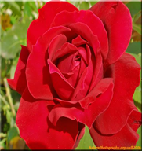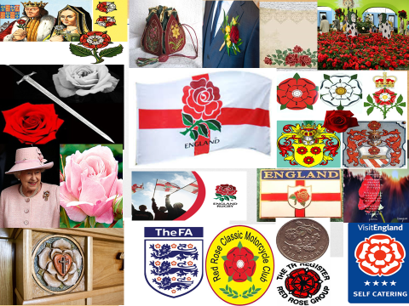
Supplement 4
The Scottish symbol is a wild plant called the THISTLE
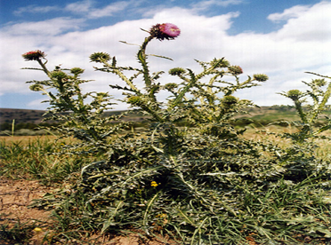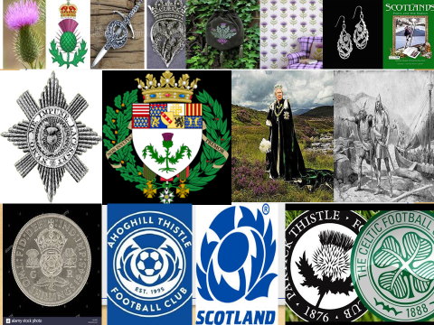

Supplement 5
The Welsh symbol is a vegetable called the LEEK (or the daffodil)
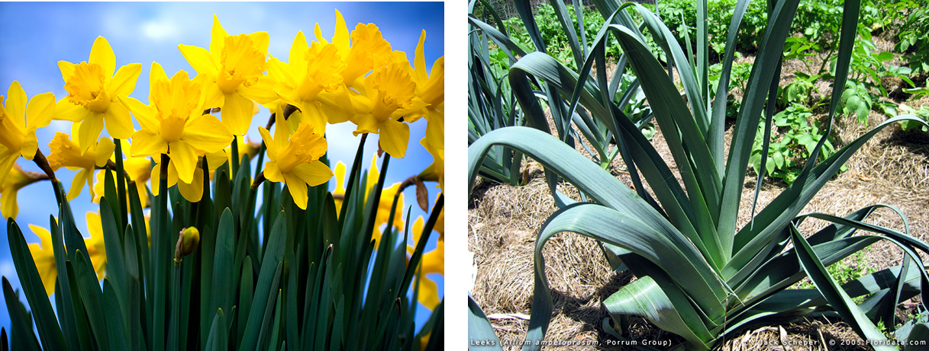
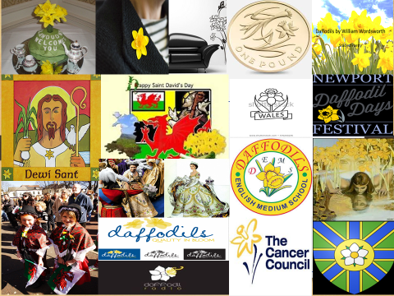

Supplement 6
The Irish symbol is a wild plant called the SHAMROCK
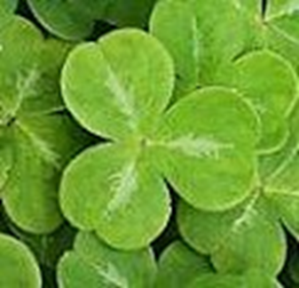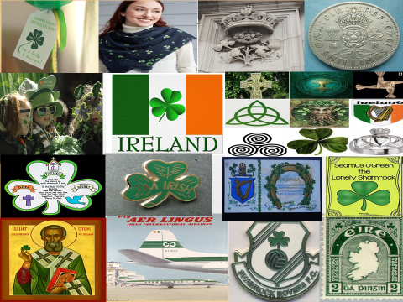

Supplement 7
The symbol of Belarusian fields is the CORNFLOWER

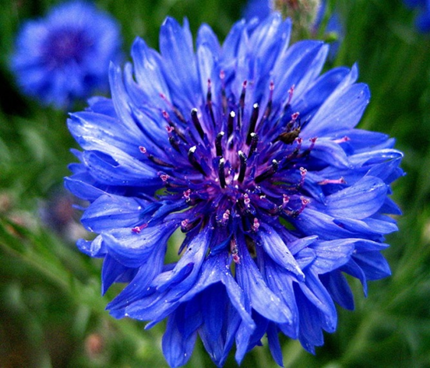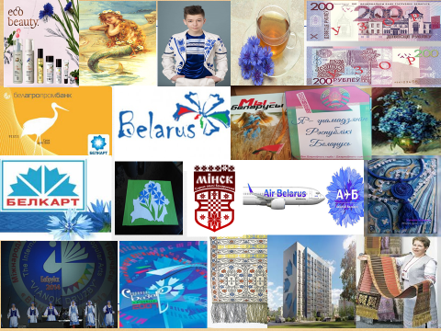

Supplement 8
Coat of arms of Krugovichi School
Supplement 9
Flower symbols in schools in Gantsevichi district

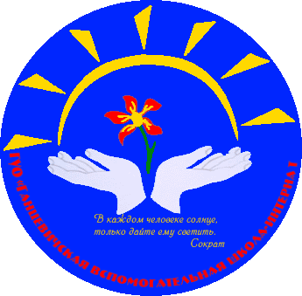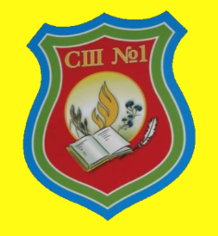
Supplement 10
Coat of arms of Kukovo School
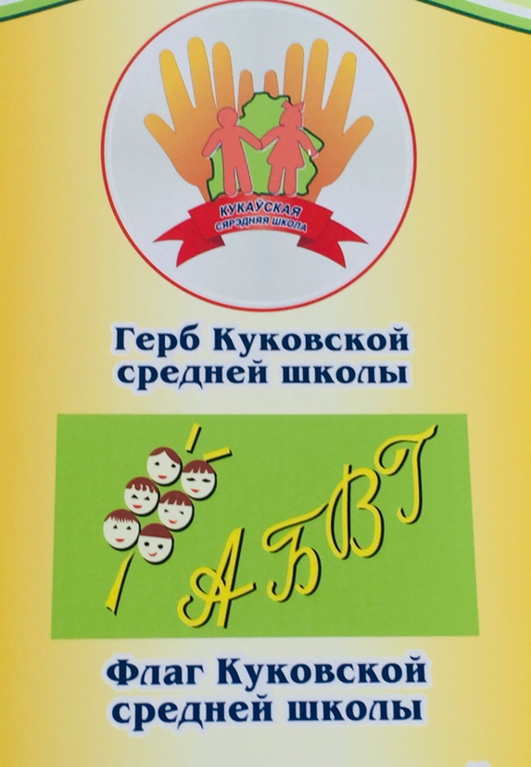
Supplement 11
Flower symbols in preschools in Gantsevichi district
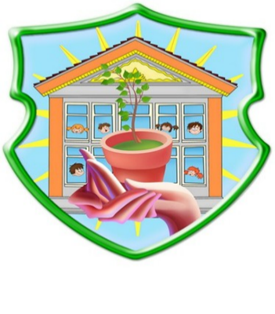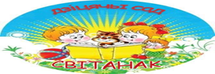
Supplement 12
Royal coat of arms of the United Kingdom
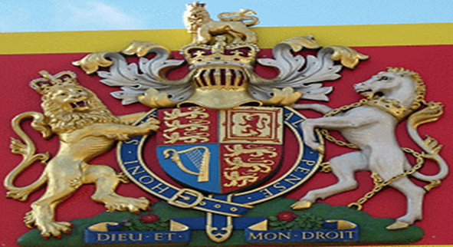
Supplement 13
Coat of arms of Belarus
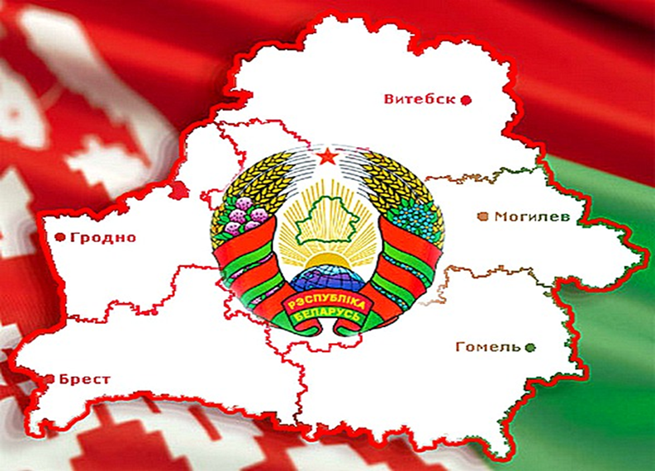

Supplement 14
Ancestral arms of the Wendorffs
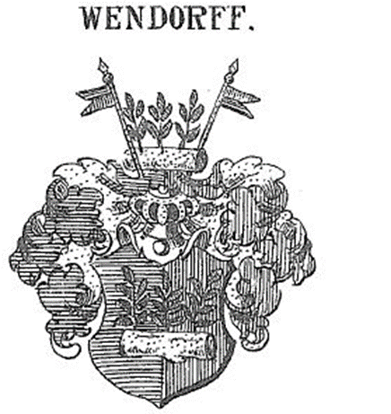

Supplement 15
The family chapel of the noble family of the Wendorffs
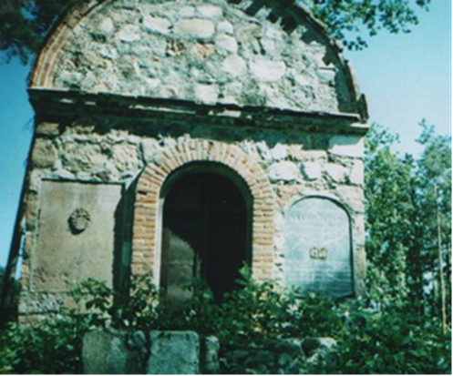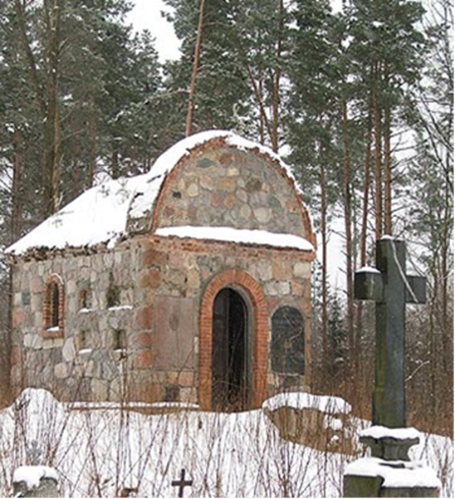

Supplement 16
The image of the family coat of arms and the signature
on the marble board
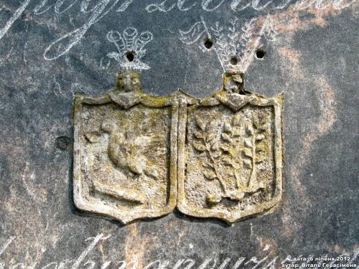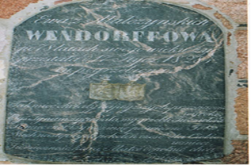
Supplement 17
The floral symbol (periwinkle) depicted on the coat of arms of the Wendorffs
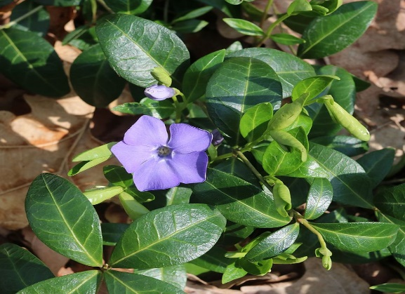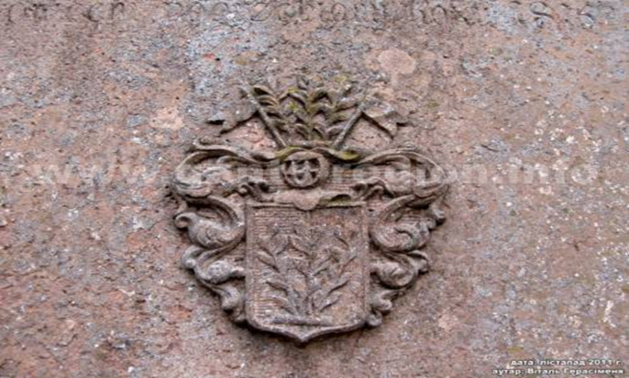
Supplement 18
The results of the survey: “Which flower will you choose as a symbol of the village Kukovo?”
