“The Village Bolshoy Kuganak and its People”

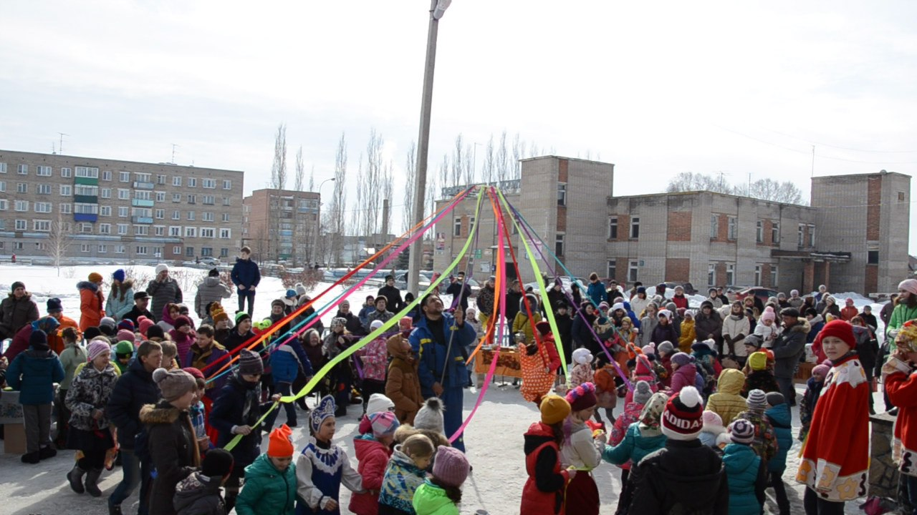

My name is Rustam, I’m the ten-grader of Kuganak high school and I’d like to tell you about the beauties of my village Bolshoy Kuganak and hospitality of our people.
I’d like to tell you about important features that I consider typical for my village, to introduce the customs and traditions in my village and to prove that Bolshoy Kuganak is really a place worth visiting for tourists. I will try to find out the reasons why people must visit Bolshoy Kuganak.
The diversity of nationalities and cultures in my village as an important part of our multicultural republic Bashkortostan. I have studied the way of living in Bolshoy Kuganak, the traditions and customs of people living in my village.
Why is this theme actual for me? Tourism is becoming more and more popular in the world nowadays. We can also make our intellectual and cultural horizons wider through contacts with people of different cultures. With the development of international tourism, people have become less interested in culture and the attractions of their native country. I also would like to travel a lot in my future. But I’m a patriot and I think that every well-educated man or woman must travel the length and breadth of his country to know the peculiar properties of his or her fatherland. I am sure that our republic Bashkortostan and my village Bolshoy Kuganak are also worth visiting. In fact, Bashkortostan has a great number of wonderful places to offer. Hundreds of tourist routes and tourist bases have been developed. Every year for hundred thousand people rest and improve health in health resorts.
I will try to explain how I see my village, and why I consider it a beautiful place. Kuganak is located in the south of Bashkortostan. Its population is 2600 people.
You could ask me a question: what is unique about Bolshoy Kuganak, except the people? The answer is: the land. The territory of our village is not only large, but also diverse. Magnificant fields and vast meadows , three picturesque rivers: Agidel, Kuganak and Meselka, many little but very attractive lakes, green plantations and a lot of flowering gardens – all this is Bolshoy Kuganak in its unique diversity. That makes it attractive for tourism.
There is a high standard of living in our village. The infrastructure is well developed. There is a school, a kindergarten, a post-office, two libraries, a museum, the house of children’s creativity, pharmacies, a hospital, a children’s home, a hair salon and a lot of shops and stores here. In my village there is an elegant skating rink for hockey players and figure skaters. A hockey team of Bolshoy Kuganak takes part in all republican competitions and often wins. We have a great boxing ring and our boxers also win in different competitions. There is a green park with the monument build in honor of soldiers killed during the Great patriotic war. It is the favourite walking zone for all villagers. And, to my mind, this is very important for people who have children. Two large construction plants provide people with work. A lot of new houses appear every year here. The old houses are being reconstructed. I think each of them has its own individual style and spirit.
But in my opinion, people have been the greatest value of Russia, our republic Bashkortostan and my village, and I’m proud of them. People are important for the country. A country without people is just a piece of land. What about the inhabitants of my fatherland? The Republic of Bashkortostan is a multicultural republic. More than 100 nationalities live there. Every nationality has its own language, its traditions and customs, values and norms, knowledge and skills, language and art.
Evidence of this can be found in our village Bolshoy Kuganak. Here, in my village, you can ask for help a man or woman or even a child in the street, and they will help you. People of 10 nationalities live in Kuganak. The relationship in our village is built on the respect for native languages, traditions, customs and culture of different nationalities. Our village has many own traditions and celebrations. Easter, Christmas, Maslenitsa, Kurban-Bairam, the Village’s Day, Victory Day, Mother’s Day are celebrated in Kuganak and loved by people of different nations and religions. A distinctive feature of all nationalities in our republic and in my village is collectivism. Throughout history, the people on the territory of modern Bolshoy Kuganak have existed through cohesion and mutual assistance. This made people strong, and paved the way for future. So, I’m concerned, Bolshoy Kuganak is worth visiting and seeing for people who are interested in the idea of multiculturism in our country.
I have asked 12 pupils of my class what are their plans about travelling and got some results:
- Are you fond of travelling?
“ Yes, I am” - 9 pupils,
“No, I’m not” – 3 pupils.
- Have you ever been abroad?
“Yes, I have” – 2 pupils,
“No, I haven’t” – 10 pupils.
- Where would you like to travel?
“Abroad” – 5 pupils,
“Around the world” – 3 pupils,
“In Russia” – 4 pupils.

- What is the journey of your dream?
“ Thailand” – 2 pupils,
“Dubais” – 3 pupils,
“London” – 1 pupil,
“The USA” – 1 pupil,
“Italy” – 1 pupil,
“Turkey” – 1 pupil.
- What do you think about that fact that Bolshoy Kuganak may be the attractive place for tourism?
“Yes” – 6 pupils,
“No” – 3 pupils,
“I’m not sure” – 3 pupils.
So, I came to the conclusion that firstly, travelling around the world is very exciting. But we all must be the patriots of our motherland, we must prefer travelling around our country to know better the history, traditions and customs of Russia, Bashkortostan, our home cities, towns and villages;
Secondly, the village Bolshoy Kuganak is a very attractive place for tourists and in futher future it may be the centre of international tourism.
Thirdly, people in Bolshoy Kuganak, their hospitality and their way of living and celebration holidays and festives are the main reason why the village is worth visiting.
As you can see, Bolshoy Kuganak is one of the most interesting places for tourism and resting. Please come and see all with your own eyes!

Bibliography
- Сахаров А.Н. Имя Россия. Исторический выбор. М.: АСТ: Астрель, 2008.
- http://www.cooldoclad.narod.ru/
- http://www.wideopenroad.ru/

