Государственное учреждение образования «Средняя школа №40 г. Витебска»

“Graffity –
art or vandalism?”

Выполнил:
Шерегов Егор,
учащийся 9 «Б» класса
Научный руководитель:
Крицина Наталья Николаевна,
учитель английского языка

The contents

Introduction 3
1. The history of graffiti 4
- Forms of graffiti 5
- Graffiti writers 7
3.1 Graffitists’ motives 7
3.2 Writer’s instruments 8
3.3 The writer’s code 8
4. Graffiti and law 9
4.1 Government responses in Europe 9
4.2 For graffiti 10
5. Graffiti in Belarus 12
Conclusion 14
Bibliography 15
SUPPLEMENT 1 Forms and styles of graffiti 16
SUPPLEMENT 2 Legal graffiti in Pinsk 19
SUPPLEMENT 3 Comparative analysis of graffiti
movement in Belarus and abroad 20

Introduction
Nowadays changes take place in different spheres of life: economic, political, cultural, etc. First and for most this process affects young people. There can be numerous ways of self-expression today.
In spite of technological progress and boundless human resources people still paint on walls. Some teenagers and grown-ups have chosen graffiti as one of the main ways of self-expression. But not all people consider painted walls to be some kind of art. They would better call it hooliganism or vandalism.
Term “graffiti” is often used for classification some banned kind of art and associated with an alternative form of urban culture.
What pushes young people to paint on state and somebody else’s property with their “stamps”? Probably it’s just a childish desire to single out from society and cry ”I’m here! Here I am!”
They say art can have different forms. Nevertheless most people deny graffiti as a kind of art.
The subject of this work is the problem of right treating graffiti and different ways of dealing with it.
Our task is to study all the theoretical and practical data dealing with the topic (books, reference-books, encyclopedias, the Internet).
Working on this topic I aimed at learning the history of graffiti; comparing the attitude to graffiti among foreigners and Belarusian people; predicting some possible ways out which can be used by different governments in the world.
In compiling the research I used such methods as collecting the information and its further analysis.
1 The history of graffiti
“Graffiti” is from the Italian word graffiato (“scratched”). In its first meaning graffities are devoting, religious, magic, everyday inscriptions and figure drawings on the walls of buildings, metal, goods, vessels and so on.
The earliest forms of graffiti date back to 30,000 BC in the form of prehistoric cave painting using such tools as animal bones, although sometimes chalk or coal could be used. People often placed these illustrations in sacred locations inside the caves. The images left on the walls mainly showed scenes of animal wildlife and hunting.
Scientists distinguish the following sorts of medieval graffities: benevolent, funeral, in memory of public events, autographic, drawing – crosses, magic signs, saints’ images.
In its second meaning graffities are inscriptions or paintings on the walls of buildings, carriages, fences, underground and other vertical surfaces with a hand.
Graffities can look like simple drawings and inscriptions, but usually they are quite complex mono- or multicolored compositions.

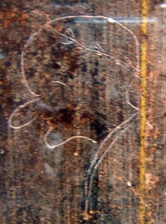
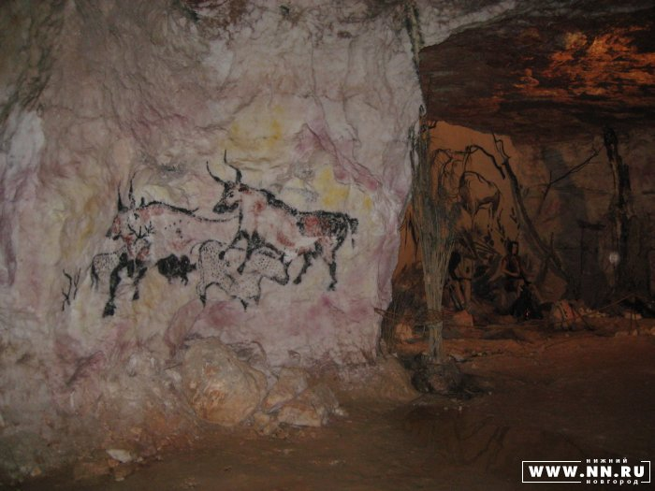

2. Forms of graffiti
As it is widely known graffiti appeared in New York in the late 1960s and this city is still considered to be “a cradle” of graffiti. It is a place where the street art with its technique, styles, kinds, forms and slang was born.
Depending on purpose, places and tools there can be the following kinds of graffiti:
- Writing – the main and most common kind of graffiti. It is what is drawn on the walls by writers;
- Tagging – is the most basic writing of an artist’s name, it is simply a handstyle. A graffiti writer’s tag is his or her personalized signature. Tagging is often the example given when opponents of graffiti refer to any acts of handstyle graffiti writing (it is by far the most common of graffiti). Tags can contain subtle and sometimes cryptic messages, and might incorporate the artist’s crew initials or other letters. No piece should be left without a tag. Sometimes graffitists just walk in the streets and leave their tags aiming to “advertise” themselves; [SUPPLEMENT 1]
- Bombing – is an extreme kind of graffiti made on different means of transport (underground, trains). Bombers usually write very quickly and carelessly. [SUPPLEMENT 1]
- Scratching (scrabbing) – is made with a whetstone or something like that on windows in transport. [SUPPLEMENT 1]
No doubt graffiti is a kind of wall art which doesn’t attract lots of people. But if artists do it, it means that someone needs it. Academic art requires and implies following different rules. Graffiti, on the contrary, is filled with freedom of self-expression. The only rule is developing and creation of your own style. Some of the most common styles of graffiti have their proper names.
Bubbles – all letters become rounded and similar to each other; they look exaggerated and are nearly ready to blow up. Few colours are used, mainly two or three. [SUPPLEMENT 1]
Wildstyle – a more complex style. It is a form of graffiti usually involving interlocking letters and connecting points. These pieces are often harder to read by non-graffiti artists as the letters merge into one another in an often undecipherable manner. Some artists also use stickers as a quick way to catch ups. While certain critics from within graffiti culture consider this lazy, stickers can be quite detailed in their own right, and are often used in conjunction with other materials. [SUPPLEMENT 1]
FX (3D style) – this style is characterized by absolute volume of its letters. To create such an FX picture you should have a well-developed imagination and outstanding way of thinking. Above all you must be well-trained. This style can be very rarely seen as 3D style drawings are usually made during some contests or to one’s order. 3D writers need much time and paints, calm atmosphere and a nice wall to write. [SUPPLEMENT 1]
Character style – its drawings look like caricatures and comics. There also can be a writer’s tag or some character’s words. Some inscription made in a different style is often used in the background. [SUPPLEMENT 1]
Throw up – another form also known as a “bombing” which is normally painted very quickly with two or three colours. Throw-ups can also be outlined on a surface with one colour. A “blockbuster’ or “roller” is a large piece done simply to cover a large area solidly with two contrasting colours, sometimes with the whole purpose of blocking other writers from painting on the same wall. [SUPPLEMENT 1]
Stencil art – stencil artists use special devices to write many identical symbols (letters, numbers, figures) on various surfaces. Dark-coloured stencils are usually made on light-coloured surfaces and vice versa. One of the most famous stencils is «Граждане! При артобстреле эта сторона улицы наиболее опасна!» made in Leningrad during the World War II.
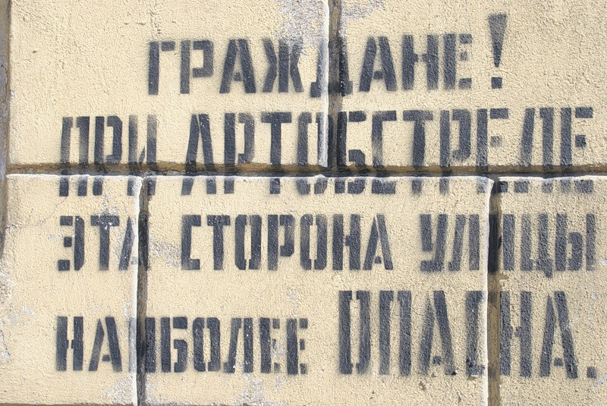
Computer Roc Style – letters are usually divided into separate fragments and bent into different sides.
As we can see, the techniques and forms used to create graffiti separates one writer from another. Luckily for the artists, there is no one traditional way to do graffiti art, because it was developed outside of traditional artistic environments.

3. Graffiti writers
“To pour your soul onto a wall and be able to step back and see your fears, your hopes, your dreams, your weaknesses, really gives you a deeper understanding of yourself and your own mental state.” – Coda.
What truly motivates someone to write on a public wall, for others to see? Who is it that is doing this, and why don’t they just grab a pen and a pad and keep it to themselves? These questions have caught the interest of many sociologists, psychologists and cultural anthropologists.
Research has shown that the identity of a person is a direct consequence of heredity and environment. From birth, a person does not choose the path he’ll lead, but instead is guided in one direction or the other through socialization that has been dictated by opportunities around him.
The founders of graffiti were at the bottom of the socio-economic pyramid, they were not born into wealth, but instead were expressing their jealousy towards those who were. In essence, graffiti is an indirect result and a modern response to the class struggle in America that has been going on for generations.
3.1 Graffitists’ motives
Since the root of the word “graffiti” is “to write”, then graffiti can be interpreted as an instinctual human need for communication. Motives for producing graffiti vary immensely from artist to artist. There are no special researches devoted to the matter, but however these motives can be categorically placed in five main groups.
- Personal or group identity. Graffiti is created by and according to somebody’s desire to leave a mark, to inform about one’s existence, to express an attachment. Identifying signs make up a considerable part (about 50%) of all drawings and inscriptions.
- Anti-social and cultural norms’ protest. Graffiti involves spoiling public and private property, which means breaking social prohibitions itself. Many inscriptions contain aggressive messages full of words and symbols treated as social taboos.
- Malicious reactions. Some inscriptions can become rather offensive and rude expressions addressed to concrete people, political and ethnic groups, subcultures, social institutions. Such pieces contain motives of struggle, rivalry and even violence.
- Creation. Most writers consider themselves to be artists who add some nice view to gloomy and expressionless urban environment.
- Entertaining motives. Some graffiti pieces contain separate words and scramled signs which can be hardly related to any of the categories mentioned. Seemingly, drawing appears to be a part of some game and brings pleasure itself.
Any writer understands that his works will be removed from the walls in time. But each writer wants his creation to be seen and estimated.
3.2 Writer’s instruments
The main instrument of any graffiti writer is paint in balloons, though sometimes another kind of paint and rollers are used. The most typical spray paint in aerosol balloons is called a can and it has a nozzle to pulverize the paint – a cap. Caps can differ greatly. Depending on a manner of fastening they can be: man and woman. They also differ according to thickness of lines. Writers often use markers, stencils and brushes and protect themselves with a kerchief or a respirator.
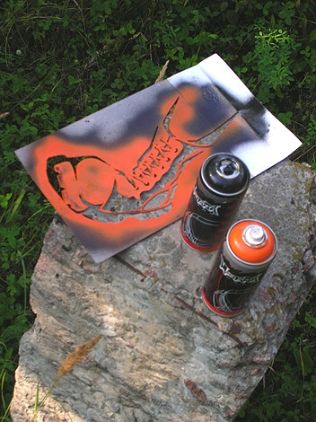
3.3 The writer’s code
Who can become a graffiti writer? Any person, practically. But he should realize that graffiti requires many hours of practice and much persistence. Otherwise you can get an offensive nickname “toy”. A toy is an inexperienced graffiti writer who is not interested in studying ethics of graffiti and is not eager to acquire necessary habit.
Nevertheless most graffiti writers follow the so-called writer’s code:
- Don’t paint historical buildings and dwelling houses.
- Don’t press your world-view on people, don’t write on other writers’ names and somebody else’s works, on gravestones.
- Those who write on somebody else’s works deserve contempt.
- Don’t copy other writers’ style, never insult people with your works, don’t sting their national and cultural self-respect. Your style is your face.
- Don’t make money on misfortune of other people. Help your brother, don’t be indifferent.
Graffiti artists who are drawn to the art form for individual expression are much more creative with their work. They turn to graffiti because they believe that it is the closest representation of who they are as a person and the background that they have. They feel that the way they would like people to view them is the best expressed through graffiti.

4. Graffiti and law
The explosion of this new style of art became so big that it was impossible not to notice. There were mixed reactions.
A majority of people tend to associate graffiti with vandalism. They think most graffiti artists are hoodlums or gang-bangers with nothing better to do with their time. But to my mind graffiti and vandalism derive from different motives and environments. Though there is sometimes a fine line between the two, this is what gives graffiti a more organic feel.
Questions pertaining to the placement and presentation of graffiti art are the most complex and controversial of all. In this area, the issue of whether graffiti is legal or illegal comes into question. The line defining the two is vague and is determined by a variety of factors. In a technical definition of graffiti under the law, many forms of graffiti are illegal. However, as with any laws regulating the expression and personal choices of people, these laws are subjective in nature.
In most countries graffiti is banned, but still there are “legal” and “illegal” walls in many cities. Legal walls are given to graffiti artists by local authorities which wish to decorate this or that district of a city and to show their democracy and tolerance towards this free art. But they are so few that graffiti artists still go ”to work” at midnight or early in the morning and paint illegal walls.
As graffiti first appeared in New York then first steps to ban it and to declare it illegal were also taken there. Authorities all over the country called graffiti a parasitizing disease, which came out from New York and was spreading across the USA. Painting on walls occupied the whole territory appearing on buildings, bridges and highways in each city. Expenses on cleaning towns from graffiti reached billions of dollars.
By the 1980s police pressure cracked down on graffiti and many well-known “writers’ corners”, where artists would converge to share ideas and techniques, were repainted and kept clean. The subway system began a massive clean-up program that discouraged kids from writing.
4.1 Government responses in Europe
In Europe community cleaning squads have responded to graffiti.
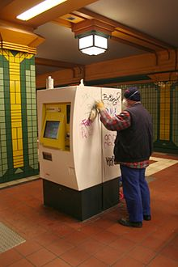
The laws on public property are very strict and anyone caught doing graffiti can be arrested and prosecuted under the Criminal Damage Act 1971.
The Anti-Social Behaviour Act 2003 became Britain’s latest anti-graffiti legislation and introduced new powers for local councils to punish offenders and to help them clear up illegal graffiti. These included:
- On-the-spot fines of £50 to anyone caught doing graffiti on public property. These can be given out by police officers, community support officers or local authority officials;
- Giving local authorities the power to give clean-up notices to owners of street furniture such as phone boxes if they have graffiti on them. If the property is not cleaned in 28 days the authority can remove the graffiti themselves and charge the owner for this service;
- Making it an offence to sell spray paint to under-16s. If a shopkeeper can't prove they took reasonable steps to determine the age of the person, they can be fined up to £2,500.
In August 2004 The Keep Britain Tidy campaign issued a press release calling for zero tolerance of graffiti.
To back the campaign, 123 members of Parliament (including Prime Minister Tony Blair) signed a charter which stated: Graffiti is not an art, it’s crime. On behalf of my constituents, I will do all I can to rid our community of this problem.
In September, 2006 the European Parliament issued the European Commission to create urban environment policies to prevent and eliminate dirt, litter, graffiti, animals’ excrement and excessive noise from domestic and vehicular systems in European cities, along with other concerns over urban life.
More than that spray paint has many negative environmental effects. The paint contains toxic chemicals and the can uses chlorofluorocarbons volatile hydrocarbon gases to spray the paint into a surface. As an alternative, moss graffiti is starting to catch on, which uses moss to create text or images. The moss is glued unto a surface by means of beer, buttermilk or yogurt combined with sugar.
Of course, not all graffiti can be treated as art pieces. Graffiti left on some illegal surfaces or preserved buildings birth to vandalism and must be banned and prosecuted. Governments in different countries use various methods to prevent graffiti vandalism. Having analyzed a number of them I picked up the most typical measures:
- quick repair (first destructions involve new and subsequent damages);
- limited access to vulnerable objects;
- security and observation;
- detention, punishment, compensation;
- distraction in the form of giving special (free) spaces to writers, attracting graffitists to designing and decorating cities.
4.2 For graffiti
Time passed and graffiti caught the eye of the art elite. Cities were on an economic upswing, and the galleries were looking for something new and exciting to represent the re-birth of cultural life.
In the early 1990s the first Art Galleries who started to show graffiti artists to the public were Fashion Moda in Bronx and Now Gallery in East Village, Manhattan.
A 2006 exhibition at the Brooklyn Museum displayed 22 works by New York graffiti artists.
Galleries in Soho began displaying graffiti art from time to time. It was at this time that the graffiti art scene began to split.
Between March and April, 2009 150 artists exhibited 300 pieces of graffiti at the Grand Palais in Paris – a clear acceptance of the art form into the French art world.
Some writers saw joining the art world as an opportunity to really make graffiti a respected and legitimate art form and spread its message to a wider audience. It also made it easier to dedicate one’s career to being a graffiti writer, if the art could bring in revenue for the artist.
Local authorities started providing approved areas round the towns where graffiti artists could showcase their talents, including underpasses, car parks and walls that might otherwise prove a target for the “spray and run”.

5. Graffiti in Belarus
Nowadays Belarusian authorities treat graffiti in a more serious way. They started active fighting against illegal graffiti pieces, painted bus-stops and buildings. At the moment according to the article 341 of the Criminal Code anyone caught doing graffiti can face either three months imprisonment or a fine or public works.
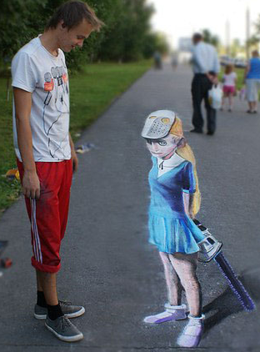
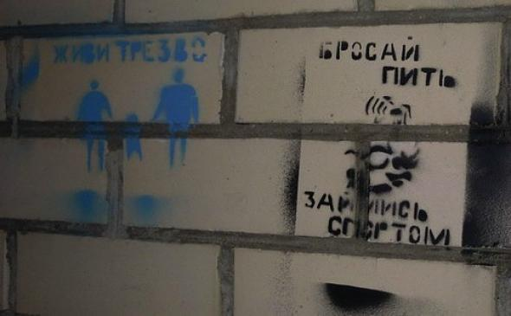
But in reality, for instance, graffiti artists from Horki faced up to 6 months of imprisonment. They painted graffiti which promoted healthy lifestyle on the houses’ walls for several months long. There might be no trial if they cover the material losses held by the houses’ owners in full scope. It is also mentioning that apart from imprisonment, the artists may be expelled from the Horki Agricultural Academy, where they study now.
Meanwhile more and more legal and free walls appear in different towns nowadays, more fests are held jointly with the state.
Minsk authorities published a list of places where graffiti can be written legally. Grounds, walls and sheds in tens of streets are included in the list which is planned to be extended.
Authorized graffiti appeared in Pinsk. The head of the culture department of Pinsk City Executive Committee has allowed graffiti on a city building. [SUPPLEMENT 3]
Vitebsk graffitists, Stas Rabunski and Kiryl Kulikou, have started working on a new level. Now there can be seen their 3D graffiti in the city streets. Optical illusions make you believe that you see real objects that can be touched and that need to be walked around rather than simple drawings. They are working on this idea of painting in all Belarusian cities.
Stanislau Rabunski: People’s attitude is not negative. When people see a person writing something on a wall, they do not like it. But when they see us painting on the asphalt – they like it a lot. The young or the elderly – I have not seen anyone who would not approve of it.
Different graffiti fests and contests are being held since 2008 in Belarus and many of them have become annual. The most famous graffiti contests are:
- an annual graffiti fest “Just Writing My Name” (Minsk, September);
- an annual ceremony Street Awards (Minsk club Reactor, February);
- graffiti fest “Stenografia” (Minsk, October 18, 2011);
- 3D graffiti festival “Around the World in Eight Hours” (Minsk, October).

Conclusion
Graffiti has been found for millions of years when cave people drew illustrations on cave walls. Modern graffiti started as tagging or writing a name on street walls. Then gangs used graffiti as a way to mark their territory. The United States is considered to be the home of the modern graffiti movement. It began in New York in the late 1960s and then spread from there. Brazilians emulated this graffiti in their own work which is thought to be some of the best in the world, with many powerful artists coming out from Sao Paolo. In Belarus graffiti has a short history. It has been growing since the 1990s. [SUPPLEMENT 3]
Graffiti may express underlying social and political messages and a whole genre of artistic expression is based on spray paint graffiti styles. Graffiti is a term with many associations, some which lean towards the world of art and some towards ideas of crime.
In modern times paint, particularly spray paint and marker pens have become the most commonly used graffiti materials. In most countries marking or painting somebody’s property without the owner’s consent is considered to be defacement and vandalism which is a punishable crime.
There is a line between graffiti and vandalism. Graffiti is street art often done over a period of time which characterizes an artist or group. Vandalism is the intentional destruction of property with the sole purpose of doing something illegal and taboo.
But graffiti is not seen as vandalism any more, unless it is done on prohibited locations. It has evolved over the years and has taken the shape of an art form. It is possible to practice graffiti legally and people appreciate it. You just need to find a space that is legally available for graffiti and then do your creative works. Graffiti art is a form of self-expression. It is a way artists can show their talent and opinions to the public.
I think graffiti should be legitimized both abroad and in Belarus as an art form and there are some preconditions to this:
- graffiti catches the eye of the viewers, experienced artists, famous galleries and museums;
- well-known companies start inviting graffitists to advertise their goods and services through graffiti pieces;
- local authorities define more and more legal surfaces to create graffiti;
- a number of graffiti fests and contests are held every year uniting people from different countries and of different nations.
Today graffiti art is flourishing and will continue to flourish, whether it is accepted by art institutions or not. I strongly believe that it is only a matter of time before graffiti artists are being compared to the great artists of the world. Rightly so: graffiti art is one of the most intricate, creative and impressive forms of art and it is becoming more and more popular each day.
Bibliography
- Bosmans B., Thiel A.: Guide to graffiti research.- London, 1995
- Christ T.: New York 82/83 subway graffiti. – Edition Aragon, 1994
- Медведева О.П.: Искусство граффити. – Ростов-на-Дону, 2005
- Орлова Э.А.: Субкультуры в структуре современного общества. Субкультурные объединения молодежи. – М.: Международные отношения, 1997
- Wikipedia.org
- http://www.graffitos.narod.ru
- http://www.graphitic.ru
- http://www.artcrimes.com

SUPPLEMENT 1
Forms and styles of graffiti (illustrations)
- Stencil graffiti
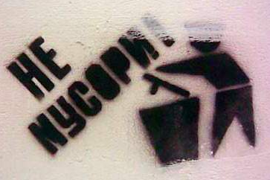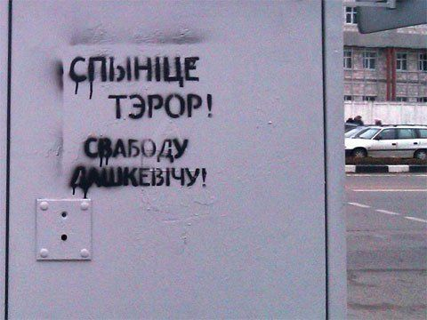
- Bubbles
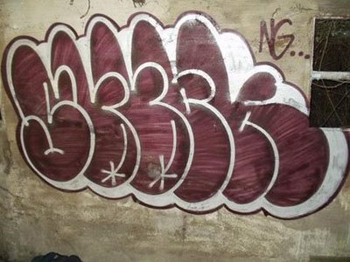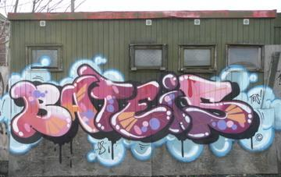
- Wild Style
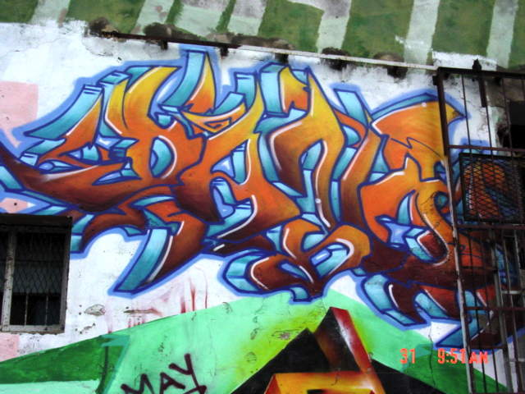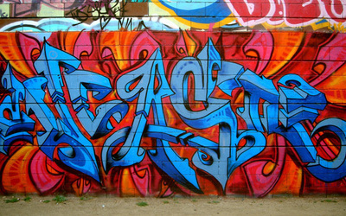
- 3D Style
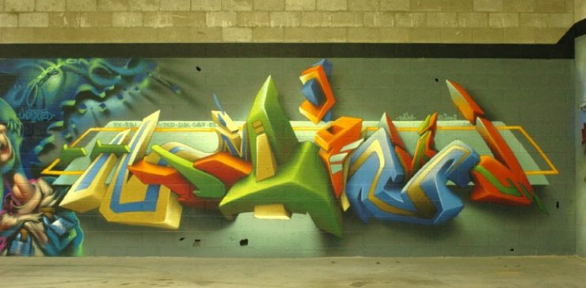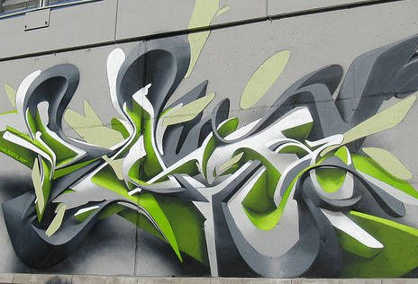

- Character
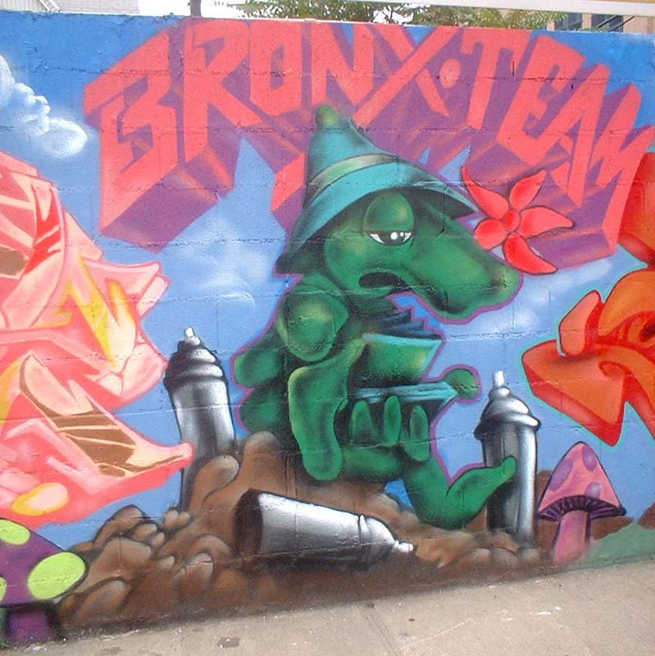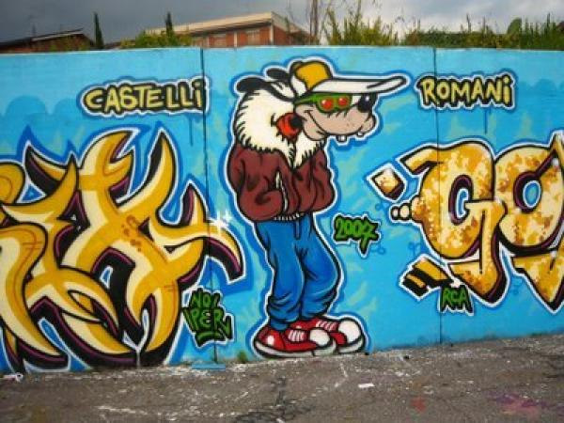
- Throw up
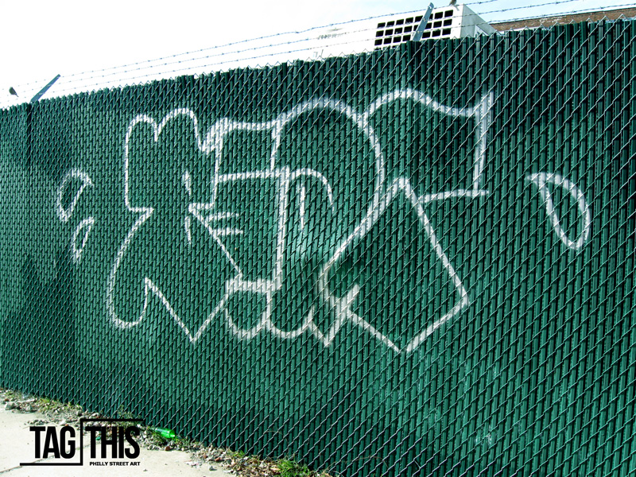
- Blockbusters
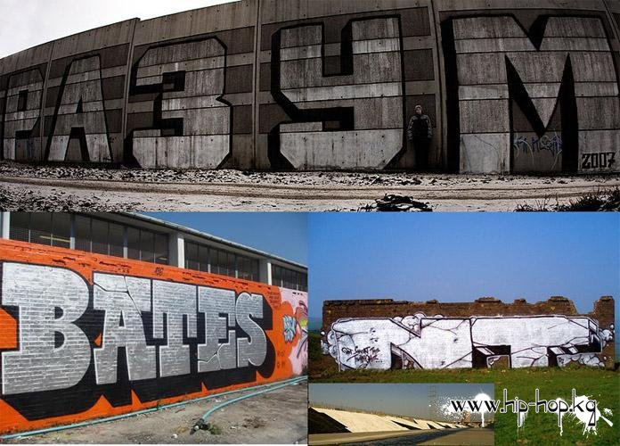
- Bombing
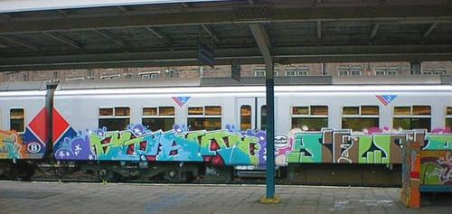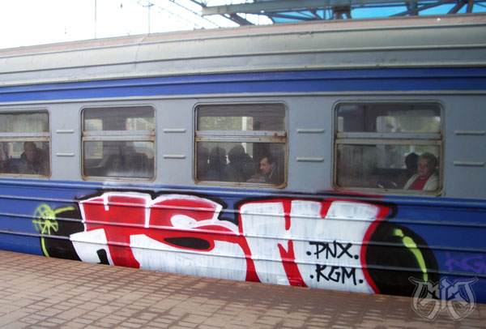

- Tagging
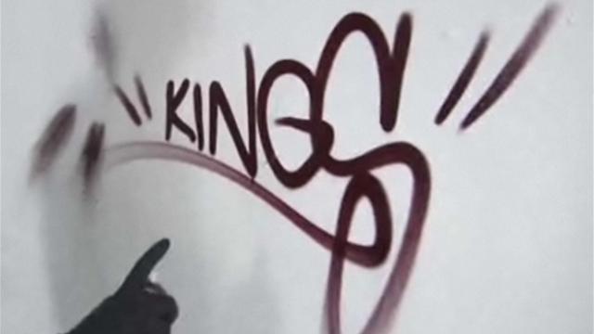
- Scratching
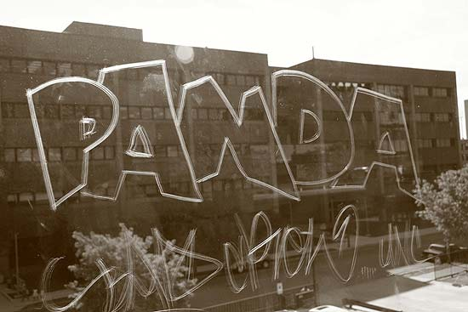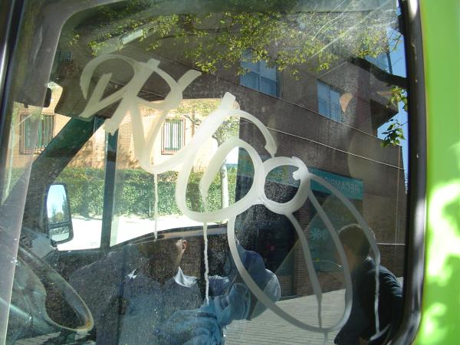

SUPPLEMENT 2
Legal graffiti in Pinsk
Interestingly, the guys caught while painting a portrait of Bob Marley have been entrusted with it. “The bombers” have paid a fine and are painting an authorized picture on the same building – trees growing through the wall.
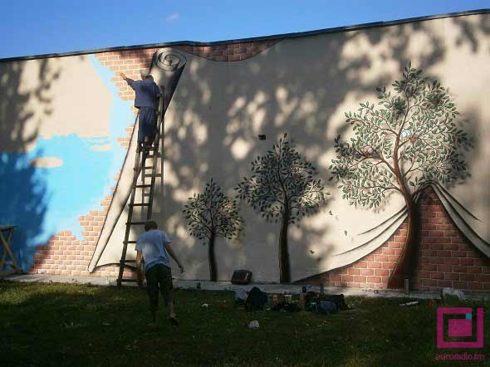

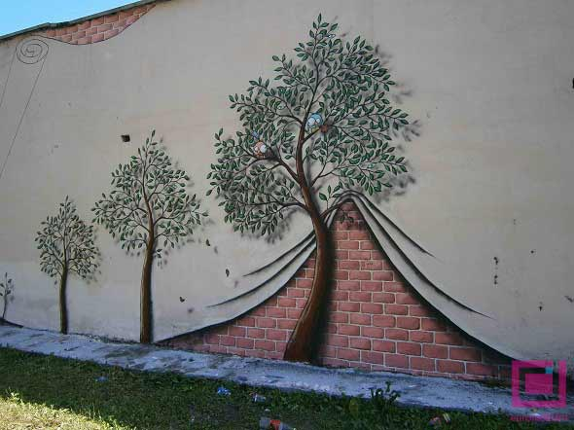

SUPPLEMENT 3
Comparative analysis of graffiti movement in Belarus and abroad

 | Britain/the USA | Belarus
Time of  appearance | the late 1960s | the late 1990s
Age of  graffitists | 14-50 | 14-30
Social state of first graffitists | low income,  urban youth | advanced youngsters,  often students
Frequently used  forms and styles | stencil, tagging, bombing,  bubbles, wild style, 3D style, character, throw up, scratching | bombing, bubbles,  scratching, wild style
Legal/free walls | + | +
Display | street walls, galleries,  museums, festivals, advertisements | street walls, fests, contests
Penalty | imprisonment, fines,  clean-up works | imprisonment, fines, clean-up works
People’s  attitude | rather negative than positive | mostly negative

